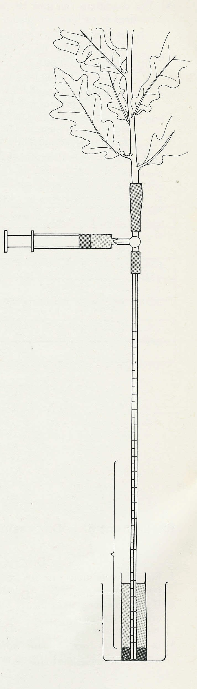

Experiment 7. Water tension in the stem

(a) Clamp the potometer upright in a retort stand. Fill a small syringe with water, expel all air bubbles and fit it to the side arm of the 3-way tap.

(b) Turn the tap down and depress the syringe plunger until water emerges from the rubber tubing.

(c) Insert the stem of a cut shoot into the rubber tubing. It is essential to make a good seal.

(d) Lower the potometer so that the capillary tube dips into a small container of water with some mercury at the
bottom. The end of the capillary must be below the mercury (Fig. 1).

(e) Turn the tap upwards and depress the syringe to expel all air bubbles from the capillary.

(f) Turn the tap horizontally and observe the apparatus
from time to time over a period of 30-45 minutes. At the end of this time measure the height of mercury above the
mercury level in the reservoir and record this distance in your notebook.

Experiment 7. Discussion

1 Atmospheric pressure is helping to push the mercury up the capillary but before it can do this, the shoot must reduce the water pressure in the capillary to below atmospheric pressure. From your results calculate the reduction of pressure, in atmospheres, in the stem. (A column of mercury 760 mm high exerts a pressure of 1 atmosphere.)

2 Atmospheric pressure can support a column of water about 10 metres high. Many trees are taller than this. How could transpiration account for the movement of water in these trees?

measure this distance
water
beaker to retain mercury in case of breakage
mercury
Fig. 1

