Experiment 7. Stomatal movements

(a) Tear the leaf with a twisting and pulling action so that some of the lower epidermis is exposed (Fig. 1).

(b) Place a small piece of the leaf with an exposed fringe of epidermis on a microscope slide, lower surface uppermost, and trim off the thick part of the leaf with a scalpel (Fig. 2).

(c) Add 2 or 3 drops of water to cover the epidermis and carefully lower a cover slip over it, excluding all air bubbles (Fig. 3).

(d) Examine the slide under the microscope using the x10 objective. Move the slide about until you find a group of stomata which are open (Fig. 4). Clip the slide firmly to the stage and leave
it there for the rest of the experiment.

(e) With a dropping pipette, place 2 drops of sodium chloride solution on the slide so that it is in
contact with one edge of the cover slip.

(f) Examine the stomata and be ready to observe them again immediately after the next operation.

(g) Place a square of blotting paper on the slide on the opposite side of the cover slip to the salt solution and move it so that it just touches the cover slip. As soon as the
blotting paper starts to draw the solution through, watch the stomata closely.

(h) If nothing seems to happen, draw through 2 more drops of sodium chloride solution.

(i) When the change is complete, try and reverse it by drawing through water instead of salt solution.
The procedure may have to be repeated 2 or 3 times in order to wash away all the salt solution.
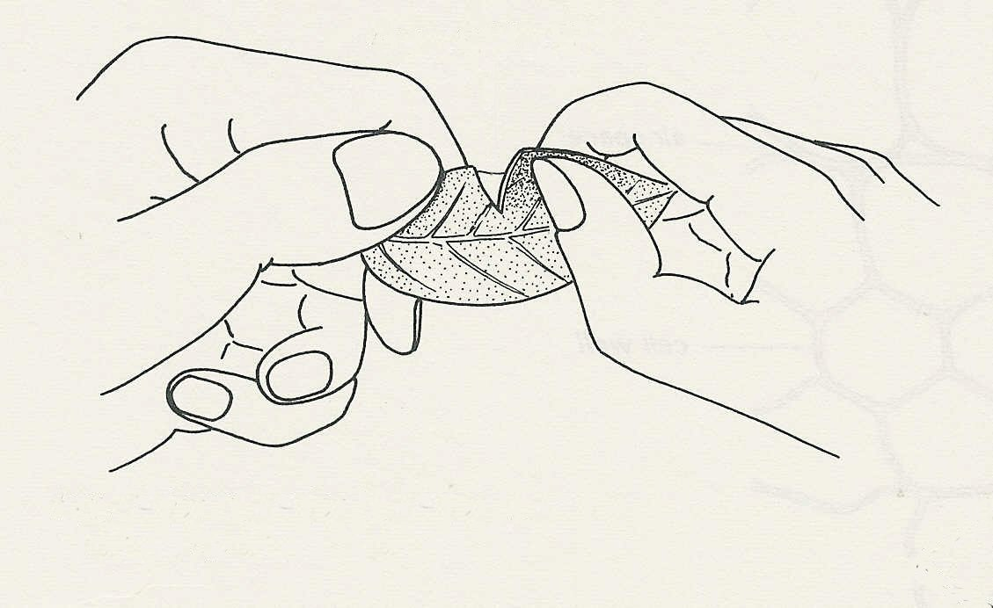
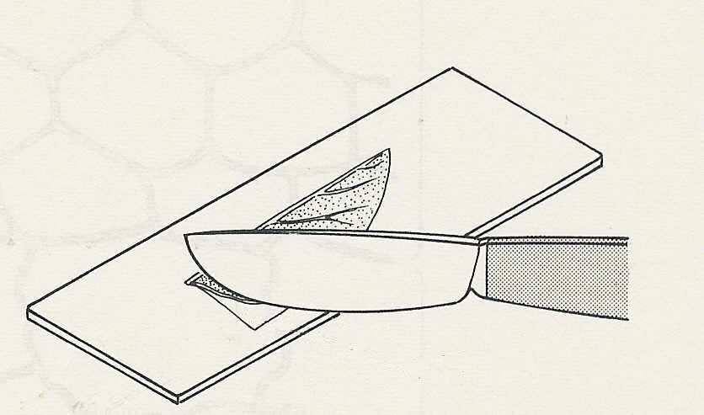
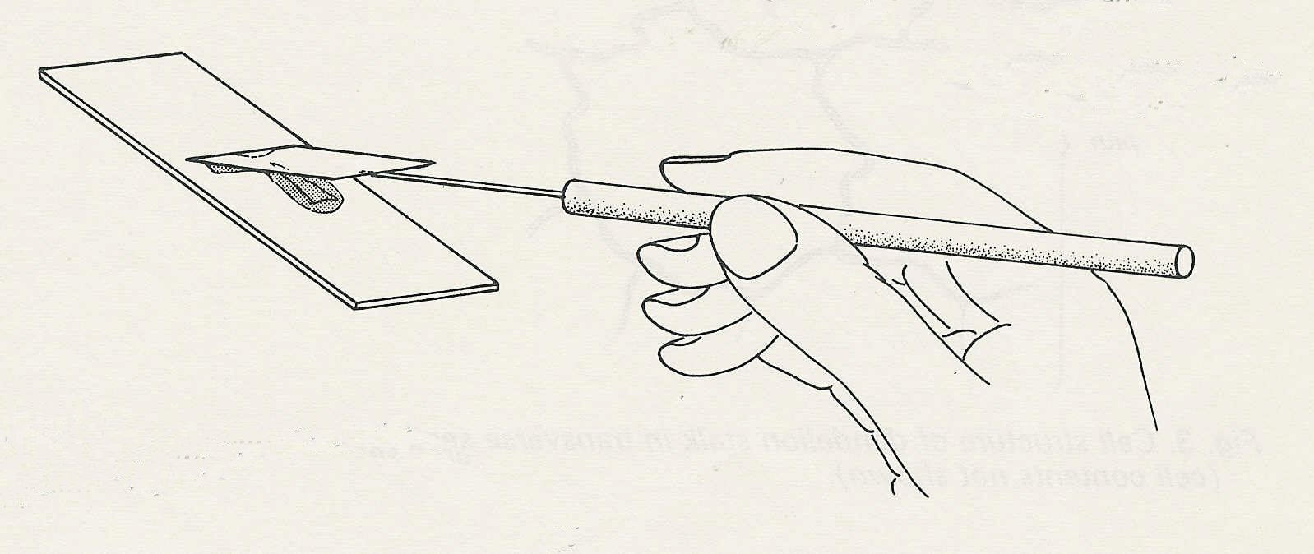
Fig. 1 Tear the leaf to expose the lower epidermis
lower epidermis
Fig. 2 Trim away the thick portion
epidermis
Fig. 3 Lower the cover slip carefully to exclude air bubbles

