Experiment 7. Judgement of distance

The object is to compare your ability to judge distance when using both eyes or only one eye. Work in teams of two, an experimenter and a subject.

(a) The experimenter, without allowing the subject to watch, sticks the coloured pins upright into the marked block. Each pin is placed at an intersection of the lines so that no two pins are on the same line whether the block is viewed from the side or the front (Fig. 1). Avoid making a
regular pattern as far as possible.

(b) The subject closes one eye and keeps it closed.

(c) The experimenter passes the block to the subject, tilting the block away from the subject so that he/she cannot see the marked grid. The subject holds the block quite steady about 30 cm away, tilted so that he or she can see the front edge of the block and the pins but not the marked grid on the top of the block or either of its sides.

(d) The subject now calls out the colours of the pins, in order from the front to the back and the
experimenter writes this down.

(e) Still holding the block in the same position, the subject opens both eyes and calls out the order of the pins again from front to back.

(f) The correct answers are marked.

(g) The experimenter changes the position of the pins and the experiment is repeated twice more.

(h) The average number of correct answers for one eye and both eyes are compared.

(i) The subject and experimenter change roles.

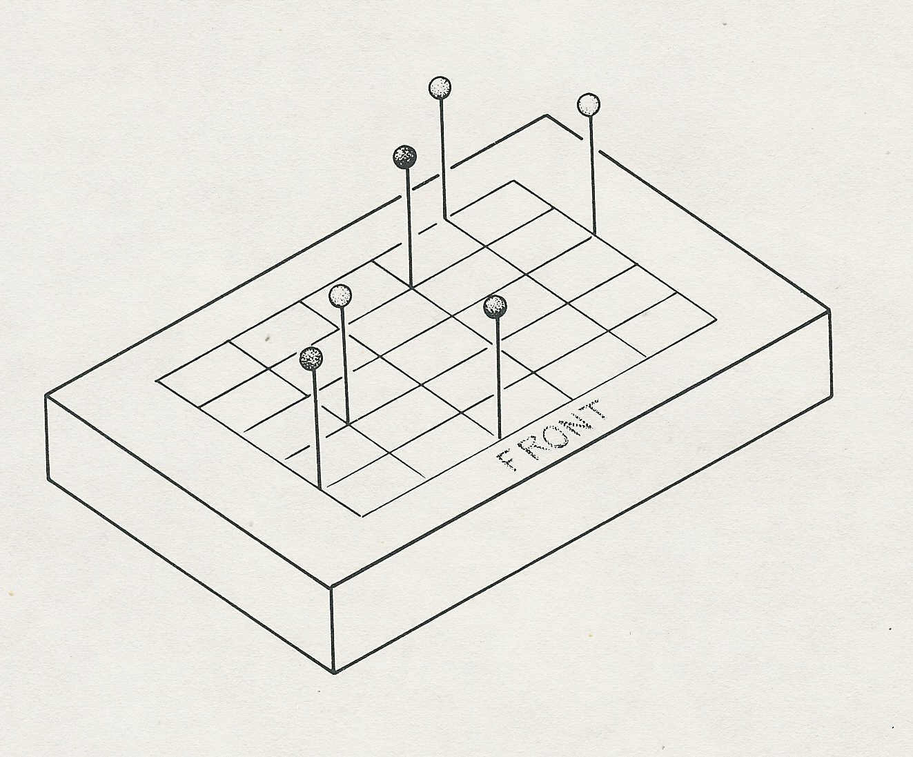
Fig. 1

