Experiment 6. Root pressure

You are provided with a potted plant. Read all instruction (a) before starting.

(a) Refer to Fig. 1 and then cut off the top of the main shoot and those branches which are sufficiently thick and sufficiently vertical to be used in the experiment. Make the cut just below a leaf at a point where the stem has a diameter of 5-7 mm. Leave the narrow or horizontal branches intact.
Put all the cuttings in water.

(b) From the two different sizes of rubber tubing offered, select a piece which will fit firmly over one of the stumps without damaging it. Note which size tubing you have used.

(c) Use a dropping pipette to fill the rubber tubing attached to the branch, with coloured water. Look to see if there is any leakage between the stem and rubber tubing. If there is, you will have to cut the stem lower down at a point where it is wider, or use a narrower piece of tubing.

(d) Select a piece of capillary tubing from the same box as the rubber tubing and insert it, marked end downwards, into the rubber tubing until it touches the stump. This will expel some liquid and air bubbles from the tube.

(e) Partially withdraw the glass tube from the rubber tubing until the liquid level corresponds to the mark near the base (Fig. 2). This operation must be carried out for all the cut branches.

(f) Remove all leaves from the plant, water the soil thoroughly and leave it for about 1 hour. Do not cut off any branches unless they are to have tubes fitted.

(g) After an hour, examine the level of the liquid in the tube and record any change.
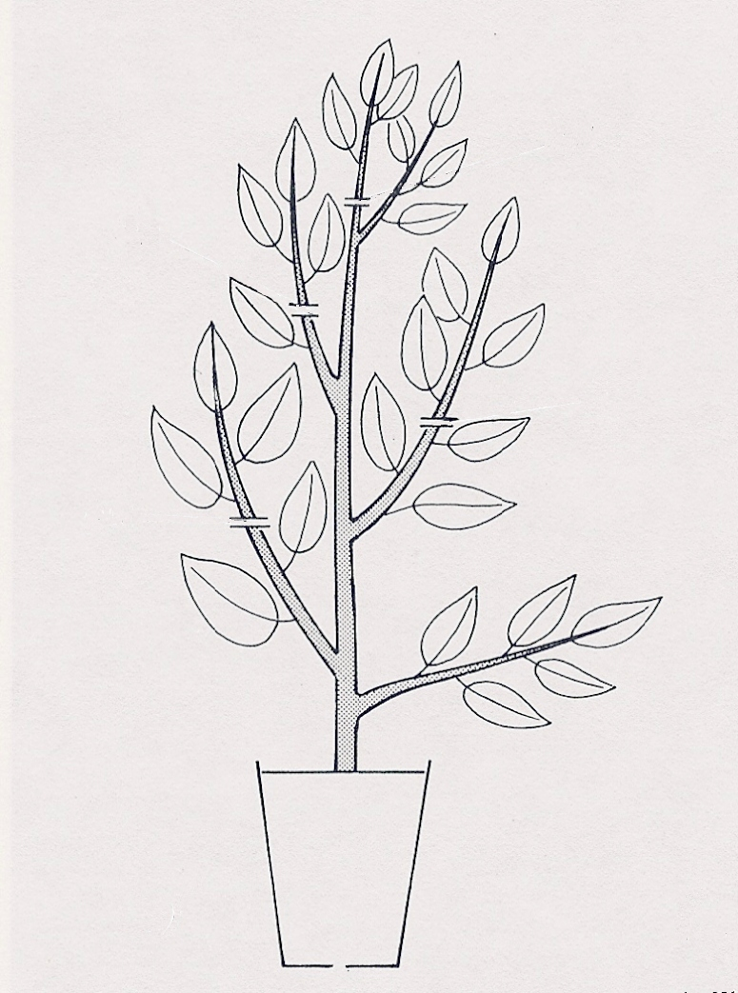
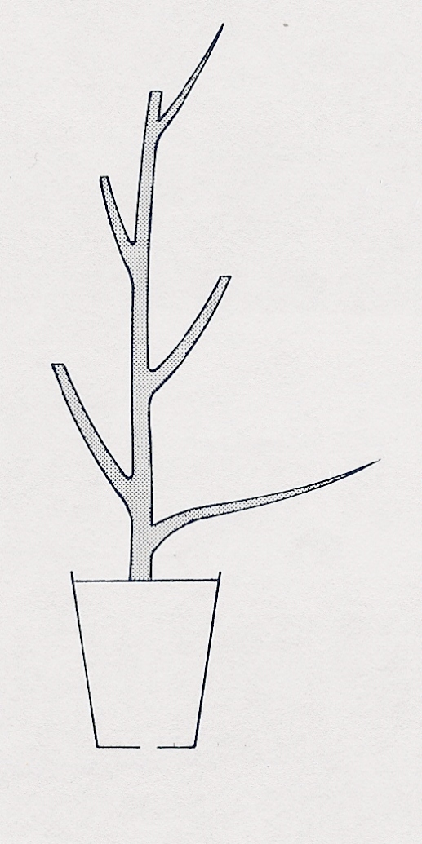
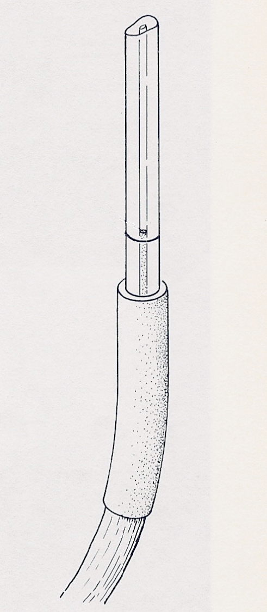
cut
cut
cut
cut
too thin to take tube
too horizontal
to take tube
liquid brought level with mark
(a)
remove all leaves and attach tubes to cut branches
(b)
Fig. 1

Fig. 2

