Experiment 6. Starch-digesting enzymes in maize fruits

You are provided with the following:
(i) A clean Petri dish.
(ii) A test-tube containing a dilute starch solution and melted agar.
(iii) Two maize fruits which have been soaked for at least twenty-four hours. One
has been killed by boiling; both have been soaked in sodium hypochlorite solution to destroy any fungi on their surface.

(a) Take a test-tube of starch-agar from the water bath and, without delay, pour it into
the lower half of the Petri dish. Replace the lid at once and allow the agar to cool and set (at least five minutes).

(b) While the agar is cooling, cut the two maize fruits in half longitudinally as shown in Fig. 1.

(c) When the agar has set, use forceps to place the half fruits carefully, cut surface downwards on the agar, arranging them as shown in Fig. 2 so that the boiled and unboiled fruits can be identified later.

(d) Replace the lid of the Petri dish, mark your initials on it with a spirit marker or glass-writing crayon, and leave for one to seven days.

(e) After the appropriate time interval, remove the maize fruits and pour dilute iodine
solution into the dish to cover the agar surface for one or two minutes.

(f) Pour off the iodine and examine the agar surface against a light background.
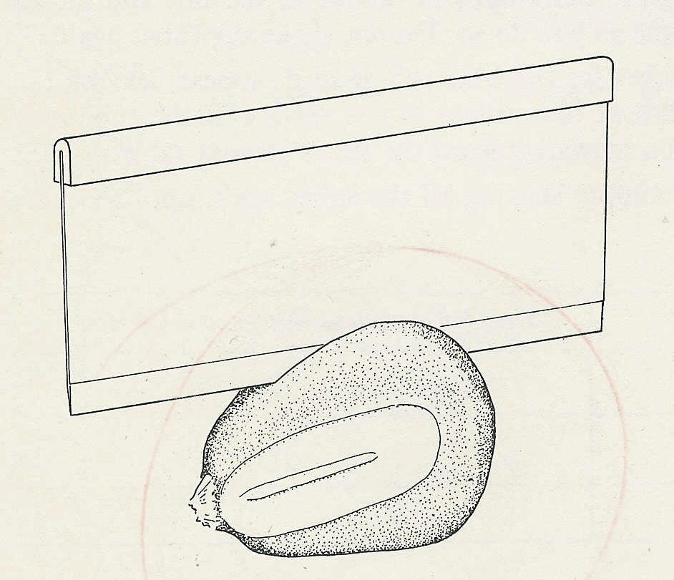
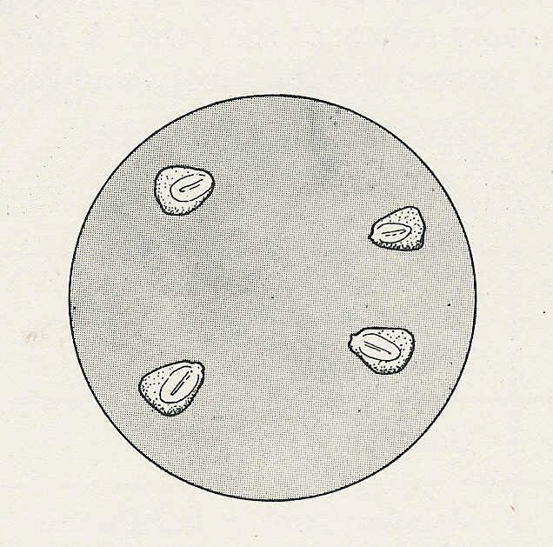
live seeds;
(further apart)
dead seeds;
(closer together)
Fig.1 Cut the maize fruits longitudinally
Fig.2 Position of grains on the agar

