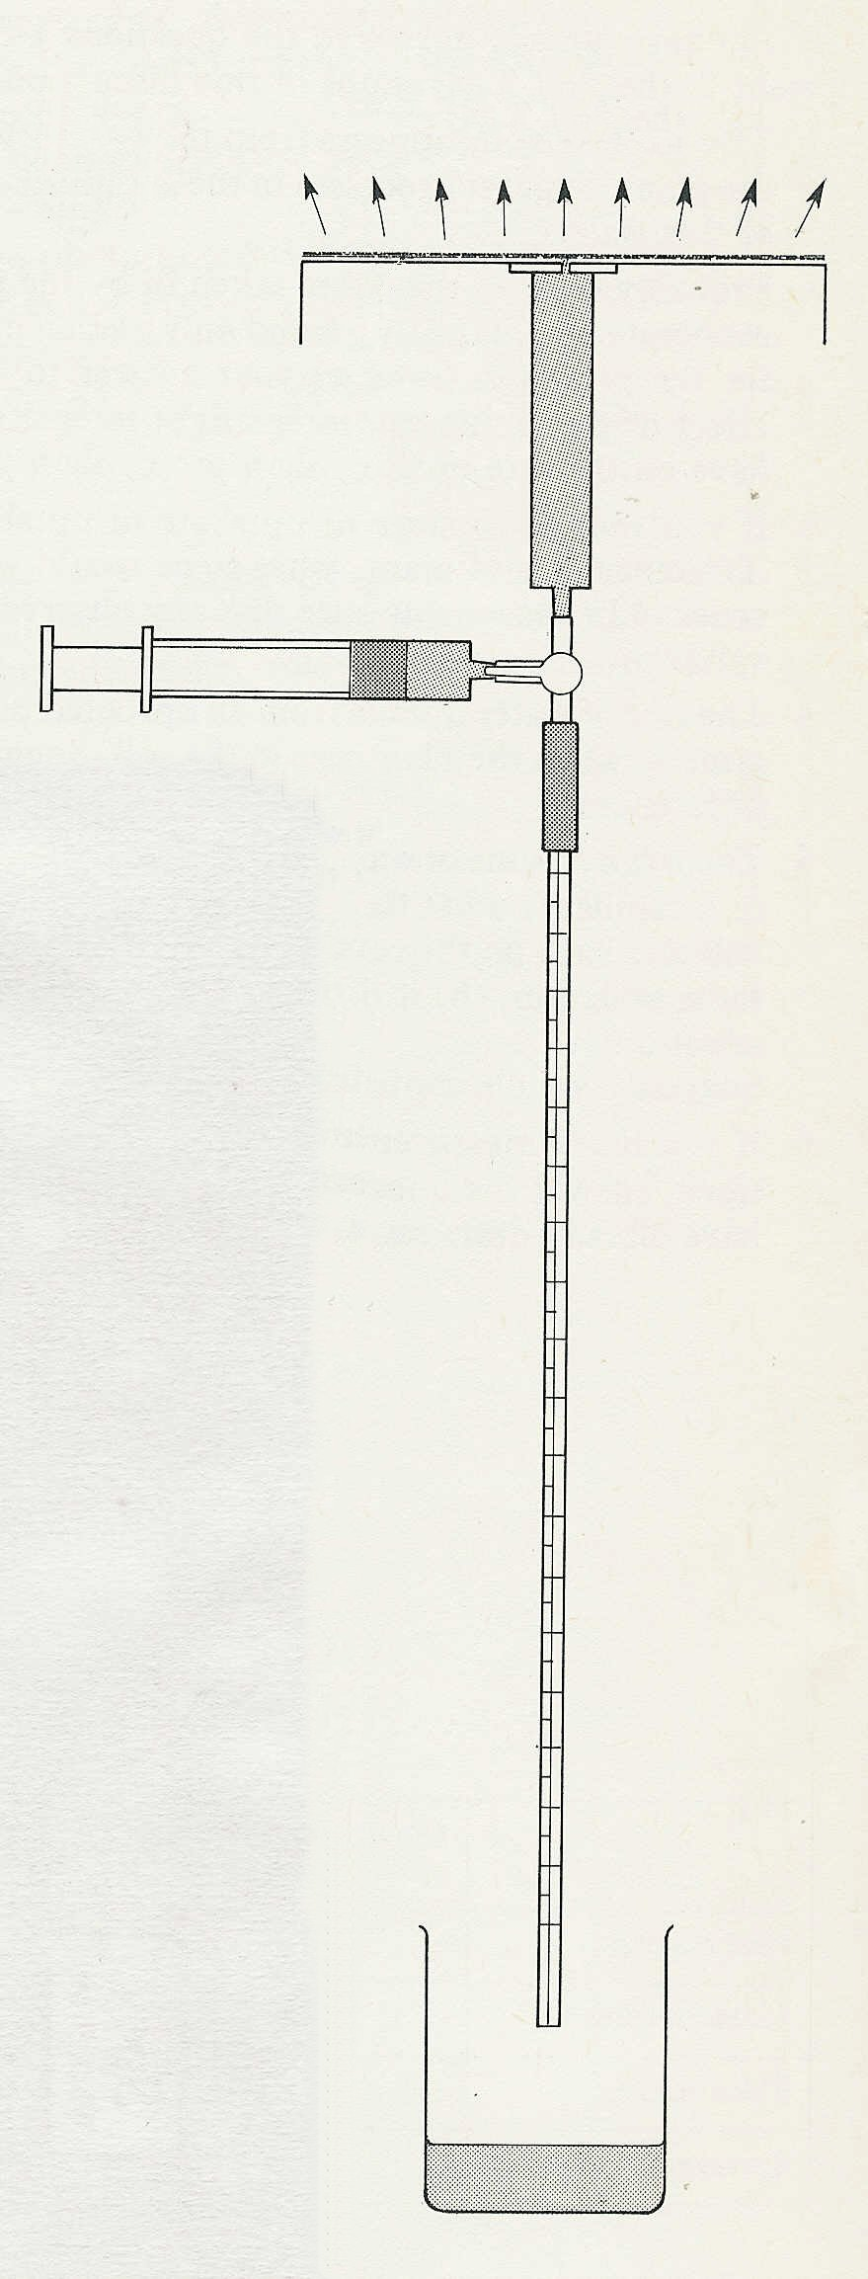

Experiment 6. Conditions affecting evaporation

The apparatus, called an atmometer, represents some of the
physical attributes of a leaf in so far as simple evaporation is concerned.

(a) Clamp the graduated tube upright in a clamp stand and
fit the nozzle of the atmometer into the top of the 3-way tap
as in Fig. 1.

(b) Fill the 5 cm³ syringe with water from the container
and place the container below the graduated tube.

(c) Place a piece of blotting paper on the disc of
the atmometer and fit the 5cm³ syringe to the side
arm of the 3-way tap.

(d) Turn the tap downwards and inject water from the syringe to fill
the atmometer and saturate the blotting paper. When the blotting
paper is thoroughly moistened, smooth out any bubbles trapped
beneath it, with your finger.

(e) Turn the tap upwards, change the 5 cm³ for a 1 cm³ syringe filled with water and depress the plunger to fill the graduated tube with
water and expel any air bubbles.

(f) Turn the tap horizontally and allow the surplus water to drain
from the apparatus for 5 minutes.

(g) Copy the table opposite into your notebook.

(h) After 5 minutes, turn the tap upwards and withdraw the syringe plunger slightly to bring the end of the water column just below the scale. Turn the tap horizontally again.

(i) Watch the end of the water column. As evaporation takes place
from the blotting paper, water is withdrawn from the capillary to replace it.
When the water column passes the zero on the scale, note the time
(or start the stop-clock) and record in your table the distance, in mm, travelled in 1 minute.

(j) Repeat this observation by turning the tap upwards, depressing
the syringe plunger to return the water column to just below the
scale and, finally, turning the tap horizontal again. If the second
reading is similar to the first, the average of the two may be taken
to represent the rate of evaporation in still air at room temperature.
If the atmometer stops working, turn the tap downwards, inject a
little water from the syringe and turn the tap horizontal again

(continued)

Fig. 1
evaporation
blotting paper

