Experiment 5. Discussion

1 Results

 | A (No CO²) |  | B (Control)
 | Colour | Interpretation | Colour | Interpretation
Leaf tested for
starch at beginning of experiment

Leaf tested for starch after ...hours light

2 Assuming that the accumulation of starch in a leaf is evidence of photosynthesis make a general statement about photosynthesis and carbon dioxide.

3 In this experiment, what abnormal conditions other than removal of carbon dioxide might have affected the plant ?

4 How far did the control (a) succeed, (b) fail, in showing that these other effects were not influencing photosynthesis ?

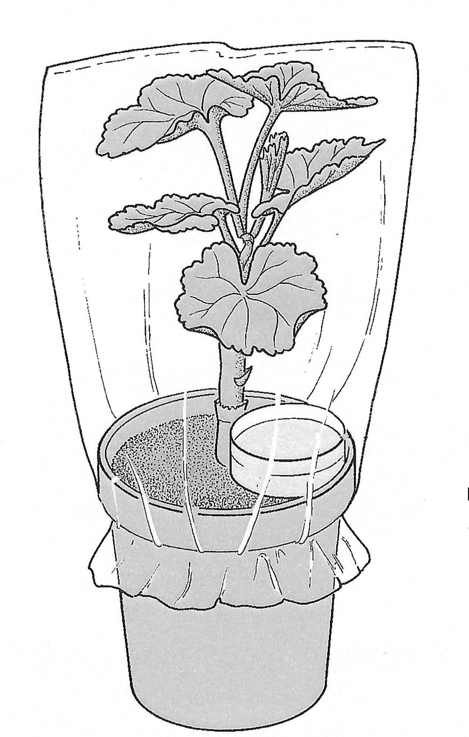
soda-lime or
sodium hydrogencarbonate
solution
plastic bag secured
with elastic band

Supplying or removing carbon dioxide

