Experiment 5. Turgor in potato tissue

(a) Label three test-tubes A, B and C and add your initials.

(b) Use a syringe or graduated pipette to put 20 cm³ water in tube A and 10 cm³ in
tube B.

(c) Similarly, put 20 cm³ 17% sucrose solution in tube C and 10 cm³ in tube B (Fig. 1, p.5.02).

(d) Working on a dissecting board or folded newspaper, cut the ends off a large potato and use a No.4 or 5 cork borer to obtain 4 or 5 cylinders of potato tissue as long as possible (Fig. 2).

(e) Push the cylinders of potato out of the cork borer with the flat end of a pencil (Fig. 3) and select the three longest.

(f) Cut all three to the same length, e.g. 50, 60 or 70 mm, trimming the ends at 90° at the same time Put one cylinder in each test-tube.

(g) Leave the potato tissue for 24 hours.

(h) After 24 hours, use forceps or a mounted needle to remove the potato cylinder from test-tube B. Rinse it in a beaker of water and measure its length in mm. Repeat this operation for the potato cores in tubes A and C noting at the same time whether the tissue is firm or flabby.
Record your results in your notebook.

First length...........mm | A Water | B 8.5% Sucrose | C 17% sucrose
Length after immersion in

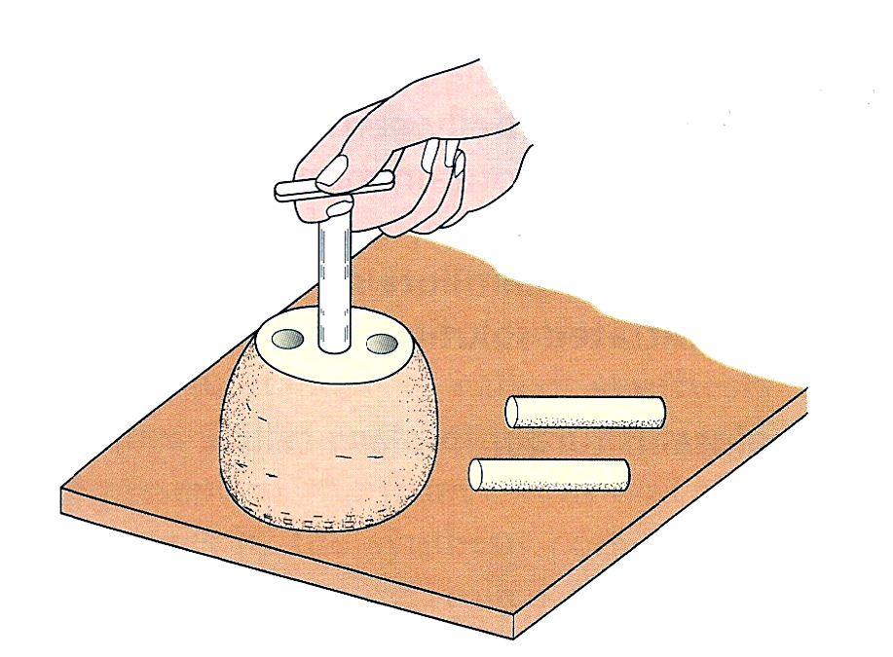
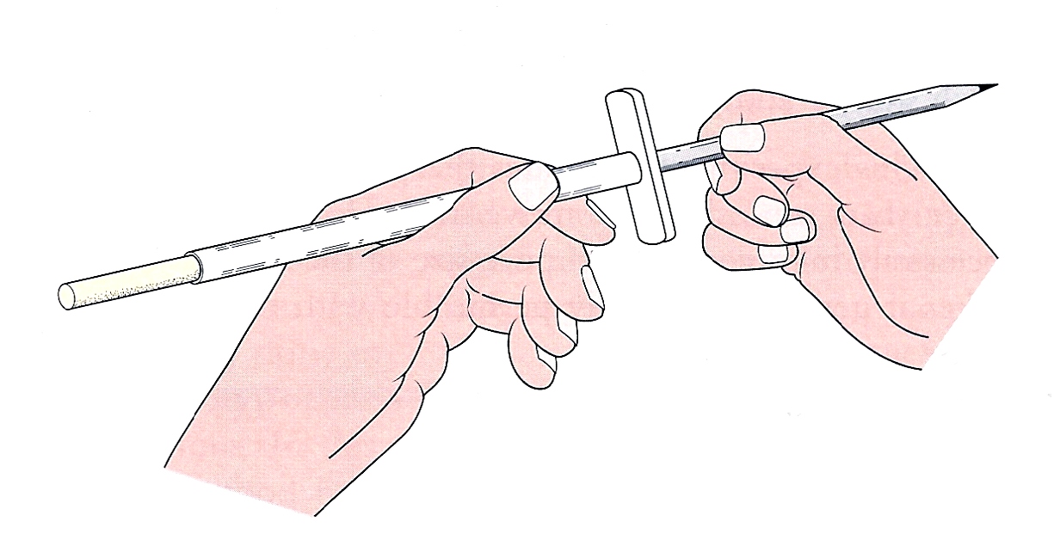
Fig 2 Obtaining cylinders of potato tissue
Fig 3 Push the core out with a pencil

