Experiment 4. The role of cotyledons in germination

(a) Remove the testa from the beans as follows:
(i) hold the seed in the left hand with the hilum to the left;
(ii) run the thumbnail of the other hand down the right-hand edge of the seed from top to
bottom, so removing a strip of testa (Fig. 1)
(iii) peel the testa off to the left, holding the cotyledons firmly together.

(b) Carefully prise the cotyledons apart from the side opposite to the hilum and separate them
completely so that the embryo is attached to one of them (Fig. 2). Discard the other cotyledon.
Repeat (a) and (b) with the other beans until you have four cotyledons with embryos attached.

(c) Leave one of the cotyledons intact and treat the other three as follows;
(i) Place the cotyledon on a Petri dish lid or tile and cut away ¾ of the cotyledon (Fig. 2).
(ii) Place another cotyledon on the dish or tile and cut away all the cotyledon except for a
small area beneath the plumule.
(iii) Push a pin into the embryo on the third cotyledon at the point where the discarded
cotyledon was attached to it and, keeping the embryo on the pin, prise it free from the
cotyledon.
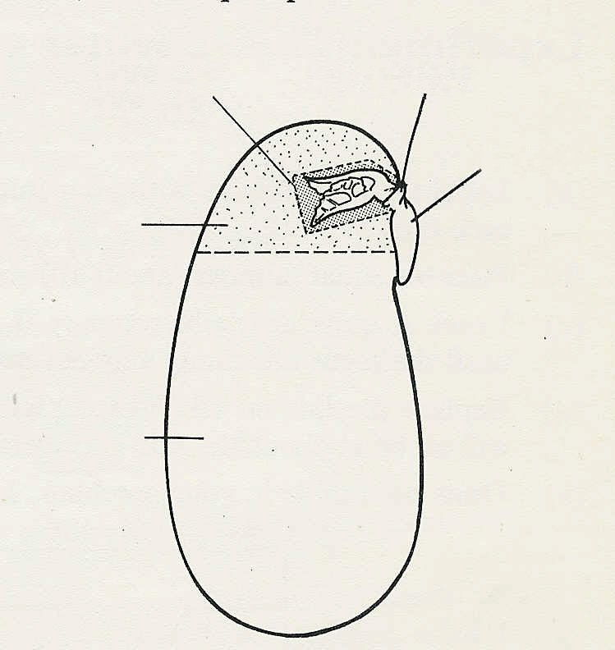

(d) Pin each of the portions of bean seed to the
(iii) pin here
(ii) leave fragment
polystyrene block with the embryos towards the
blotting paper and the radicles pointing down-
wards. When the pin is securely in the block
embryo
withdraw it about 1 mm to leave the embryo
just clear of the blotting paper (Fig 3).
¼ cotyledon

(e) Moisten the blotting paper and put the block
into a screw-top jar, add about 10 mm water and
replace the lid. Use a spirit marker to write your
name and the date on the outside of the jar and
leave the jar in moderate light (not direct sunlight)
cut away ¾
for a week.

(f) Copy the table below into your notebook.
Fig. 2

(g) After a week, remove the polystyrene block
and the seedlings and make the measurements
indicated in the table (Fig. 4).

 | 1 cotyledon | ¼ Cotyledon | Cotyledon fragment | No cotyledon
Length of radicle
Length of epicotyl
Number of lateral roots
Total growth score

(h) Add up the measurements for each seedling to obtain a 'score' for the degree of growth in each case and make a block graph to show the differences.

