Experiment 4a The iris diaphragm (1)

For this experiment the room must be darkened but not blacked out.

(a) If you are working in pairs, sit facing each other and take it in turns to hold a bench lamp or
torch about 10 cm from the side of your partner's face.

(b) Switch it on and watch the pupil of the eye very carefully.

(c) Switch the light on and off at 3 or 4 second intervals.

If you are working on your own, you must look closely at a mirror while switching the light on and off. Study the pupil of the illuminated eye.

Experiment 4b The iris diaphragm (2) (Broca's pupillometer)

(a) Close one eye and hold the card very close to the other, actually touching your face, and look
through the pin-holes at a brightly lit sheet of plain white paper.

(b) The pin-holes will appear as a pattern of unfocussed light discs. Some of the discs will appear to overlap, others will appear to be separated.

(c) Concentrate on a pair which are nearly touching but not overlapping.

(d) While still concentrating on this pair of discs with one eye, open the other.

(e) Describe what you observe.

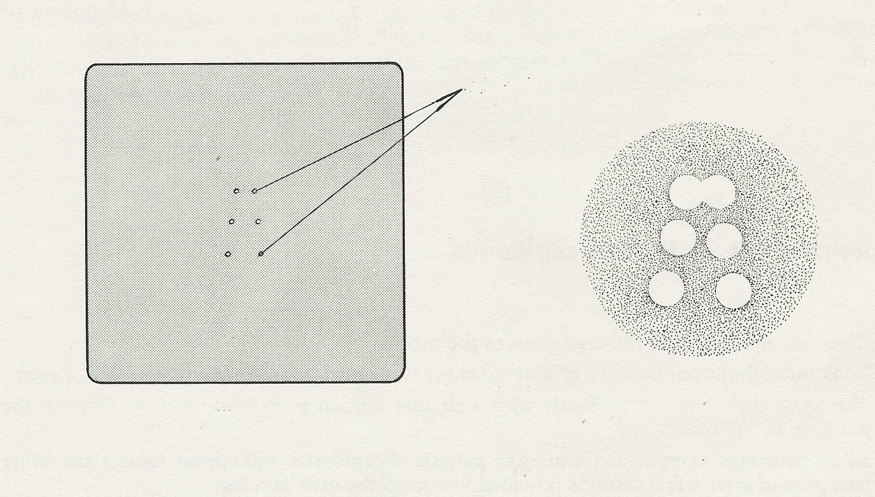
Broca’s pupillometer
Appearance of pin-holes
pin-holes

