Experiment 4. Turgor in a dandelion stalk

(a) Label two watch-glasses or Petri dishes A and B. In A place some tap-water and in B some salt solution.

(b) Use a razor blade or scalpel to cut a piece of dandelion stalk about 40 mm long and then spit it lengthwise (on a Petri dish lid) into strips about l or 2 mm wide (Fig. I).

(c) Place one of these strips in the water in dish A and the other in the salt solution in dish B
.
(d) Watch what happens to each strip in the next few seconds. If any curling takes place notice whether the epidermis side of the strip is on the inside or the outside of the curve.

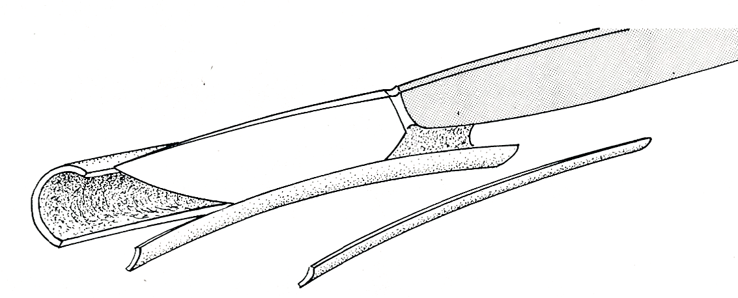
(e) When no further change takes place, swap the strips over so that the one which was in the water is now in the salt solution and vice versa.
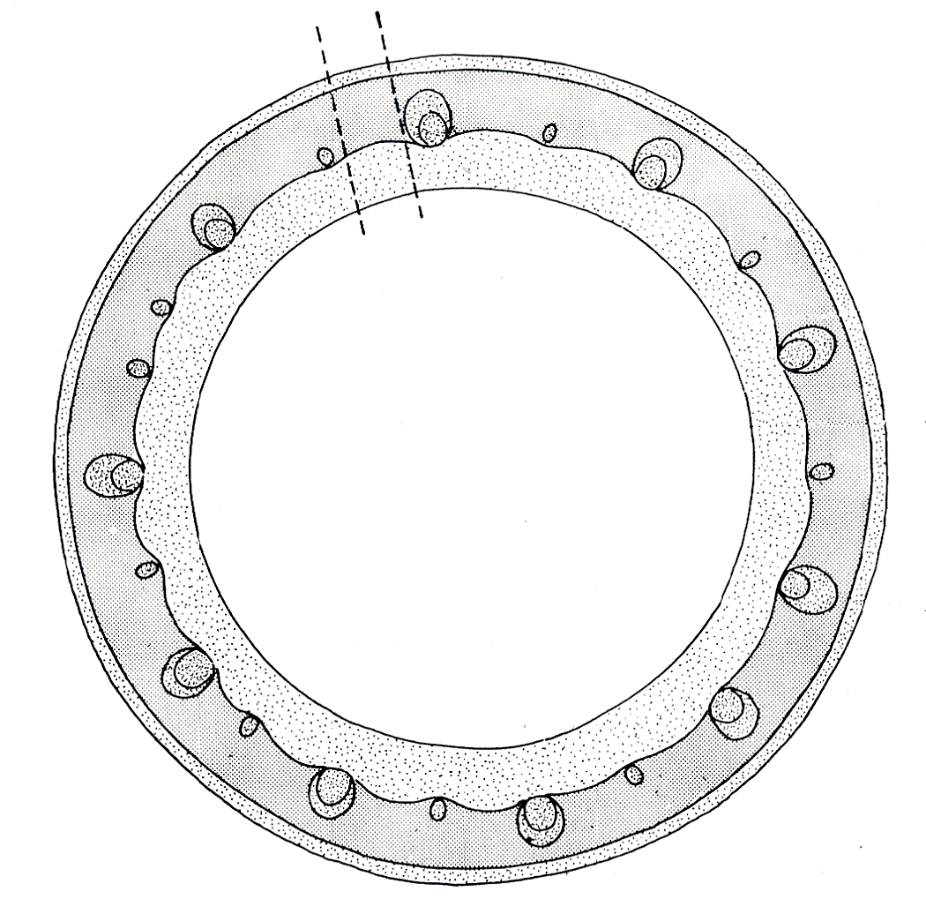
Fig. 1. Cut the stalk into strips
(but not on the bench top)
details of the cell structure
in this region shown in
Fig. 3
epidermis
cortex
pith
hollow centre
vascular bundle
(‘vein’)
Fig. 2. Diagram of transverse section through a dandelion stalk

