Experiment 4. Exhaled air (2)

You are provided with two large test-tubes fitted with rubber bungs and delivery tubes as shown in the Figure below, and also two lengths of rubber tubing.
Label the tubes A and B.

(a) Use a graduated pipette or syringe to place 10 cm³ lime water in each test-tube.

(b) Place the bungs in both tubes and connect one length of rubber tubing to each test-tube as follows: with tube A fit the rubber tubing to the shorter glass tube, with tube B fit the rubber tubing to the longer glass tube (see Figure).

(c) Put the ends of both rubber tubes at the same time in your mouth and breathe in and out through the tubes for about 15 seconds. Notice which tube is bubbling when you breathe out and which one bubbles when you breathe in.

(d) Compare the lime water in each tube. If there is no difference, breathe in and out through the tubes for another 15 seconds.

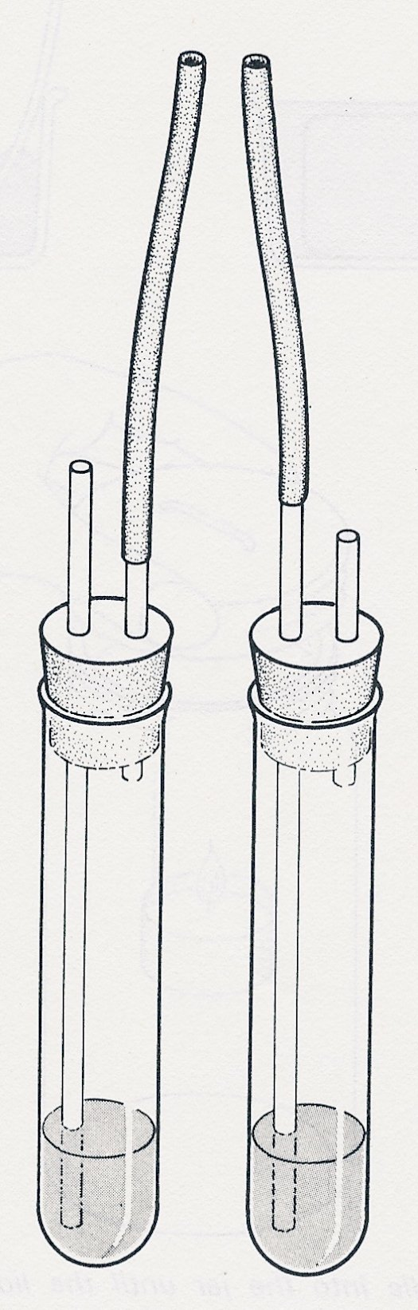

A

B

