Experiment 3. Discussion

I In general terms, what is the relationship between the rate of penetration of acid into the gelatine block and the size of the block?

2 How much more rapidly did acid penetrate to the centre of the smallest block than to the largest block?

3 (a) Was the rate of penetration the same or nearly the same for any of the blocks?
(b) Suggest a reason to support your observation.

4 Imagine that, on a much smaller scale, the gelatine block represents a cell of a single-celled creature :(a) what substances need to penetrate to all parts of a living cell;
(b) what substances need to diffuse out of the cell in the opposite direction ?

5 Most single-celled animals are less than 1 mm across and the largest are only about
2 mm long.
By reference to your results in this experiment suggest one reason why single-celled animals are no larger than this ?

6 On the basis of the results of this experiment, the penetration of substances into a large, multi-cellular organism such as a fish should take a very long time. What aspects of structure and organisation in a fish allow it to survive and be active despite such a slow rate of diffusion ?

7 Suggest one or more shapes for a volume of one cubic centimetre of gelatine, which would increase the rate of penetration of substances.

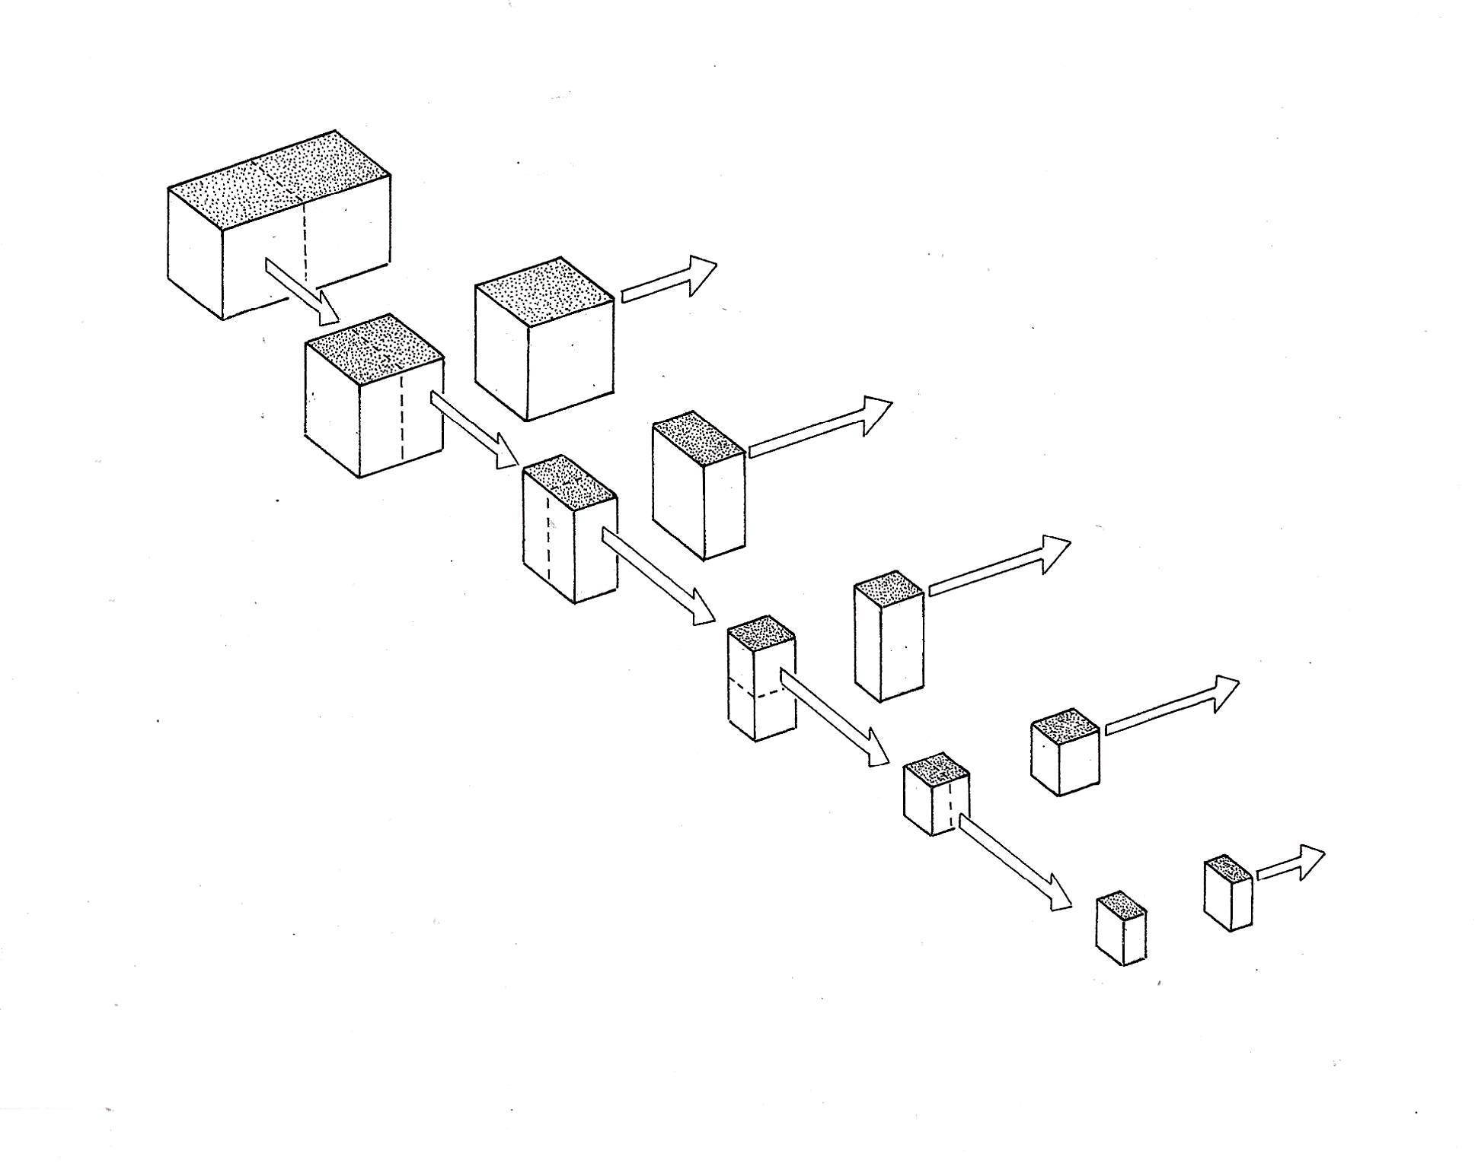
1
2
3
4
5
Keep these

Cut these

.
1

