Experiment 3. Turgor

You are provided with a length of cellophane tubing which has been soaked in water and knotted at one end.

(a) Use a syringe or graduated pipette to place 3 cm³ syrup solution in the cellophane tubing (Fig. I).

(b) Tightly knot the open end of the dialysis tubing to leave only about 20 mm tubing free above the knot, taking care to exclude air bubbles from the tubing (Fig. 2).

(c) Wash the tubing under the cold tap to remove all traces of syrup solution from the outside. The partly filled tube should be flexible enough to bend through 90° (Fig. 3, p.3.02)
.
(d) Place the cellophane tubing in a test-tube and fill the test-tube with water (Fig. 4, p.3.02).

(e) Label the test-tube with your initials and leave it in the rack for 30-45 minutes.

(f) After 30-45 minutes remove the cellophane tubing filled with syrup and note how it differs from its starting condition.
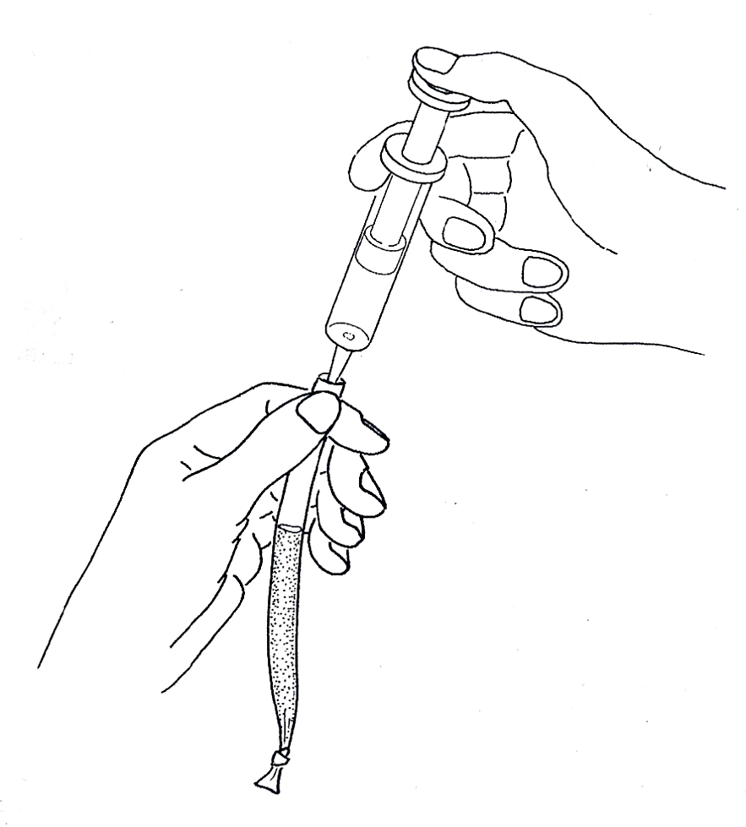
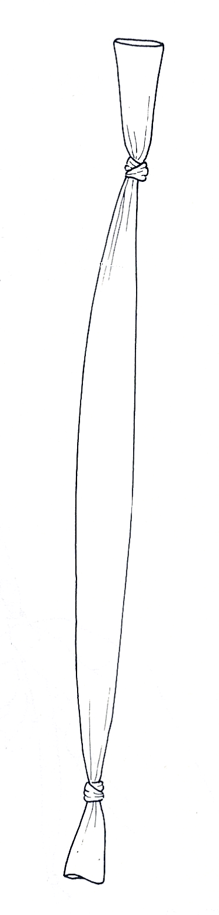
Fig. 1 Place 3cm³ syrup in the cellophane tube
about 20 mm
knot tightly...
... after expelling air bubbles
Fig. 2

