Experiment 10. The effect of one-sided lighting on cress seedlings

You are provided with two sets of cress seedlings growing on moist cotton wool.

(a) Use a spirit marker to label two Petri dish bases 1 and 2 and add your initials. Mark the base
and sides of each dish as shown in Fig. 1.
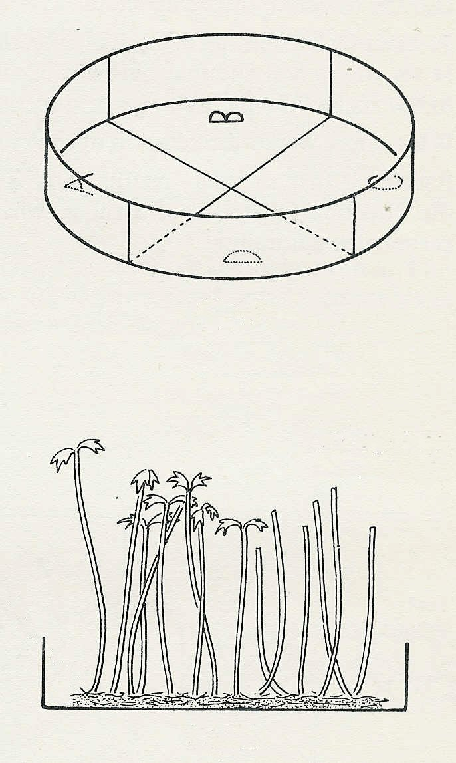

(b) Use forceps to remove any seedlings
which have fallen over or are leaning unduly.

(c) Use scissors to remove the cotyledons and
extreme shoot tips of the seedlings growing on
ONE HALF of the cotton wool (Fig. 2) in both sets.

(d) Place each group of seedlings in one of the
marked dishes as shown in Fig. 3 and place
Fig. 1
dish 1 directly under a light source such as a bench
lamp about 20-40 cm away. Place dish 2 so that it
half the seedlings decapitated
is receiving light from a source to one side and a
few cm below the dish (Figs. 3 and 4).

(e) Rotate dish 2 so that sector A is towards the light
source and 20-40 cm away from it if it is a bench
lamp, or 5 cm away if it is a fluorescent tube.
moist cotton wool

(f) Thoroughly moisten the cotton wool and place
cardboard screens round the experiment so that the
seedlings cannot receive direct light from windows,
Fig. 2
skylights or other sources.

(g) If the experiment is to be left for more than one day, the seedlings must be watered each day.

(h) After a period of 90 minutes - 7 days, remove the screens and collect your two dishes of seedlings.

(i) Answer discussion questions 1-3 while the seedlings are available for observation.

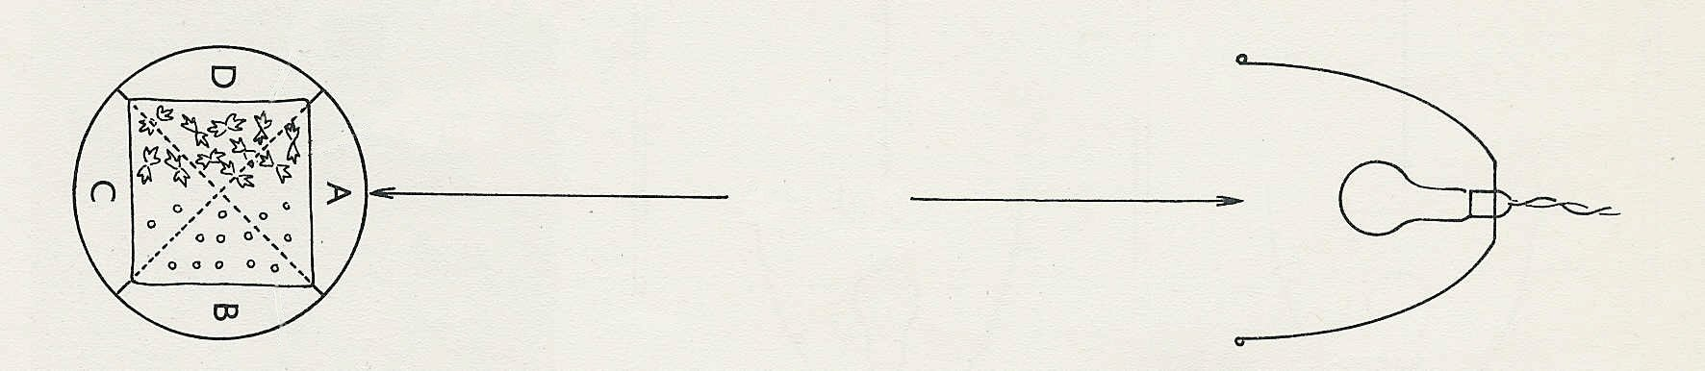
intact seedlings
decapitated seedlings
20-40 cm
Fig. 3

