Experiment 1. Osmosis - preparation

Outline A dialysis tube containing syrup is immersed in water and connected to a capillary tube. The syrup level is seen to rise.

Prior knowledge Syrup is mainly sucrose. Meaning of 'molecule'. Substances diffuse from regions of high concentration to regions of low concentration.

Advance preparation and materials

Osmometers. Cut 2 cm lengths of 6-7 mm diameter soda glass tubing and flame polish the ends.
Cut 15 cm lengths of 6 mm (¼ in) dialysis tubing, soak in water for a minute or two and knot one end securely. Push the glass tubing into the open end of the dialysis tubing and allow to dry. Cut 3 cm lengths of red rubber tubing 8 mm outside diameter, 5 mm bore, and fit these over the end 10 mm of the glass tubing.
The osmometers may be stored in 30% alcohol to keep them moist and flexible, or they
can be stored dry though they may develop cracks in this way. In either case, soak the
osmometers in water for a few minutes before the experiment and allow I per group.
Capillary tubes. Cut 40 cm lengths of I mm bore, 6-7 mm diameter, capillary tubing and
flame polish the ends. Allow I per group.
Markers. Cut rings about 2 mm wide from the red rubber tubing and fit one on each
capillary.
Syrup. Dilute golden syrup with its own volume of water and stir to obtain a uniform
consistency. Allow 5 cm³ per group. Alternatively, dissolve sucrose in its own weight of
warm water. Colour the syrup solution with a little food colouring (e.g. cochineal
substitute).

Apparatus-per group

clamp, boss-head and stand
tall beaker or jar, e.g. 150 g coffee jar
osmometer
container for syrup solution

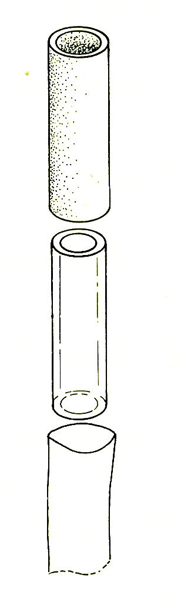
rubber tubing
3 cm long

delivery tubing
2 cm long

dialysis tubing
15 cm long
dropping pipette
ruler to measure rise in level
capillary tube and marker
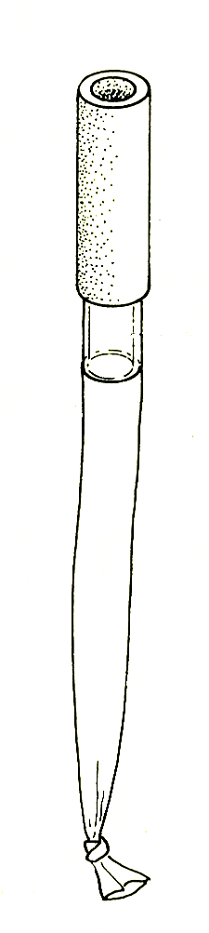
(1) slide the delivery tubing into the dialysis tubing
(2) fit the rubber tubing over the glass and dialysis tubing

