Experiment 1. The gas used up in respiration

You are provided with two screw-top jars and some germinating seeds.

(a) Label the jars A and B. Add your initials and the date.

(b) Place some cotton wool in the bottom of each jar and add enough water to just moisten it.

(c) Count an exact number of germinating seeds into jar A and the same number of dead seeds into jar B.

(d) Close each jar, screwing the lid down as tightly as possible. Leave the jars for 24 hours or more.

READ ALL OF INSTRUCTION (e) BEFORE PROCEEDING.

(e) Loosen the lid on jar B but do not remove it. Use a match or splint to light the candle on the special holder (See Figure below). Remove the lid of jar B and lower the lighted candle into it, noting the time or starting to count the seconds. Lower the candle until the lid is pressed firmly against the mouth of the jar and count or time the number of seconds for which the candle burns.

(f) Repeat this operation for jar A.

A

B
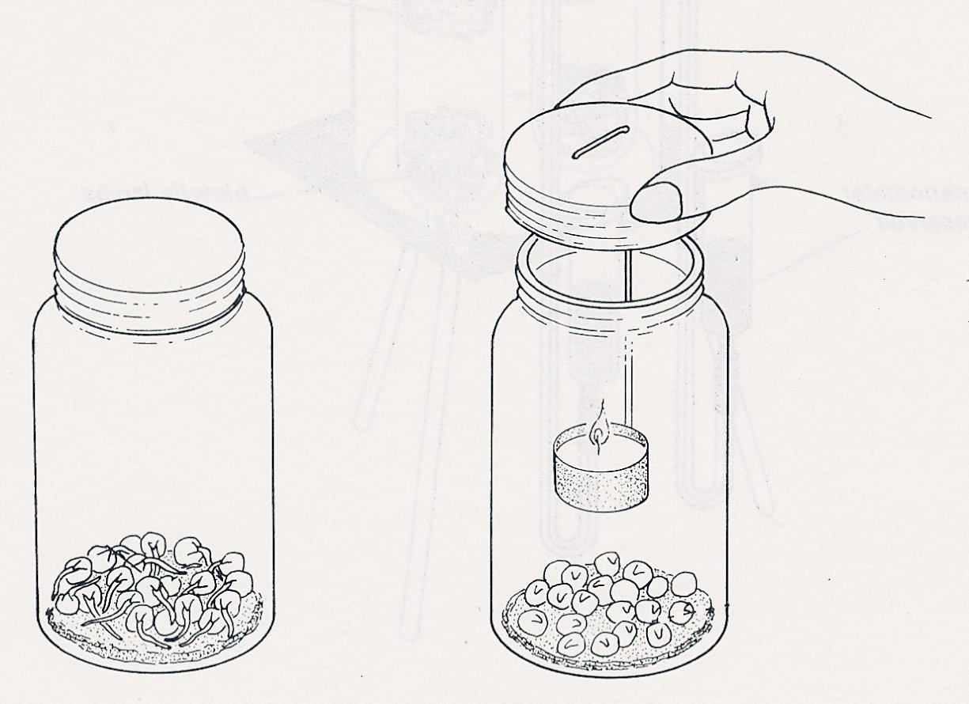
lower the candle into the jar till the lid is pressed firmly against the neck
dead seeds
germinating
seeds

