Experiment 1. Production of gas by pond-weed

(a) Fill a beaker or glass jar with tap-water and add about 5 cm³ (20 mm in a test- tube) saturated sodium hydrogencarbonate solution.

(b) Select a pond-weed shoot between 5 and 10 cm long
.
(c) Take a small paper clip, prize it slightly open and slide it over the pond-weed shoot a
short distance behind the growing point. This is to hold the weed down in the water.

(d) Place the pond-weed in the jar so that it floats vertically with the cut end of the stem uppermost but still entirely below the water.

(e) Switch on the bench lamp and bring it close to the jar.

(f) After a minute or two, bubbles should appear from the cut end of the stem. If they do not, obtain a fresh piece of plant material and try again.

(g) When the bubbles are appearing with regularity, switch the lamp off and observe any changes in the production of bubbles.

(h) Switch the lamp on and place it about 25 cm from the pond-weed. Try to count the number of bubbles appearing in a minute. Now move the lamp to about 10 cm from the plant and again try to count the number of bubbles.

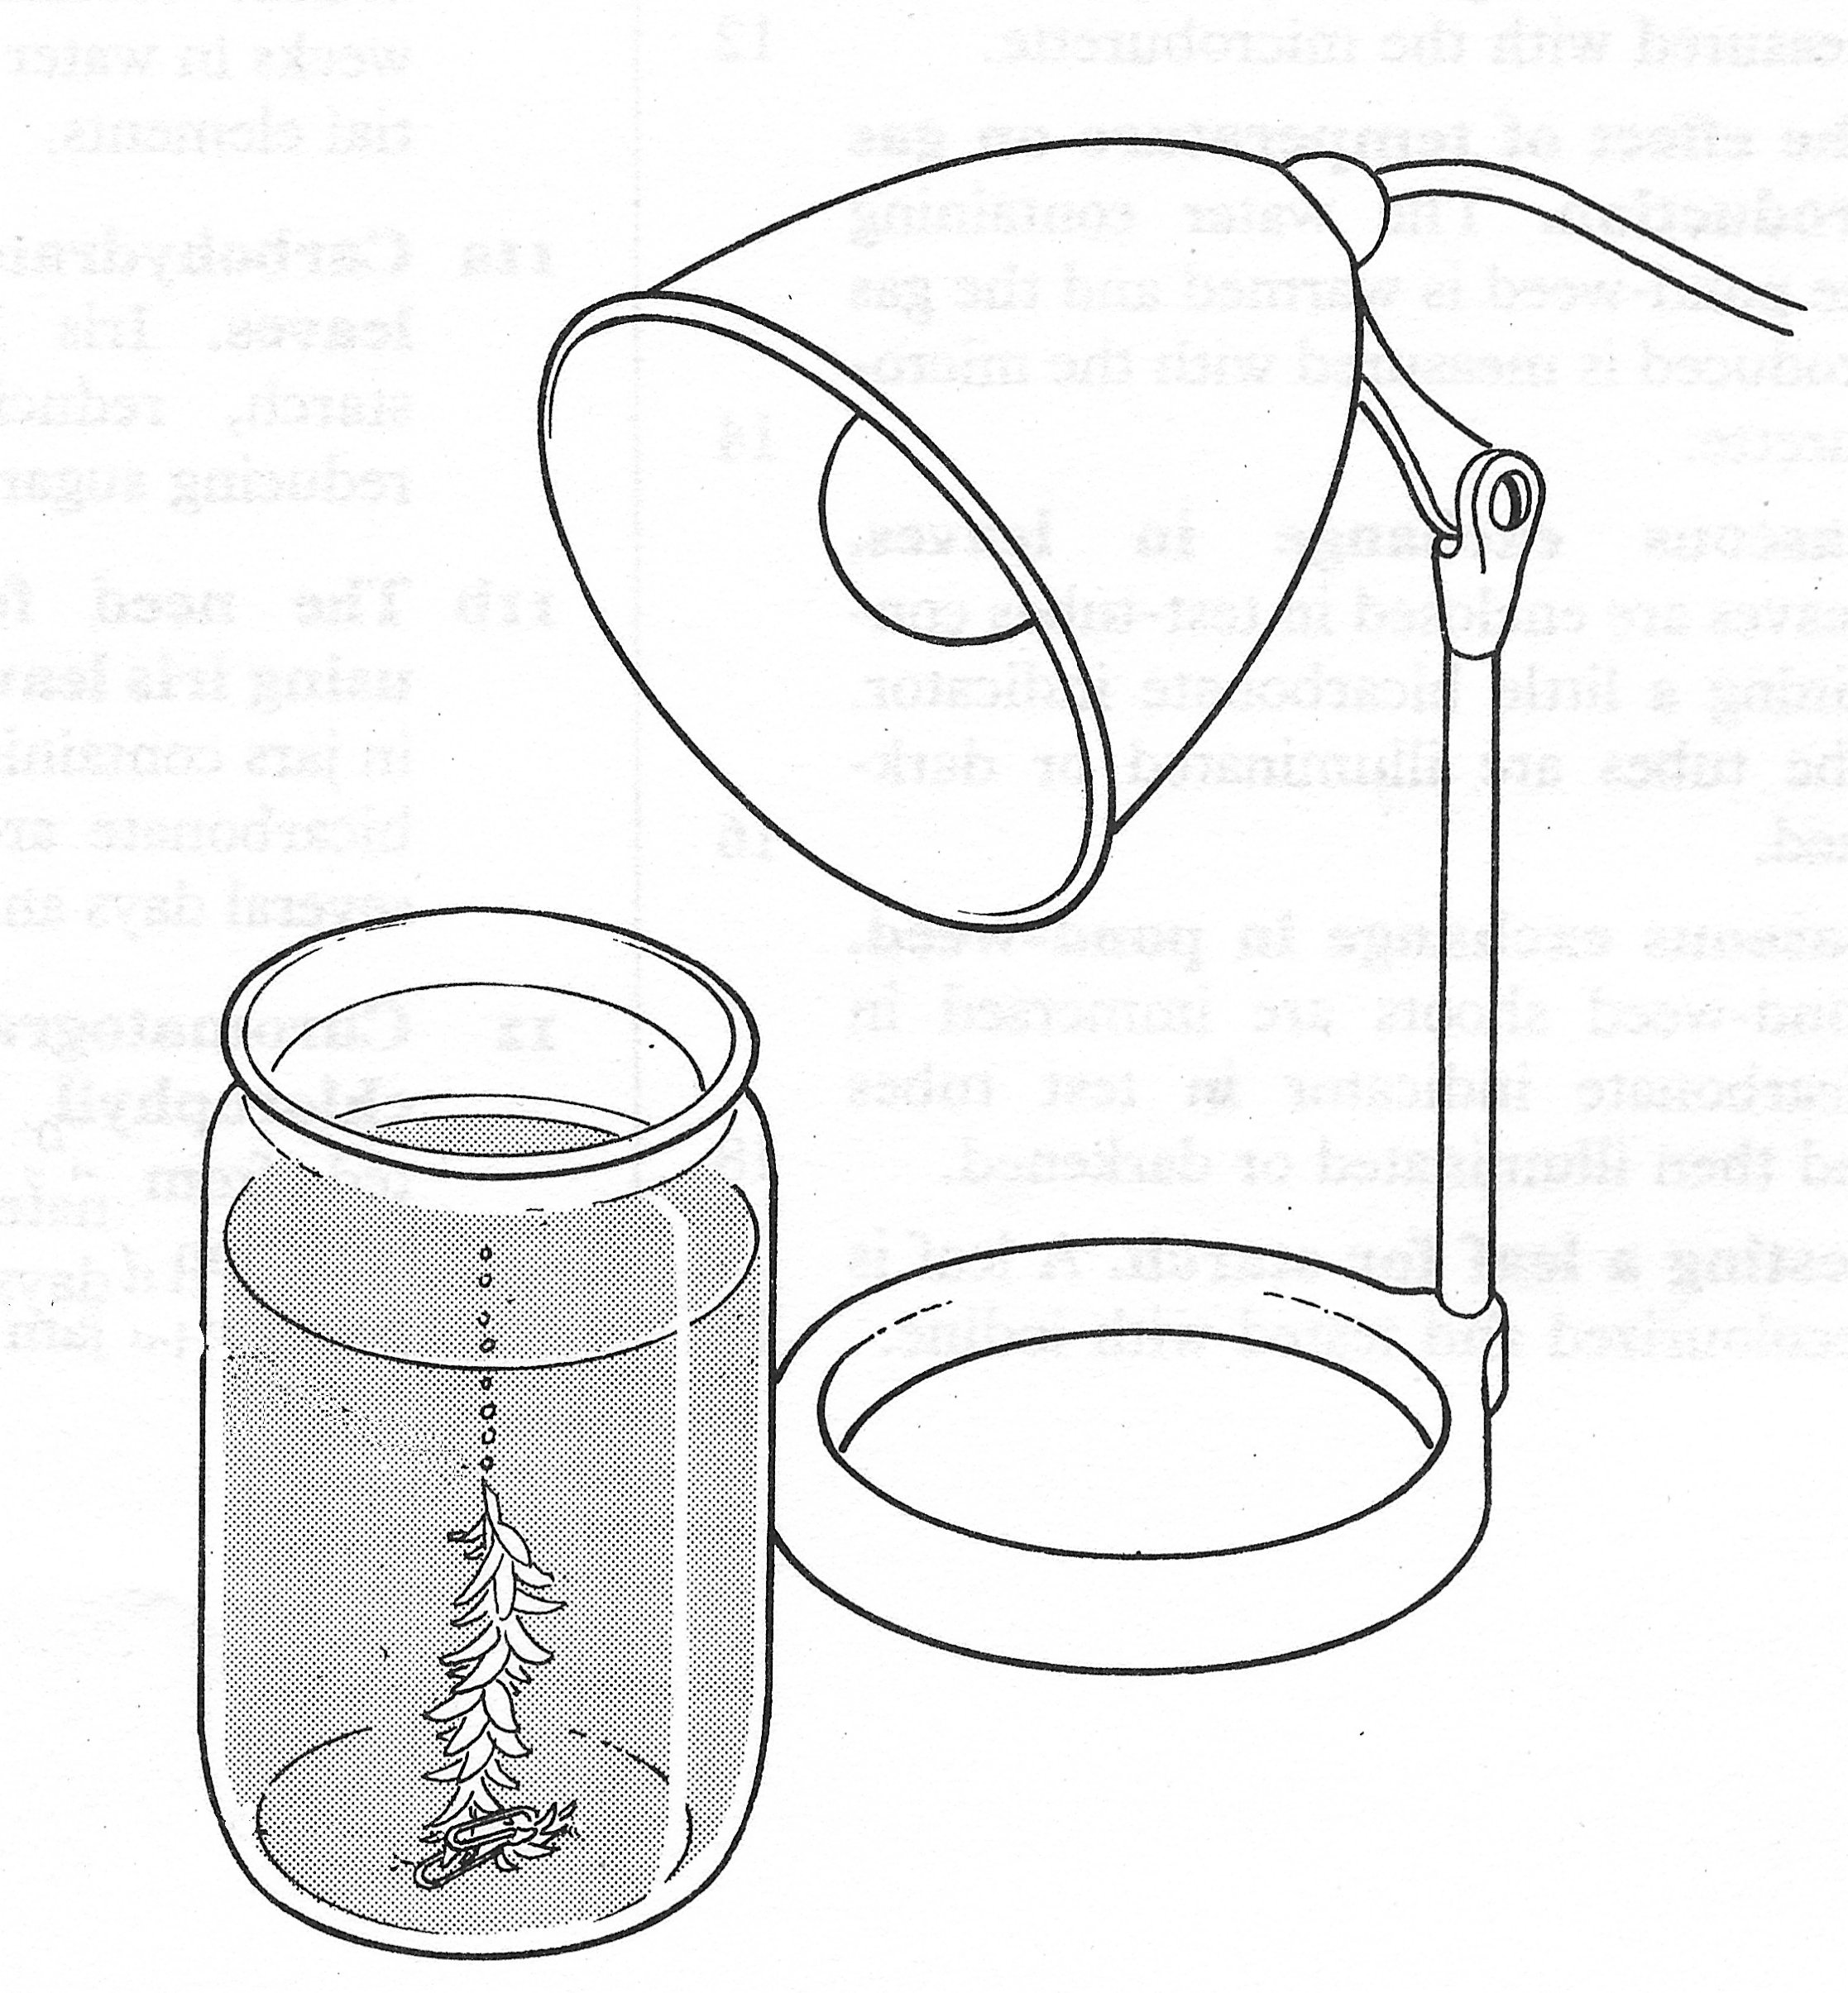
bubbles appear from cut end of stem
paper-clip

