SUNFLOWER
Day | Action | Stage
0 | Soak
1 | Plant
2 |  | Fruit wall splitting; radicle emerging
3 |  | Radicles about 10 mm  Hypocotyls 2-5 mm
4 |  | Radicles 15-30 mm  Hypocotyls 2-5 mm
5 |  | Radicles 40-60 mm  Hypocotyls about 10 mm
6 |  | Radicles 80-110 mm  Hypocotyls 15-25 mm
7 | Remove fruit walls; roll up with cotyledons free from paper; expose to top lighting | Radicles 120-150 mm  Hypocotyls 30-50 mm
8 |  | Hypocotyls 40-60 mm

MAIZE
Day | Action | Stage
0 | Soak
1 | Drain
2 | Select for Experiment 16
3 | Select for Experiment 2 | Radicles emerging in about 30%
4 | Select for Experiment 2 | Radicles emerging in about 60%
5 | Select for Experiment 16 | Radicles 30-40 mm  Coleoptiles 5-10 mm
6 |  | Radicles 45-60 mm  Coleoptiles 10-15 mm
7 | Select for Experiment 14 | Radicles 60-90 mm  Coleoptiles 25-30 mm
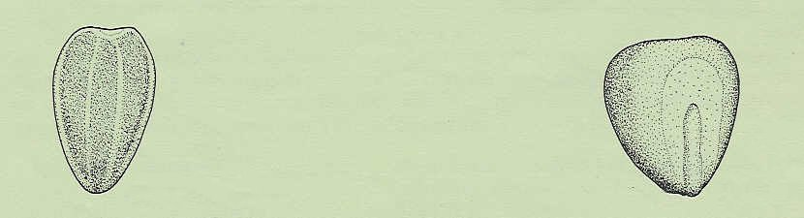
SUNFLOWER
MAIZE
embryo
For conveniently shaped seedlings, plant this way up

