Germination times.

The times and stages given in the following timetables of germination will vary with temperature and variety of seeds. The tables were compiled for daytime temperatures of 16-20ºC

PEAS
Day | Action | Stage
0 | Soak
1 | Plant
2 |  | Radicles emerging; about 5mm
3 | Select for expts. 6, 7 & 8 | Radicles 15-25mm
4 | Radicles too long for expts. 7 & 8; suitable for expt. 6 if results checked in 24 hours | Radicles 30-40 mm
5 |  | Radicles 50-70 mm  Epicotyl emerging
6 |  | Radicles 70-110mm  Epicotyls 10-15 mm
7 | Select for expt. 15 | Radicles 120-140 mm with laterals.  Epicotyls 30-40 mm

WHEAT
Day | Action | Stage
0 | Soak
1 | Drain
2 | Select for planting | Radicles emerging in some
3 | Select for planating | Radicles & coleoptiles emerging
4 |  | Coleoptiles 2-3 mm
5 |  | Coleoptiles 5-10 mm
6 | Select for expts. 11 & 12 or put in refrigerator overnight; select for expt.5 | Coleoptiles 15-25 mm
7 | Coleoptiles too long for expt. 11 & less satisfactory for expt 12 | Coleoptiles 30-50 mm
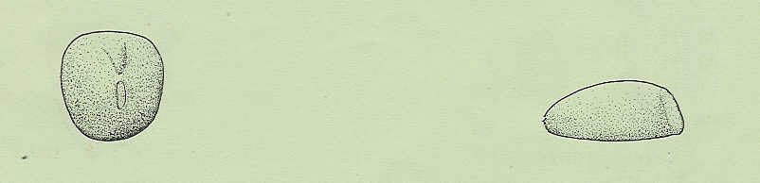
radicle
PEA
hilum
embryo
WHEAT
For conveniently shaped seedlings, plant this way up

