1. The diagram below shows some blood cells that may be seen in a stained blood film when observed under a microscope.
In the table below, name the cells A, B and C and give one function of each cell.
Blood cell | Name of cell | One function
A
B
C
(Total 6 marks)

2. The diagram below shows the sequence of stages in meiosis.
(a) Describe what is happening to the chromosomes during the following stages.
(i) Prophase I
................................................................................................................................
................................................................................................................................
................................................................................................................................
................................................................................................................................
(2)
(ii) Metaphase I
................................................................................................................................
................................................................................................................................
................................................................................................................................
................................................................................................................................
(2)
(iii) Anaphase II
................................................................................................................................
................................................................................................................................
................................................................................................................................
................................................................................................................................
(2)
(b) Meiosis in humans results in the production of gametes. Name the type of cell produced by each of the following stages.
(i) Meiosis I in oogenesis.
................................................................................................................................
(1)
(ii) Meiosis I in spermatogenesis.
................................................................................................................................
(1)
(Total 8 marks)

3. The diagram below shows the structure of the heart and some associated blood vessels.
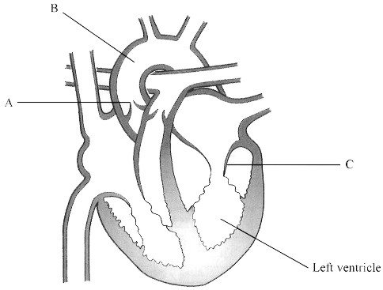

(a) Name the parts labelled A, B and C.
A ...................................................................................................................................
B ...................................................................................................................................
C ...................................................................................................................................
(2)
(b) Describe how the structure of the left ventricle and the parts labelled B and C enable
the left ventricle to carry out its function.
......................................................................................................................................
......................................................................................................................................
......................................................................................................................................
......................................................................................................................................
......................................................................................................................................
......................................................................................................................................
......................................................................................................................................
......................................................................................................................................
......................................................................................................................................
......................................................................................................................................
(4)
(c) Many organs such as the uterus, heart and kidneys of a pregnant woman use more oxygen than when she is not pregnant. The graph below shows the increased usage of oxygen by these organs near the end of pregnancy, as compared with the oxygen used before pregnancy.
Suggest why the use of oxygen by each of the following organs increases during pregnancy.
(i) Uterus
...............................................................................................................................
...............................................................................................................................
...............................................................................................................................
...............................................................................................................................
(ii) Heart
...............................................................................................................................
...............................................................................................................................
...............................................................................................................................
...............................................................................................................................
(4)
(Total 10 marks)

4. The diagram below shows part of the duodenum and an associated gland from the human digestive system. Part of the wall of the duodenum has been removed to show the internal structure.
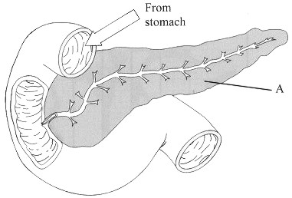
(a) Name the gland labelled A.
......................................................................................................................................
(1)

(b) Gland A produces a secretion with a pH of about 7.5. The secretion contains a number of different enzymes, including amylase.
(i) Describe the action of amylase in the digestion of carbohydrates.
...............................................................................................................................
...............................................................................................................................
...............................................................................................................................
...............................................................................................................................
(2)
(ii) Suggest why it is important that the secretion has a pH of about 7.5.
...............................................................................................................................
...............................................................................................................................
(1)
(c) Describe how the structure of the ileum is adapted for the absorption of the products of digestion.
.......................................................................................................................................
.......................................................................................................................................
.......................................................................................................................................
.......................................................................................................................................
.......................................................................................................................................
.......................................................................................................................................
.......................................................................................................................................
.......................................................................................................................................
.......................................................................................................................................
.......................................................................................................................................
(5)
(Total 9 marks)

5. The rate of diffusion of gases across an exchange surface is greater if the surface is thin and a concentration gradient is maintained across it.
Describe how each of these factors is involved in respiratory gas exchange in the following.
Alveoli in human lungs
..............................................................................................................................................
..............................................................................................................................................
..............................................................................................................................................
..............................................................................................................................................
..............................................................................................................................................
Protozoa
..............................................................................................................................................
..............................................................................................................................................
..............................................................................................................................................
..............................................................................................................................................
..............................................................................................................................................
(Total 5 marks)

6. The photograph below shows a transverse section through part of a leaf of Nymphaea, as seen using a light microscope. Nymphaea is a hydrophyte (a plant which lives in water).
The upper epidermis and air spaces are labelled.
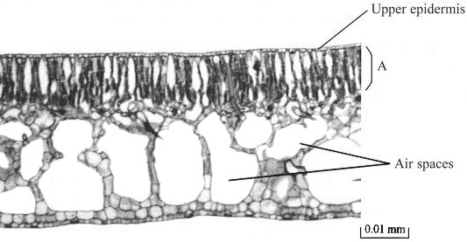

(a) Suggest one function of the tissue labelled A, giving an explanation for your answer.
Function ........................................................................................................................
Explanation ...................................................................................................................
......................................................................................................................................
......................................................................................................................................
......................................................................................................................................
(3)
(b) Suggest two functions of the large air spaces in this leaf.
1 ...................................................................................................................................
......................................................................................................................................
2 ...................................................................................................................................
......................................................................................................................................
(2)
(c) Suggest why stomata are found only in the upper epidermis of this leaf.
......................................................................................................................................
......................................................................................................................................
......................................................................................................................................
......................................................................................................................................
(2)
(Total 7 marks)

7. An investigation was carried out into the effect of potassium ions (K+) on the opening of stomata. Pieces of the lower epidermis were carefully removed from broad bean (Vicia faba) leaves. These epidermal strips were floated on a solution of potassium chloride (KCl) in a small dish. Similar strips were floated on distilled water in another dish as a control. The dishes were illuminated from above by a light bulb.
The widths of the stomatal pores were measured using a microscope fitted with an eyepiece graticule. The widths of the pores were determined at the start of the experiment, then at hourly intervals for five hours. The results are shown in the table below. Each result is the mean of 20 measurements.
 | Mean width of stomatal pore /µm
Time/h | In potassium chloride  solution | In distilled water
0 (start) | 1.0 | 0.0
1 | 3.0 | 0.0
2 | 5.5 | 0.0
3 | 8.6 | 0.0
4 | 8.4 | 0.0
5 | 8.6 | 0.0
(a) Describe the changes in the mean width of the stomatal pores during this investigation.
.......................................................................................................................................
.......................................................................................................................................
.......................................................................................................................................
.......................................................................................................................................
.......................................................................................................................................
.......................................................................................................................................
(3)
(b) Suggest an explanation for these results.
.......................................................................................................................................
.......................................................................................................................................
.......................................................................................................................................
.......................................................................................................................................
.......................................................................................................................................
.......................................................................................................................................
(3)
(Total 6 marks)

8. The graph below shows oxygen dissociation curves for haemoglobin at two different partial pressures of carbon dioxide.
(a) (i) From the graph, determine the percentage saturation of haemoglobin with oxygen at a partial pressure of oxygen of 4.2 kPa, at low and at high partial pressures of carbon dioxide.
Low partial pressure of carbon dioxide .................................................................
High partial pressure of carbon dioxide ................................................................
(1)
(ii) High partial pressures of carbon dioxide are found in active tissues such as muscle. Suggest why the difference between the percentage saturation of haemoglobin at low and at high partial pressures of carbon dioxide is important for the functioning of such tissues.
...............................................................................................................................
...............................................................................................................................
...............................................................................................................................
...............................................................................................................................
...............................................................................................................................
...............................................................................................................................
(3)

(b) Describe how the carbon dioxide produced in tissues is transported in the blood to the lungs.
.......................................................................................................................................
.......................................................................................................................................
.......................................................................................................................................
.......................................................................................................................................
.......................................................................................................................................
.......................................................................................................................................
.......................................................................................................................................
.......................................................................................................................................
(5)
(Total 9 marks)

