1. The distribution of seaweeds growing on rocky shores is thought to be influenced by their ability to withstand drying in air when the tide goes out. Seaweeds growing high up the shore are exposed to the air for longer periods than those growing further down the shore. Different species of seaweed grow in bands at different distances i the shore from the low tide level.
At the low tide level, the shore is covered by sea water most of the time. The sea reaches the high tide level twice each day.
A student formed the hypothesis that the species of seaweed growing closest to the low tide level would lose water more quickly than those at the higher levels. To test this suggestion she took samples of six different seaweeds at different distances from the low tide level. All the samples were soaked in sea water for two hours, blotted carefully and weighed. They were then left to dry in air and weighed again after three hours.
An extract from her field records is, shown below.
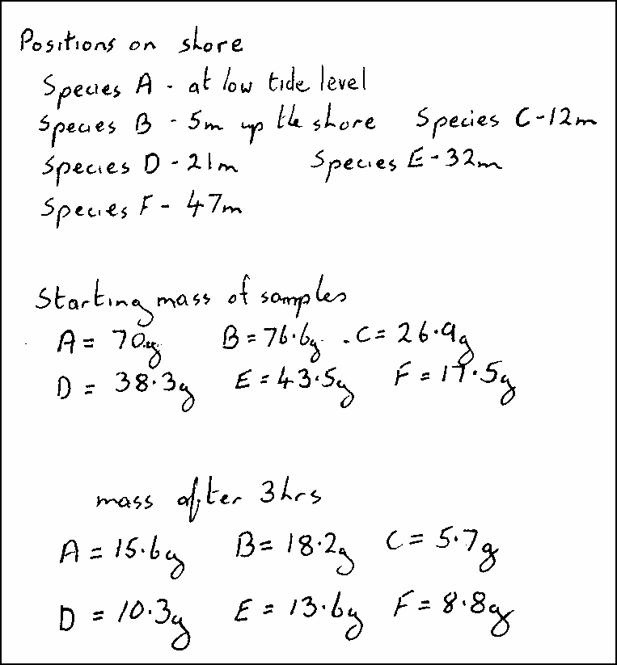
(a) Calculate the percentage loss in mass for each species. Then prepare a. table and organise the data in a suitable way so that the percentage loss in mass can be related to the position of each species on the shore.
(4)
(b) Use the data in your table to present the information in a suitable graphical form.
(4)

(c) The student applied a correlation test to her data to find out whether they supported her hypothesis. The correlation coefficient was found to be 0.83.
The table below shows critical values for correlation coefficients at the p = 0.05 level.
Number of pairs of  measurements | Critical value  p = 0.05
5  6  7  8  9  10 | 1.00  0.89  0.79  0.74  0.68  0.65
What conclusions can be drawn from this investigation? Use the information provided to explain your answer.
(3)
(Total 11 marks)

2. The rate of respiration in cells can be affected by metabolic poisons. A student formed a hypothesis that sodium malonate is a metabolic poison that decreases hydrogen production during the Krebs cycle. Hydrogen production can be measured using redox indicators that change colour when they take up hydrogen.
Plan an investigation, which you personally could carry out, to test this hypothesis, using yeast and a redox indicator such as methylene blue or tetrazolium. chloride.
Your answer should give details under the following headings.
(a) Plan of the investigation to be carried out.
(12)
(b) Recording of raw data measurements, presentation of results and methods of data analysis.
(4)
(c) Limitations of your proposed method and an indication of farther work that could be undertaken.
(5)
(Total 21 marks)

