1. The table below refers to reproductive hormones in female humans. If the statement is correct, place a tick () in the appropriate box, and if the statement is incorrect, place a cross () in the appropriate box.
Hormone | Secreted by ovary | Found at highest level in blood after fertilisation
Oestrogen
Follicle stimulating
hormone (FSH)
Progesterone
Luteinising hormone (LH)
Oxytocin
(Total 5 marks)

2. The diagram below shows cross-sections of three different types of blood vessel, A, B and C.
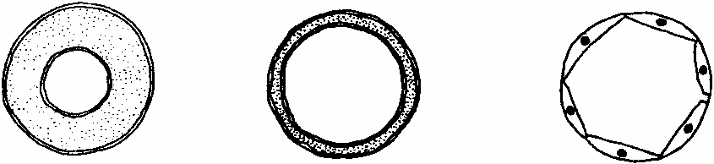
(a) Name the blood vessels A and B.
A ...............................................................................................................................
B ...............................................................................................................................
(1)
(b) State two ways in which blood vessel C is adapted to enable the formation of tissue fluid.
1 ................................................................................................................................
...................................................................................................................................
2 ................................................................................................................................
...................................................................................................................................
(2)

(c) Give one function of tissue fluid.
……………………………………………….………………………………………
(1)
(d) When tissue fluid is not efficiently reabsorbed, it collects in tissues causing swelling (oedema). Suggest one factor that could cause oedema.
……………………………………………….………………………………………
……………………………………………….………………………………………
(1)
(Total 5 marks)

3. The diagram below shows part of a section through the ileum, as seen under a light microscope.
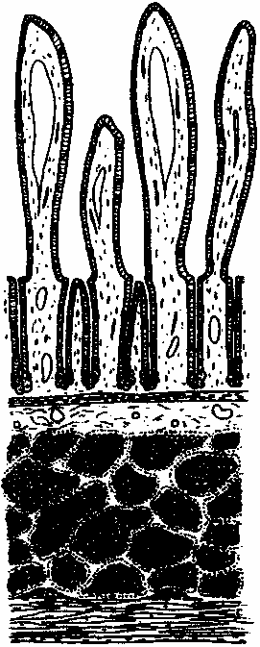
(a) Name the parts labelled A, B and C.
A ...............................................................................................................................
B ...............................................................................................................................
C ...............................................................................................................................
(2)

(b) Describe the functions of the following regions of the ileum.
Part A
……………………………………………….………………………………………
……………………………………………….………………………………………
……………………………………………….………………………………………
……………………………………………….………………………………………
……………………………………………….………………………………………
……………………………………………….………………………………………
……………………………………………….………………………………………
……………………………………………….………………………………………
(4)
Muscularis externa
……………………………………………….………………………………………
……………………………………………….………………………………………
……………………………………………….………………………………………
……………………………………………….………………………………………
(2)
(Total 8 marks)

4. The graph below shows changes in the blood pressure in the aorta and the left ventricle during two complete cardiac cycles.
(a) On the graph, draw an arrow to show when the left atrioventricular (mitral) valve closes.
(1)

(b) Use the information in the graph to calculate the heart rate. Show your working.

Answer ..................................
(2)
(c) During the cardiac cycle, the pressure in the left ventricle falls to a much lower level than in the aorta. Suggest an explanation for this difference.
……………………………………………….………………………………………
……………………………………………….………………………………………
……………………………………………….………………………………………
……………………………………………….………………………………………
……………………………………………….………………………………………
……………………………………………….………………………………………
(3)
(d) During the cardiac cycle, the pressure in the right ventricle rises to a maximum of about 3.3 kPa. Suggest reasons for the difference between this pressure and the maximum pressure in the left ventricle.
……………………………………………….………………………………………
……………………………………………….………………………………………
……………………………………………….………………………………………
……………………………………………….………………………………………
……………………………………………….………………………………………
……………………………………………….………………………………………
(3)
(Total 9 marks)

5. The diagram below shows part of the lower surface of a leaf, as seen using a light microscope.
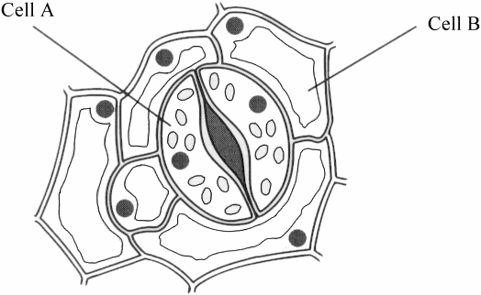
(a) Name the cells labelled A and B.
A …………………………………………….………………………………………
B …………………………………………….………………………………………
(2)
(b) In an investigation, the concentrations of potassium ions (K+) were measured in cells A and B, when the stoma was open and when it was closed. The results are shown in the table below.
(i) Describe these changes in potassium ion concentrations.
……………………………………………….………………………………..
……………………………………………….………………………………..
……………………………………………….………………………………..
……………………………………………….………………………………..
(2)

(ii) Suggest how changes in potassium ion concentrations are involved in the mechanism for opening of stomata.
……………………………………………….………………………………..
……………………………………………….………………………………..
……………………………………………….………………………………..
……………………………………………….………………………………..
……………………………………………….………………………………..
……………………………………………….………………………………..
(3)
(Total 7 marks)

6. The diagram below shows a germinating pollen grain as seen using a light microscope.
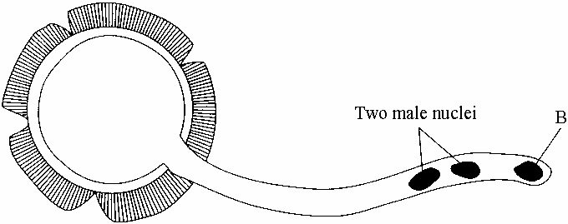
(a) Name the parts labelled A and B.
A ...............................................................................................................................
B ...............................................................................................................................
(2)

(b) Describe the roles of the two male nuclei during fertilisation.
……………………………………………….……………………………………..
……………………………………………….……………………………………..
……………………………………………….……………………………………..
……………………………………………….……………………………………..
……………………………………………….……………………………………..
……………………………………………….……………………………………..
……………………………………………….……………………………………..
……………………………………………….……………………………………..
(4)
(c) An investigation was carried out into the effect of sucrose concentration on the germination of pollen grains from two species of plants, Bauhinia purpurea and Camellia japonica. The results are shown in the graph below.
Graph J. B. E. Summer 2001, p. 150
(i) What is the optimum concentration of sucrose for the germination of pollen grains from both species?
………..……………………………….………………………………………
(1)

(ii) Compare the germination rate of these two species as the concentration of sucrose increases from 20%.
………..……………………………….………………………………………
………..……………………………….………………………………………
………..……………………………….………………………………………
………..……………………………….………………………………………
………..……………………………….………………………………………
………..……………………………….………………………………………
(3)
(Total 10 marks)

7. The diagram below shows a midge larva, Chironomus. This is a species which is adapted to live in fresh water with a low concentration of dissolved oxygen.
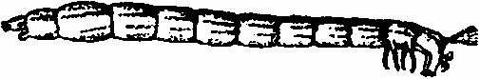
Describe two ways in which invertebrates such as Chironomus are adapted to live in water with a low concentration of dissolved oxygen.
..............................................................................................................................................
..............................................................................................................................................
..............................................................................................................................................
..............................................................................................................................................
..............................................................................................................................................
..............................................................................................................................................
..............................................................................................................................................
..............................................................................................................................................
(Total 4 marks)

8. The diagram below shows part of a section at low magnification through the root of a dicotyledonous plant.
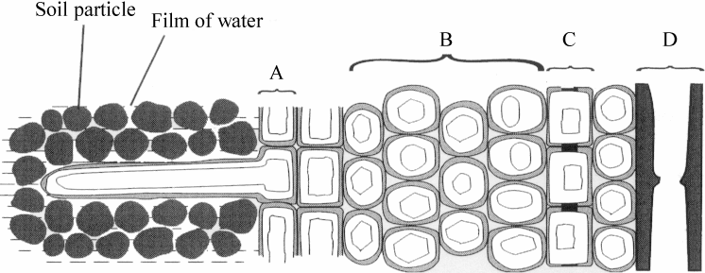
(a) Name the parts labelled A, B, C and D.
A ...............................................................................................................................
B ...............................................................................................................................
C ...............................................................................................................................
D ...............................................................................................................................
(2)
(b) Describe how water passes from part A to part D.
……………………………………………….………………………………………
……………………………………………….………………………………………
……………………………………………….………………………………………
……………………………………………….………………………………………
……………………………………………….………………………………………
……………………………………………….………………………………………
……………………………………………….………………………………………
……………………………………………….………………………………………
(4)
(c) A root takes up mineral ions in addition to water. An investigation was carried out into the effects of aeration on the uptake of nitrate ions (NO) by plant roots.
Sections of root, including the root hairs, were immersed in a culture solution containing 6.3 mmol per dM3 of nitrate ions. The solution was aerated (air was bubbled through it). After nine hours the root sections were removed and the concentration of nitrate ions in the root cells was determined.

The procedure was repeated with a second batch of root sections from which the root hairs had been removed. Both procedures were then repeated without aeration. The results are shown in the table below.
(i) Suggest an explanation for the difference between the results with and without aeration when the root hairs were present.
............................................................................................................................
............................................................................................................................
............................................................................................................................
............................................................................................................................
............................................................................................................................
............................................................................................................................
............................................................................................................................
............................................................................................................................
(4)
(ii) Suggest reasons for the results obtained when no root hairs were present.
............................................................................................................................
............................................................................................................................
............................................................................................................................
............................................................................................................................
(2)
(Total 12 marks)

