1. The table below refers to two disaccharides, sucrose and maltose. If the statement is correct, place a tick () in the appropriate box and if the statement is incorrect, place a cross () in the appropriate box.
Statement | Sucrose | Maltose
Contains glucose
Is a reducing sugar
Contains glycosidic bonds
Is transported in the phloem of flowering plants
(Total 4 marks)

2. Read through the following account of the properties of water, then write on the dotted lines the most appropriate word or words to complete the account.
Water has the chemical formula ………………………………… . Water molecules are
described as ………………………………….. because they have a slight positive charge
at one end of the molecule and a slight negative charge at the other end. As a result,
individual molecules form ………………………………….. bonds with each other.
Water is an important ………………………………….. in living organisms because
most biochemical reactions take place in aqueous solution. Water also has a high
………………………………….., which means that its temperature remains relatively
stable despite large changes in the temperature of the surrounding environment.
(Total 5 marks)

3. The diagram below shows the structure of a bacterium, a typical prokaryotic cell.
(a) Name A, B and C as labelled on the diagram.
A ...............................................................................................................................
B ...............................................................................................................................
C ...............................................................................................................................
(3)
(b) Complete the table below to show three differences between a prokaryotic cell and a eukaryotic cell.
 | Prokaryotic cell | Eukaryotic cell
1
2
3
(3)
(Total 6 marks)

4. Explain what is meant by the following terms.
(a) Semi-conservative replication of DNA
………………………………………………………………………………………..
………………………………………………………………………………………..
………………………………………………………………………………………..
………………………………………………………………………………………..
………………………………………………………………………………………..
………………………………………………………………………………………..
(3)
(b) Tertiary structure of a protein
………………………………………………………………………………………..
………………………………………………………………………………………..
………………………………………………………………………………………..
………………………………………………………………………………………..
………………………………………………………………………………………..
………………………………………………………………………………………..
(3)
(Total 6 marks)

5. The photograph below shows human cells as seen using a light microscope. It has been magnified 800 times.
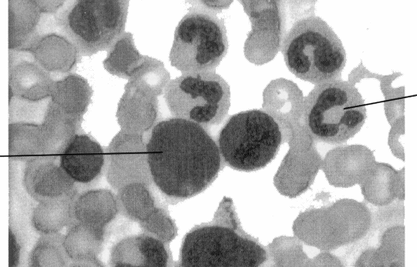

(a) Calculate the actual diameter of the cell labelled A, expressing your answer in μm (micrometres). Show your working.

Answer ……………………… μm
(3)
(b) In the space below, make an accurate drawing of the cells labelled A and B,
enlarge 2 ×. Do not label your drawing.

(4)
(Total 7 marks)

6. The diagram below shows cells from a root tip, prepared by the root tip squash method.
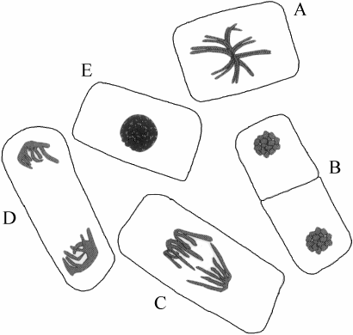

(a) Describe how you would prepare a root tip squash so that mitosis can be studied.
………………………………………………………………………………………..
………………………………………………………………………………………..
………………………………………………………………………………………..
………………………………………………………………………………………..
………………………………………………………………………………………..
………………………………………………………………………………………..
………………………………………………………………………………………..
………………………………………………………………………………………..
(4)
(b) State which of the cells labelled A–E is in:
(i) metaphase ...................
(ii) anaphase .....................
(2)
(c) State two events that take place during interphase.
1. ……………………………………………………………………………………..
2. ……………………………………………………………………………………..
(2)
(Total 8 marks)

7. (a) (i) Explain what is meant by the term facilitated diffusion.
...........................................................................................................................
...........................................................................................................................
...........................................................................................................................
...........................................................................................................................
(2)
(ii) State two ways in which active transport differs from facilitated diffusion.
1 .........................................................................................................................
...........................................................................................................................
2 .........................................................................................................................
...........................................................................................................................
(2)

(b) In an investigation into the effects of osmosis on red blood cells, seven samples of red blood cells were placed in potassium chloride solutions of different concentrations. After two hours, each sample was examined to find the percentage of cells that had swollen and burst (lysed). The results are shown in the graph below.
(i) Calculate the difference between the percentage of red blood cells that burst in 0.05 mol dm–1 and 0.07 mol dm–1 potassium chloride solutions.
Show your working.

Answer ................................
(2)

(ii) With reference to water potential, explain why most of the cells burst when placed in 0.05 mol dm–3 potassium chloride solution.
……………………………………………….……………………………….
……………………………………………….……………………………….
……………………………………………….……………………………….
……………………………………………….……………………………….
……………………………………………….……………………………….
……………………………………………….……………………………….
(3)
(iii) Suggest what would happen if red blood cells were placed in a 0 1 mol dm–3 solution of potassium chloride.
……………………………………………….……………………………….
……………………………………………….……………………………….
(1)
(c) Explain why plant cells do not burst when placed in distilled water.
……..……………………………………………….……………………………….
……..……………………………………………….……………………………….
……..……………………………………………….……………………………….
……..……………………………………………….……………………………….
(2)
(Total 12 marks)’

8. An experiment was performed to determine the effect of pectinase on the yield of apple juice. An apple was cut into small pieces and blended in a food processor to produce apple pulp. The pulp was then left to stand for 15 minutes.
One 50 g sample of pulp was mixed with 5 cm3 of pectinase solution and a second 50 g sample of pulp was mixed with 5 cm3 of water. Each sample was then placed in a separate filter funnel and the Juice was collected in a measuring cylinder. The volume of Juice produced was recorded every minute for 20 minutes.

The results of this experiment are shown in the graph below.
(a) (i) With reference to the graph, describe how pectinase affects the production of apple juice.
..........................................................................................................................
..........................................................................................................................
..........................................................................................................................
..........................................................................................................................
(2)
(ii) Explain why pectinase has this effect on the production of apple juice.
..........................................................................................................................
..........................................................................................................................
..........................................................................................................................
..........................................................................................................................
(2)

(b) Apples contain chemicals which act as active site-directed inhibitors of pectinase, However, these chemicals lose their effectiveness when exposed to air.
(i) Explain what is meant by the term active site-directed inhibition.
..........................................................................................................................
..........................................................................................................................
..........................................................................................................................
..........................................................................................................................
(2)
(ii) In a second experiment the apple pulp was left to stand for 30 minutes before mixing it with pectinase. Suggest what effect this would have had on the volume of juice produced. Explain your answer.
..........................................................................................................................
..........................................................................................................................
..........................................................................................................................
..........................................................................................................................
(2)
(c) Describe how you would carry out an experiment to investigate the effect of temperature on the production of apple juice using pectinase.
……………………………………………….………………………………………
……………………………………………….………………………………………
……………………………………………….………………………………………
……………………………………………….………………………………………
……………………………………………….………………………………………
……………………………………………….………………………………………
……………………………………………….………………………………………
……………………………………………….………………………………………
(4)
(Total 12 marks)

