1. Read through the following passage on the structure of prokaryotic cells, then write on the dotted lines the most appropriate word or words to complete the account.
Bacteria, such as Escherichia coli, are prokaryotic organisms. One of the main
differences between prokaryotic cells and eukaryotic cells is that in a prokaryotic cell,
the bacterial chromosome is not surrounded by a ............................................. .
Prokaryotic cells store carbon compounds in the form of .............................................
and ................................................. and they may also contain one or more small circular
DNA molecules, known as ................................................ . E. coli cells are motile due
to the presence of a......................................................... .
(Total 5 marks)

2. The table below refers to some disaccharides, their constituent monomers and their roles in living organisms.
Complete the table by writing in the appropriate word or words in the empty boxes.
Disaccharide | Constituent monomers | One role in living  organisms
Lactose |  | Carbohydrate source in  mammalian milk
 | Glucose + glucose
Form in which sugars
are transported in plants
(Total 5 marks)

3. The photograph below shows a section through a mitochondrion as seen using an electron microscope.
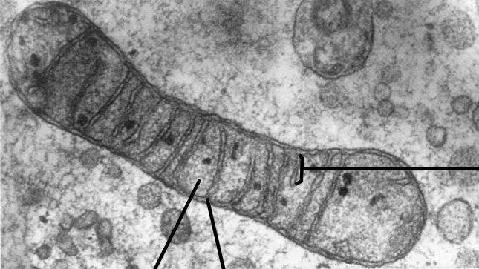
Prof. R. Bellairs/Wellcome Photo Library
(a) Name the parts labelled A, B and C.
A ................................................................................................................................
B ................................................................................................................................
C ................................................................................................................................
(3)
(b) Describe the role of mitochondria.
....................................................................................................................................
....................................................................................................................................
....................................................................................................................................
....................................................................................................................................
(2)
(Total 5 marks)

4. (a) Explain what is meant by the primary structure of a protein molecule.
.....................................................................................................................................
.....................................................................................................................................
.....................................................................................................................................
.....................................................................................................................................
(2)

(b) Explain the role of hydrogen bonding in maintaining the structure of a globular protein such as insulin.
....................................................................................................................................
....................................................................................................................................
....................................................................................................................................
....................................................................................................................................
....................................................................................................................................
(3)
(c) Describe how the structure of a fibrous protein, such as collagen, differs from the structure of a globular protein.
....................................................................................................................................
....................................................................................................................................
....................................................................................................................................
....................................................................................................................................
(3)
(Total 8 marks)

5. The photomicrograph below shows some cells viewed using a light microscope.
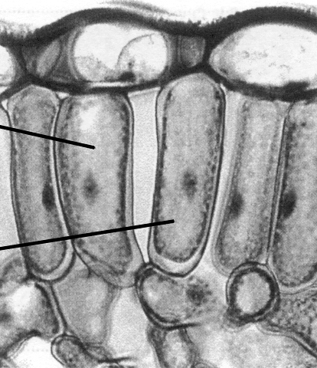

(a) Name the tissue in which the cells labelled J and K are found, giving one reason for your identification.
Tissue..........................................................................................................................
Reason for identification.............................................................................................
....................................................................................................................................
(2)
(b) Give the function of this tissue.
....................................................................................................................................
(1)
(c) In the space below make an accurate drawing, enlarged × 1.5, of the cells labelled
J and K. Do not label your drawing.

(5)
(Total 8 marks)

6. The diagram below shows the structure of a chromosome as it might appear at the end of prophase of mitosis.

(a) Name the parts labelled A and B.
A .................................................................................................................................
B .................................................................................................................................
(2)
(b) During metaphase of mitosis, the chromosomes become attached to the equator of the spindle. Name the stage of mitosis that follows metaphase and describe the events that occur in this stage.
Stage ...........................................................................................................................
Events occurring ........................................................................................................
....................................................................................................................................
....................................................................................................................................
....................................................................................................................................
(3)
(c) Explain the significance of the stage you have named and described in (b).
....................................................................................................................................
....................................................................................................................................
(1)
(d) Mitosis forms part of the cell cycle. Name one other stage of the cell cycle and state what occurs in the stage that you have named.
....................................................................................................................................
....................................................................................................................................
....................................................................................................................................
....................................................................................................................................
(2)
(Total 8 marks)

7. Urease is an enzyme which catalyses the breakdown of urea to ammonia and carbon dioxide.
An experiment was carried out into the effect of pH on the activity of urease. 10 cm3 of pH 3 buffer solution was mixed with 1 cm3 of urease solution. This mixture was then added to
10 cm3 of urea solution and the concentration of ammonia in the mixture was measured after 60 minutes. This procedure was repeated using buffer solutions of pH 4, 5, 6, 7, 8 and 9.

The results are shown in the graph below.
(a) What do these results suggest is the optimum pH for urease activity?
....................................................................................................................................
(1)
(b) Suggest how the experiment could be modified to determine the optimum pH more accurately.
....................................................................................................................................
....................................................................................................................................
(1)
(c) Explain why no ammonia was produced at pH 3.
....................................................................................................................................
....................................................................................................................................
....................................................................................................................................
(3)

(d) Explain why less ammonia is produced at pH 9 than at pH 8.
....................................................................................................................................
....................................................................................................................................
....................................................................................................................................
(2)
(e) Describe how this experiment could be modified to determine the effect of enzyme concentration on the activity of urease.
....................................................................................................................................
....................................................................................................................................
....................................................................................................................................
....................................................................................................................................
....................................................................................................................................
....................................................................................................................................
(4)
(Total 11 marks)

8. The diagram below shows part of a molecule of deoxyribonucleic acid (DNA).
(a) Name A, B, C and D.
A ................................................................................................................................
B ................................................................................................................................
C ................................................................................................................................
D ................................................................................................................................
(4)

(b) Analysis of a molecule of DNA showed that cytosine accounted for 42 per cent of the content of the nitrogenous bases. Calculate the percentage of bases in the molecule which would be thymine. Show your working.

Answer...............................................
(3)
(c) During the process of transcription, one of the DNA strands is used as a template for the formation of a complementary strand of messenger RNA (mRNA). The diagram below shows the sequence of bases in part of a strand of DNA.
(i) Write the letters of the complementary bases in the boxes of the mRNA strand.
(2)
(ii) How many amino acids are coded for by this part of the strand of mRNA?
..........................................................................................................................
(1)
(Total 10 marks)

9. Give an account of the ways in which molecules and ions move into and out of cells.
............................................................................................................................................
............................................................................................................................................
............................................................................................................................................
............................................................................................................................................
............................................................................................................................................
............................................................................................................................................
............................................................................................................................................
(Allow 2 lined pages)
(Total 10 marks)

