Types of Databases
As with just about everything else in the world, there are many different types of databases. There are also different ways to classify these types of databases. Two popular ways to differentiate between databases is by the function of the database and by the data model of the database.

Data Model:

One way of classifying databases is by their data model. A data model is the intangible form in which data is stored. It is kind of like the structure of a database, but data models are only a theoretical idea; they are abstract concepts that you cannot touch. Data models are used to describe how the data is stored and retrieved in a database. Now, we will discuss a few of the types of data models.

Flat-file Database Model:

The flat-file data model is generally used by the old paper-based databases. In this system, data was stored in numerous files. However, the files were not linked, so often, data might be repeated in more than one file. This caused everything to be quite redundant. The original "database," flat-file databases inspired scientists to find a way to link files so that they would not be repetitive.

Hierarchical Database Model:

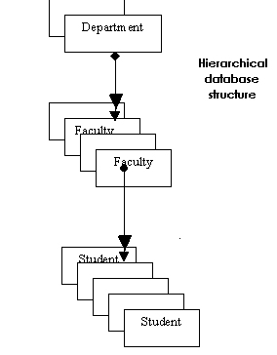
The hierarchical database model took steps to get rid of the repetitiveness of the flat-file database model, but although it was somewhat successful, it did not completely succeed. There is still a level of redundant data in hierarchical databases.

A hierarchical database consists of a series of databases that are grouped together to resemble a family tree:
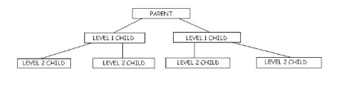
Each of the boxes in the diagram represents one database. The top database in the hierarchical model is called the "parent" database. The databases under it are called "child" databases. One "parent" can have many "children," but a "child" can only have one "parent." The child databases are all connected to the parent database via links called "pointers."

To get to a child database in the hierarchical database model, you must first go through the parent database, and then through the levels above it. If you have Microsoft Windows, you might realize that this is how Windows Explorer works. First, you open up a file- usually it's "My Computer." Under "My Computer," you can then choose from a list of drives.

Notice in the diagram above how the child databases on the same level are not connected. This presents a problem in the hierarchical database model and makes searching for data extremely difficult. Another problem is that data cannot be entered into the child databases until that field has been added to the parent database. This method was quite inefficient. Thus, although the hierarchical database model reduced some repetitiveness of data, it also presented many new problems.

Hierarchical structures were widely used in the first mainframe database management systems. However, owing to their restrictions, they often cannot be used to relate structures that exist in the real world.

Hierarchical relationships between different types of data can make it very easy to answer some questions, but very difficult to answer others. If a one-to-many relationship is violated (e.g., a patient can have more than one physician) then the hierarchy becomes a network.

While the hierarchical model is rare in modern databases, it is common in many other means of storing information, ranging from file systems to the Windows registry to XML documents.
It is used in systems such as On Line Analytical Processing which specialises in business reporting such as sales marketing, management reporting, and business performance management (BPM) and also budgeting and forecasting.

Network Database Model:

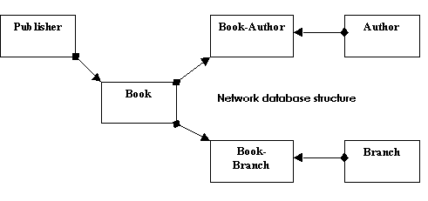
The network database model was designed to help resolve some of the hierarchical database model's problems. For one thing, it allowed for links between the child databases. This no only reduces the chance of redundant data, but also makes searching for data much easier!

Another improvement of the network database model over the hierarchical model is that while in the hierarchical model a child database can only have one parent, in the network model, a child database can have more than one parent!

However, the network database model still had its share of problems. For one thing, it was difficult to execute and maintain. Only database experts could successfully use these databases. It was difficult for the general public to use network databases for real-life applications.

One type of network DBMS is a distributed database. A distributed database is a database that is under the control of a central database management system (DBMS) in which storage devices are not all attached to a common CPU. It may be stored in multiple computers located in the same physical location, or may be dispersed over a network of interconnected computers.

Collections of data (e.g. in a database) can be distributed across multiple physical locations. A distributed database is distributed into separate partitions/fragments. Each partition/fragment of a distributed database may be duplicated.

The other type of network database is one which is held centrally but can be accessed simultaneously by many users remotely using a WAN or locally as part of a LAN.
Good examples are large organisations spread over wide geographical areas such as police officers using the PNC (Police National Computer in the UK) and the DVLA (Driver and Vehicle Licensing Authority) which can also be accessed by police officers remotely.

Relational Database Model:

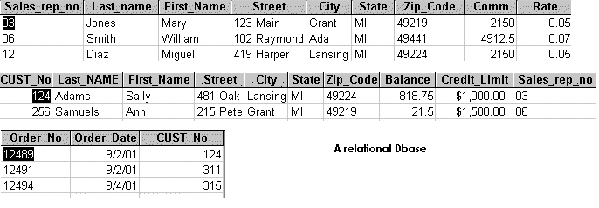
The relational database model came in at full swing during the 1980s. Modeled after the work of Dr. E. F. Codd of IBM, the relational database model is extremely popular because it solved many of the problems displayed in the hierarchical and network database models.
The relational database model is different from the hierarchical and network database models in that there are no "parent" and "child" databases. Rather, all of the databases in the relational database model are equal.
Data can be stored in any number of separate databases. Then, these databases are connected by a "key" field.
For example, consider an address book, which is a paper-based database. If we were to use the relational database model, then we would store all of the data in separate databases. One database could hold a person's address; another could hold the person's phone number, etc. However, all of the databases might have one field that is the same, like, for example, the person's name.
This makes it easy to search for and extract data from the databases. It is also very efficient and easy to use.
They are mainly used as Interrogational databases e.g. customer database linked to sales records.

References:

http://library.thinkquest.org/C0115420/Cyber-club%20800x600/DatabaseS/Types%20of%20Databases.htm

