Technical and customer support

Technical support (also tech support) is a range of services providing assistance with technology products such as mobile phones, televisions, computers, or other electronic or mechanical goods. In general, technical support services attempt to help the user solve specific problems with a product—rather than providing training, customization, or other support services.
Most companies offer technical support for the products they sell, either freely available or for a fee. Technical support may be delivered over the telephone or via various online media such as e-mail or a Web site. Larger organizations frequently have internal technical support available to their staff for computer related problem. The internet is also a good source for freely available tech support, where experienced users may provide advice and assistance with problems. In addition, some fee-based service companies charge for premium technical support services.

Utility companies

Electricity, gas and water companies operate help centres which offer customer support. These are usually call centres which have operators ready to deal with customer enquiries regarding breaks in the service and also problems with paying bills.

Mail order catalogue firms

Most of these operate telephone call centres. A call centre consists of several telephone operators each sat at a work station. This consists of a computer, a telephone set/headset connected to a telecom switch. It can be operated on its own or can be networked to additional centres using a computer network sometimes consisting of mainframes, microcomputers and LANs. Computer telephony integration (CTI) is being used more and more to combine the data and voice input to the system.
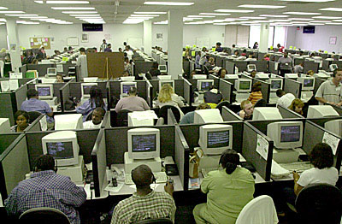
http://blogs.ipswitch.com/archives/call%20center.jpg

Customer support for computer hardware and software

On-line help is provided by most hardware and software manufacturers. In addition help lines are provided. The on-line help asks customers to click on links which narrow down their problem and hopefully provide a solution.

References:
http://en.wikipedia.org/wiki/Customer_support

