Electronic publishing

Electronic publishing includes the digital publication of ebooks and electronic articles, and the development of digital libraries and catalogues. Electronic publishing has become common in scientific publishing where it has been argued that peer-reviewed paper scientific journals are in the process of being replaced by electronic publishing. Although network distribution is nowadays strongly associated with electronic publishing, there are many non network electronic publications such as Encyclopedias on CD and DVD, as well as technical and reference publications relied on by mobile users and others without reliable and high speed access to a network.
There is usually a delay of several months after an article is written before it is published in a paper journal and this makes journals not an ideal format for disseminating the latest research. In some fields such as astronomy and some parts of physics, the role of the journal at disseminating the latest research has largely been replaced by preprint databases such as arXiv.org. However, scientific journals still provide an important role in quality control, archiving papers, and establishing scientific credit. In general, the electronic material uploaded to preprint database are still intended for eventual publication in a peer-reviewed journal.
There is an article titled "Online or Invisible?" which provides statistical evidence that electronic publishing provides wider dissemination. A number of journals have, while retaining their peer review process, established electronic versions or even moved entirely to electronic publication.
Electronic publishing is increasingly popular in works of fiction as well as with scientific articles. Electronic publishers are able to provide quick gratification for late-night readers, books that customers might not be able to find in standard book retailers and books by new authors that would be unlikely to be profitable for traditional publishers.

THE PRINTING PROCESS

Letterpress printing
Letterpress printing is the oldest printing technique, in which a raised surface is inked and then pressed against a smooth substance to obtain an image in reverse.
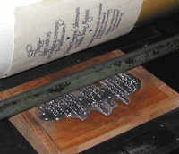

Offset lithography
Printing processes such as offset lithography (the most commonly used printing process), use printing plates to transfer an image to paper or other substrates. The plates may be made of metal, plastic, rubber, paper, and other materials. The image is put on the printing plates using photomechanical, photochemical, or laser engraving processes. The image may be positive or negative.

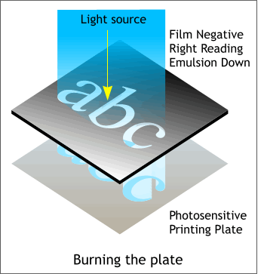
Before the job can be printed, the document must be converted to film and "plates." Film negatives are created from digital files. Images from the negatives are transferred to printing plates in much the same way as photographs are developed. A measured amount of light is allowed to pass through the film negatives to expose the printing plate. When the plates are exposed to light, a chemical reaction occurs that allows an ink-receptive coating to be activated. This results in the transfer of the image from the negative to the plate. There are different materials for plates, including paper (which produces a lower-quality product). The best plate material is aluminum, which is more costly.
Each of the primary colors -- black, cyan (blue), magenta (red), and yellow -- has a separate plate. Even though you see many, many colors in the finished product, only these four colors are used.
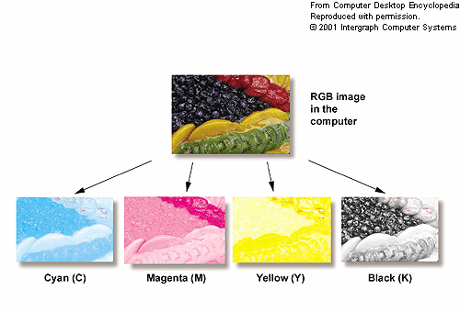

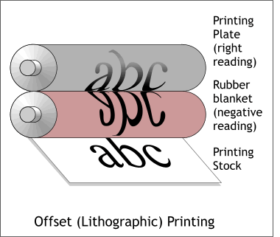
The offset lithography process works by first transferring an image photographically to thin metal, paper, or plastic printing plates. Unlike other forms of printing, in offset lithography the image on the printing plate is not recessed or raised. Rollers apply oil-based ink and water to the plates. Since oil and water don't mix, the oil-based ink won't adhere to the non-image areas. Only the inked image portion is then transferred to a rubber blanket (cylinder) that then transfers the image onto the paper as it passes between it and another cylinder beneath the paper. The term offset refers to the fact that the image isn't printed directly to the paper from the plates, but is offset or transferred to another surface that then makes contact with the paper.
Examples: Offset lithography is the most commonly used commercial printing process for the bulk of desktop publishing on paper.
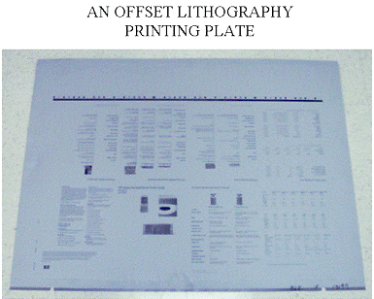

Computerised typesetting

Typesetting involves the presentation of textual material in graphic form on paper or some other medium. Before the advent of desktop publishing, typesetting of printed material was produced in print shops by compositors working by hand, and later with machines.
The general principle of typesetting remains the same: the composition of glyphs into lines to form body matter, headings, captions and other pieces of text to make up a page image, and the printing or transfer of the page image onto paper and other media.
Computers excel at automatically typesetting documents. Character-by-character computer-aided phototypesetting replaced continuous casting machines in the 1980s, and was in turn rapidly rendered obsolete by fully digital systems employing a raster image processor to render an entire page to a single high-resolution digital image, now known as imagesetting.

Facsimile transmission

It is used to transfer a newspaper from one site to another for printing.
Black and white pages are sent in one file transmission. Full color pages require four separate file transmissions, one each for magenta, cyan, yellow and black.
Computers are used extensively to monitor the entire process. The computers keep track of the time the pages were transmitted and determine which print sites, if any require re-transmission. If there are errors, a computer that is part of the broadcast control system automatically re-transmits data to the print sites, without any operator intervention.

DESKTOP PUBLISHING

Desktop publishing is the use of the computer and specialized software to create documents for desktop or commercial printing. Desktop publishing refers to the process of using the computer to produce documents such as newsletters, brochures, books, and other publications that were once created manually using a variety of non-computer techniques along with large complex phototypesetting machines.
Desktop publishing software can be found in both graphic design firms and other types of businesses of all sizes, homes, schools, quick copy centers, service bureaus, and print shops. Just about anywhere there is a need to produce printed communications from billboards to baby announcements to business cards; you can find desktop publishing software and people using it.
Desktop publishing is important as a tool that can enhance communication by making it possible to quickly and efficiently produce printed and electronic documents. Desktop publishing software allows the user to rearrange text and graphics on screen, change typefaces as easily as changing shoes, and resize graphics on the fly, before finally committing a design to paper.

The three primary differences in offset printing and desktop printing (such as inkjet and laser) are the colors of ink and the way the ink is placed on the paper as well as the type of machinery used to accomplish the task.

For serious freelance desktop publishing a minimum suite of desktop publishing software tools would be:
- Word Processing Software
- Page Layout Software
- Graphics Software (two kinds)
  - Illustration
Illustration or drawing programs work with vector graphics formats. Examples: Adobe Illustrator, CorelDRAW, Macromedia Freehand
  - Photo/Image Editing
Image editors, also called paint programs or photo editors work with bitmap images. Bitmap graphics tools are needed for working with photos, scans, or other "realistic" images. Examples: Adobe Photoshop, Corel Photo-Paint, Jasc Paint Shop Pro

References
http://en.wikipedia.org/wiki/Electronic_publishing
http://computer.howstuffworks.com/offset-printing.htm
http://en.wikipedia.org/wiki/Typesetting
http://www.usatoday.com/media_kit/pressroom/pr_production.htm
http://desktoppub.about.com/cs/beginners/f/what_dtp.htm

