Control systems
A control system is a device or set of devices to manage, command, direct or regulate the behavior of other devices or systems.
There are two common classes of control systems, with many variations and combinations: logic or sequential controls, and feedback or linear controls. There is also fuzzy logic, which attempts to combine some of the design simplicity of logic with the utility of linear control. Some devices or systems are inherently not controllable.
Logic control
Logic controllers may respond to switches, light sensors, pressure switches etc and cause the machinery to perform some operation. Logic systems are used to sequence mechanical operations in many applications. Examples include elevators, washing machines and other systems with interrelated stop-go operations.
Logic systems are quite easy to design, and can handle very complex operations.
On-off control
For example, a thermostat is a simple negative-feedback control: when the temperature (the "measured variable" or MV) goes below a set point (SP), the heater is switched on. Another example could be a pressure-switch on an air compressor: when the pressure (MV) drops below the threshold (SP), the pump is powered. Refrigerators and vacuum pumps contain similar mechanisms operating in reverse, but still providing negative feedback to correct errors.
Simple on-off feedback control systems like these are cheap and effective. In some cases, like the simple compressor example, they may represent a good design choice.
Linear control
Linear control systems use linear negative feedback to produce a control signal.
Basically, all computer control means is using a computer to control the action or movement of an object.
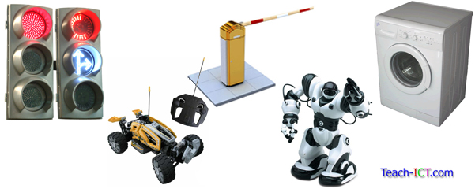

Sensors
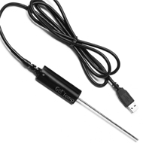
A sensor is something which can measure physical quantities in the surrounding environment. An example might be a heat sensor which measures the temperature in a room or a pressure sensor which senses when someone has walked over it.
Once they have taken a reading or measurement, they might send that reading straight back to the computer or they may store it up and take a set of readings over time and send them back in a batch.
This data is called an ‘input’.
There are many different types of sensors, below is a table showing you a few of the most common ones:
Sensors
Sensor | Measures | Where Used
Heat | Temperature | Living room for central heating system
Humidity | Water vapour in the air | Swimming pool, greenhouse
Infra-red | Infra-red radiation e.g. body heat | Security alarm systems
Light | Light levels | External security lights
PH | Acid/alkali levels e.g. pH of soil | Environmental experiments, river pollution
Pressure | Pressure | Burglar alarm systems, automatic doors
Smoke | Smoke in the atmosphere | Offices
Sound | Levels of sound | Security alarm systems
Tilt | Angle of tilt | Windows in security alarm system
Touch | Detects if one object bumps into another | Computer controlled robots

ADC
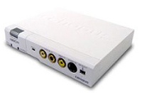
Most sensors take analogue measurements. This means that the measurement can have a wide range of values or be on a continuous scale.
All computers need digital data in order to be able to understand it and process it. Digital data only has two values either 0 and 1 or On and Off.
In order for the data collected by the sensor to be understood by the computer, it needs to be converted from an analogue signal to a digital signal. To do this, a special piece of hardware is needed called an analogue-to-digital converter or ADC.
The ADC is connected between the sensor and the computer’s input-output port and it is called an ‘interface’.

Process
Once the input data from the sensors has been received by the computer, it can then begin to process it.  The data will be compared against a set of rules which have been programmed into the control system and a decision will be made.  For example, think about a central heating system: | 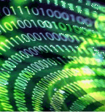
The system is set to keep the room at a constant 22 degrees C.
- The sensor will take regular temperature readings in the room and send the readings back to the computer.
- The computer will then process the data to see if it matches the ideal 22 degrees C.
- If it is lower e.g. 20 degrees C, then the computer will need to identify the correct response (e.g. the heating must be turned on).
- If it is equal or above 22 degrees C then the computer must identify the correct response (e.g. the heating must be turned off).
This stage is called processing. The computer can only follow the rules that it has programmed into the control system, it cannot make its own decisions.

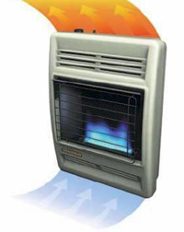
Output
Once the processing has taken place and a decision has been made, the computer will send the correct signal to the output device.
For a central heating system, this might be to turn the heating on or off. For a greenhouse watering system this might be to turn the sprinklers on or off.
Sending the message and the resulting action is known as the ‘output’ stage.

Open Loop System
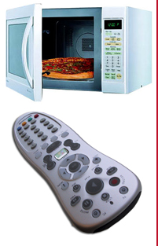
There two types of computer control system:
1. Open loop system
2. Feedback system
The first type, Open Loop System, only looks at its input signal in order to decide what to do.
It takes no account at all of what is happening to its output.
Examples of 'open-loop' systems:
a) You set the microwave oven to run for two minutes. After cooking
for two minutes, the control system turns the microwave off. It has no idea whether your food is still frozen, burnt or cooked perfectly.
b) You program the video recorder to start recording the football game at 7.30pm. However, because the news program finished early, you miss the first vital 15 minutes of the match. Because the system is only checking its input(time), it had no idea that the starting time of the match had changed.

Feedback System
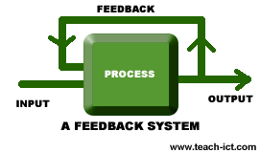
Most control systems carry on working continuously, they don’t just stop after one decision has been made.
Take the example of the central heating system previously.
1. The sensor takes a reading of 20 degrees and sends it to the computer. The computer processes this and sends a signal to the central heating to switch on.
2. The sensor takes a reading of 21 degrees and sends it to the computer. The computer processes this and sends a signal to the central heating to remain switched on.
3. The sensor takes a reading of 22 degrees and sends it to the computer. The computer processes this and sends a signal to the central heating to switch off.
4. The sensor takes a reading of 21 degrees and sends it to the computer. The computer processes this and sends a signal to the central heating to remain switched on.
This cycle of taking one reading and responding to it, then taking another reading and responding to it is known as ‘Feedback’.
Definition: Feedback is where the output of a system affects the input.

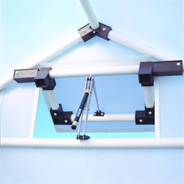
Actuator
An actuator is often part of a computer control system.
The actuator is a mechanical device or motor which carries out the action or decision made by the control system.
For example, in a greenhouse, sensors may measure the temperature. When the temperature rises too much, the control system will send a signal to open the windows or vents.
The actuator is the motor which will open the vents. Likewise, when the temperature drops, the control system will send a message to the actuator (motor) to close the vents.

Examples of Computer Control
Now that you understand what computer control means, lets identify where you will find examples of it in your everyday life:
At home  - Washing machines  - Microwave cookers  - Dishwashers  - Electric kettles  - Fridges  - Video recorders  - Remote control television  - Central heating systems  - Burglar Alarm system  - External Security lights | 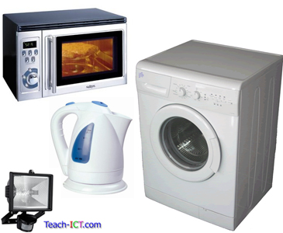
At work  - Air conditioning systems  - Lifts  - Automatic doors  - Factory robots | 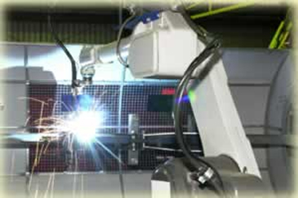
Outside the home  - Traffic light systems  - Car park barriers  - Cars – engine management systems  - Lifts  - Rides at theme parks  - Computer controlled lighting systems at discos and concerts  - Remote controlled car | 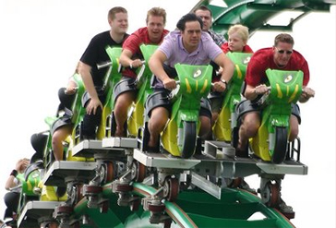

Advantages of Computer Control
Computers:
- Can operate 24 hours a day without taking a break.
- Can work without holidays or sick days
- Will work without any wages.
- Will repeat actions over and over and over again
- Can process data from sensors very quickly
- Can take account of hundreds of inputs at the same time
- Can make reliable and accurate decisions
- Can be used in dangerous or awkward environments where it wouldn't be a good idea to send humans to.

Disadvantages of Computer Control
- The software for the control system is specialist and may cost a lot of money to develop
- If the computer malfunctions the system will not work
- If there is a power cut the system will not work
- The computer can’t react to unexpected events like a human could. It can only respond in the way it has been programmed to.
- It can cause some concern if total control for a system and the decisions are handed over to a computer.
Refrigeration
Ironically, refrigerators keep things cold because of the nature of heat. The Second Law of Thermodynamics essentially states that if a cold object is placed next to a hot object, the cold object will become warmer and the hot object will become cooler. A refrigerator does not cool items by lowering their original temperatures; instead, an evaporating gas called a refrigerant draws heat away, leaving the surrounding area much colder. Refrigerators and air conditioners both work on the principle of cooling through evaporation.
The main inputs would be through a temperature sensor, a contact switch for the door and a number pad or similar device to input the required temperature. The outputs would be the control of an actuator operating the compressor, LEDs showing temperature status and a warning buzzer if the door is left open as well as a timer to calculate how long the door had been left open.
The refrigeration process begins with the compressor.
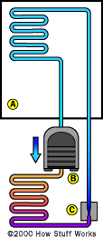
- The compressor compresses the ammonia gas. The compressed gas heats up as it is pressurized (orange).
- The coils on the back of the refrigerator let the hot ammonia gas dissipate its heat. The ammonia gas condenses into ammonia liquid (dark blue) at high pressure.
- The high-pressure ammonia liquid flows through the expansion valve.
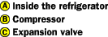
You can think of the expansion valve as a small hole. On one side of the hole is high-pressure ammonia liquid. On the other side of the hole is a low-pressure area (because the compressor is sucking gas out of that side).
- The liquid ammonia immediately boils and vaporizes (light blue), its temperature dropping to -27 F. This makes the inside of the refrigerator cold.
- The cold ammonia gas is sucked up by the compressor, and the cycle repeats.
A device called a thermocouple (it's basically a thermometer) can sense when the temperature in the refrigerator is as cold as you want it to be. When it reaches that temperature, the device shuts off the electricity to the compressor.
But the refrigerator is not completely sealed. There are places, like around the doors and where the pipes go through, that can leak a little bit.
So when the cold from inside the refrigerator starts to leak out and the heat leaks in, the thermocouple turns the compressor back on to cool the refrigerator off again.

Air conditioning systems
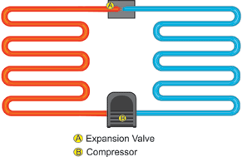
Air conditioners and refrigerators work the same way. Instead of cooling just the small, insulated space inside of a refrigerator, an air conditioner cools a room, a whole house, or an entire business.
Air conditioners use chemicals that easily convert from a gas to a liquid and back again. This chemical is used to transfer heat from the air inside of a home to the outside air.
The machine has three main parts. They are a compressor, a condenser and an evaporator. The compressor and condenser are usually located on the outside air portion of the air conditioner. The evaporator is located on the inside the house, sometimes as part of a furnace. That's the part that heats your house.
The working fluid arrives at the compressor as a cool, low-pressure gas. The compressor squeezes the fluid. The working fluid leaves the compressor as a hot, high pressure gas and flows into the condenser. The fins act just like a radiator in a car and helps the heat go away, or dissipate, more quickly.
When the working fluid leaves the condenser, its temperature is much cooler and it has changed from a gas to a liquid under high pressure. The liquid goes into the evaporator through a very tiny, narrow hole. On the other side, the liquid's pressure drops. When it does it begins to evaporate into a gas.
By the time the working fluid leaves the evaporator, it is a cool, low pressure gas. It then returns to the compressor to begin its trip all over again.
Connected to the evaporator is a fan that circulates the air inside the house to blow across the evaporator fins. Hot air is lighter than cold air, so the hot air in the room rises to the top of a room.
There is a vent there where air is sucked into the air conditioner and goes down ducts. The hot air is used to cool the gas in the evaporator. As the heat is removed from the air, the air is cooled. It is then blown into the house through other ducts usually at the floor level.
This continues over and over and over until the room reaches the temperature you want the room cooled to. The thermostat senses that the temperature has reached the right setting and turns off the air conditioner. As the room warms up, the thermostat turns the air conditioner back on until the room reaches the temperature.

Medical applications:

The main use of computer control in hospitals is in life-support systems.  Sensors attached to a patient monitor  - pulse  - temperature  - blood pressure  - breathing rate  The readings are taken at regular intervals and used as input to a computer.  If any of these readings goes outside acceptable levels an output signal sets off an alarm to alert the nursing staff. | 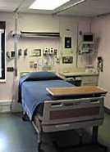
These systems may be used for
- patients in intensive care (eg after operations)
- prematurely born babies
The advantages of this system...  - monitoring can be continuously done 24 hours a day  - no chance of human errors due to eg tiredness  - frees the nursing staff to carry out other duties | disadvantages...  these systems are expensive

Process control
Process control is a statistics and engineering discipline that deals with architectures, mechanisms, and algorithms for controlling the output of a specific process. There are three types of process control:
- Discrete – Found in many manufacturing, motion and packaging applications. Robotic assembly, such as that found in automotive production, can be characterized as discrete process control. Most discrete manufacturing involves the production of discrete pieces of product, such as metal stamping.
- Batch – Some applications require that specific quantities of raw materials be combined in specific ways for particular durations to produce an intermediate or end result. One example is the production of adhesives and glues, which normally require the mixing of raw materials in a heated vessel for a period of time to form a quantity of end product. Other important examples are the production of food, beverages and medicine. Batch processes are generally used to produce a relatively low to intermediate quantity of product per year (a few pounds to millions of pounds).
- Continuous – Often, a physical system is represented though variables that are smooth and uninterrupted in time. The control of the water temperature in a heating jacket, for example, is an example of continuous process control. Some important continuous processes are the production of fuels, chemicals and plastics. Continuous processes, in manufacturing, are used to produce very large quantities of product per year(millions to billions of pounds).
http://en.wikipedia.org/wiki/Control_system
http://www.teach-ict.com/gcse/software/control/miniweb/index.htm

