USE OF ICT IN TIME MANAGEMENT

Organising meeting times
Software can be used to arrange and schedule meetings and other events. As a productivity tool it makes the planning process easier and more effective.

E.g. MeetingWizard
MeetingWizard automatically does the following:
- sends invitations to participants proposing alternate times
- summarizes their responses
- updates you on the results
- sends confirmations
- sends optional reminders prior to meetings

MeetingWizard requires only that you and your participants have access to e-mail and a browser. It uses the simplest technologies possible, ensuring that all of your guests will be able to use the system.

MeetingWizard has been designed to be effective in more than 90% of meeting planning situations, and does not try to fulfill every possible need. However, it allows for enough flexibility to make changes, add personalized notes, make cancellations and handles most other situations that might arise.
MeetingWizard is designed for the modern workplace. It is friendly but professional.

How MeetingWizard Works

The system typically works in a 3-step process.
1. You invite participants providing a number of optional dates/times.
2. Participants respond to invitations by indicating when they are available.
3. You confirm the meeting or event after reviewing responses.
In addition, there are many other features that ensure you don't forget important details, and that all participants receive complete information about meetings.

Here's the visual summary (dates and attendees are removed for privacy reasons):
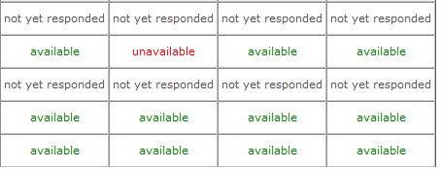

Project Management
Project Management is the discipline of planning, organizing, and managing resources to bring about the successful completion of specific project goals and objectives. The primary challenge of project management is to achieve all of the project goals and objectives while adhering to classic project constraints--usually scope, quality, time and budget. A Gantt chart is a popular type of bar chart that illustrates a project schedule. Gantt charts illustrate the start and finish dates of the terminal elements and summary elements of a project. Terminal elements and summary elements comprise the work breakdown structure of the project.

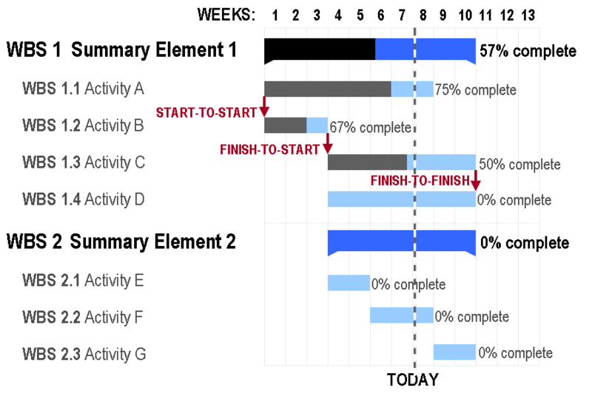

The Critical Path Method, abbreviated CPM, or critical path analysis, is a mathematically based algorithm for scheduling a set of project activities. It is a very important tool for effective project management.
The essential technique for using CPM is to construct a model of the project that includes the following:
A list of all activities required to complete the project (also known as Work breakdown structure), the time (duration) that each activity will take to completion, and the dependencies between the activities.

Using these values, CPM calculates the longest path of planned activities to the end of the project, and the earliest and latest that each activity can start and finish without making the project longer. This process determines which activities are "critical" (i.e., on the longest path) and which have "total float" (i.e., can be delayed without making the project longer). In project management, a critical path is the sequence of project network activities which add up to the longest overall duration. This determines the shortest time possible to complete the project. Any delay of an activity on the critical path directly impacts the planned project completion date.

References
http://en.wikipedia.org/wiki/
http://www.meetingwizard.com/

