
Sample Schemes of Work and Lesson Plans
GCE in Travel and Tourism
OCR Advanced Subsidiary GCE in Travel and Tourism H189/H389
Unit G723: International travel

This Support Material booklet is designed to accompany the OCR Advanced GCE in Travel and Tourism specification for teaching from September 2009.

Contents
Contents 2
Sample Scheme of Work: OCR GCE in Travel and Tourism Unit G723: International travel 4
Sample Lesson Plan: OCR GCE in Travel and Tourism Unit G723: International travel 7

A Guided Tour through the Scheme of Work

= Innovative Teaching Idea
This icon is used to highlight exceptionally innovative ideas.


= ICT Opportunity
This icon is used to illustrate when an activity could be taught using ICT facilities.

OCR GCE in Travel and Tourism Unit G723: International travel
Suggested teaching time | 6-8 hours | Topic | 3.4.1 Different types of international transport and major routes to/from the UK  3.4.2 Different transport products to/from the UK  3.4.3 Ancillary products and services provided to international travellers
Topic outline |  | Suggested teaching and homework activities |  | Suggested resources | Points to note
Candidates need to identify major transport routes and interpret information about their relative popularity and suitability for different passengers with different needs and requirements, such as leisure travellers, business travellers and those visiting friends and relatives.  It is important that candidates have a clear understanding about the following international-transport products and services:  air services – these can be either scheduled or charter flights and may offer different classes (First, Business, Economy and Premium cabins), baggage allowances, lounge access, variations of in-flight service, as well as ‘no-frills’ options, all at different costs |  | - Choose an important international carrier serving the local market and identify its route network.  - Investigate frequency of service on these routes.  - Provide details about what is available for First, Business and Economy class passengers on such routes.  - Compare the chosen carrier with both a charter airline and a “no frills” operator.  - Suggest reasons for the various differences that you identify. |  | - In-flight magazine.  - Airline website.  - CAA’s “UK Business Air Travel Traffic Trends and Characteristics” .  - CAA’s “International Relations - The growth in air travel to visit friends or relatives”.  - Blackman H, Rowe A, Smith J & Stewart S, GCE AS Travel and Tourism for OCR double award, 2005, Heinemann Educational, 043544641X. | Use an image showing an Economy class cabin  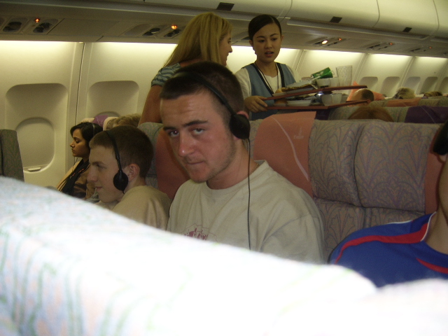  Candidates should be able to:  - identify at least five features of cabin design provided for passenger convenience  - explain at least two ways in which cabin crew will provide a service to passengers  - explain how the passenger experience would be different for those travelling in business class.
For this sub-section, candidates need to investigate at least one international airport. Candidates need to identify the key features of the major types of product currently available. In particular, candidates are expected to know that certain types of product are aimed at passengers with specific needs and expectations. There are many other products and services, besides those involving international transport, that are currently made available to meet the needs of international travellers. Candidates need to know how providers of each of the following cater for different types of visitor at different times: major transport terminals. |  | With reference to one UK international airport:  - identify the ways in which different passenger needs are being met  - attempt an analysis of the ways in which airport service provision meets the needs of both incoming and outbound passengers  - make reasoned evaluative comments about aspects of the airport’s service provision and come to a conclusion about the extent to which both leisure & business travellers, both inbound and outbound, are having their international travel needs met. |  | - Airport website.  - Results of an investigative visit to an international airport.  - CAA’s “Research on the air passenger experience at Heathrow, Gatwick, Stansted and Manchester airports”. | - Candidates are expected to have made a study of an airport and in this instance they will be expected to be able to assess the effective meeting of passenger needs. They need to be able to put forward a range of views and opinions, including comments about carriers and destinations served.  - However, if a visit is not a practical option, candidates are very likely to find all the appropriate information listed on the selected airport’s website. Furthermore, their own experiences of international air travel can certainly help to inform their studies of this topic.

OCR GCE in Travel and Tourism Unit G723: International travel

Airport products, services and facilities available to international travellers
OCR recognises that the teaching of this qualification above will vary greatly from school to school and from teacher to teacher. With that in mind this lesson plan is offered, as a possible approach but will be subject to modifications by the individual teacher.
Lesson length is assumed to be one hour.

Learning Objectives for the Lesson
Objective 1 | To know about the range of products and services available within a chosen UK international airport
Objective 2 | To understand how products and services meet international traveller needs
Objective 3 | Be able to assess how well international traveller needs are being met

Recap of Previous Experience and Prior Knowledge
- Candidates will have made an initial investigation of a chosen UK international airport and will be aware that a range of domestic and international destinations are served by a variety of carriers. This lesson will focus on features of the airport terminal and its role in serving departing and arriving passengers.

Content
Time | Content
5 minutes | Starter activity to help remind candidates of their investigation could address the ways in which the airport was accessible to international travellers. Candidates could list both internal (design, layout, signage, transport within and between terminals) & external (transport routes, parking etc) access features.
10 minutes | Consider responses – how easy was it to arrive and how easy was it to depart?  How were travellers with special needs (e.g. families with small children, the elderly etc) catered for in terms of accessibility? What improvements might be introduced?
5 minutes | Get candidates to work in pairs/small groups to complete a table listing products and services that were available land-side and air-side. Is it possible to categorise these in any way? E.g. Business versus Leisure? Domestic versus Overseas?
15 minutes | Suggest reasons for the differences.  Which services are most significant to which groups of international traveller?
10 minutes | Security is an issue at airports. Identify the main security checks and procedures that were in operation and suggest what the purpose of each one was.

Consolidation
Time | Content
10 minutes | Candidates to present to class on product/service provision at the chosen UK international airport in line with their findings.
5 minutes | Agree main features of provision and suggest valid improvements.  Set Homework Extended Answer  Discuss the types of ancillary service which are available land-side at UK international airports for the convenience of international business and leisure travellers.

