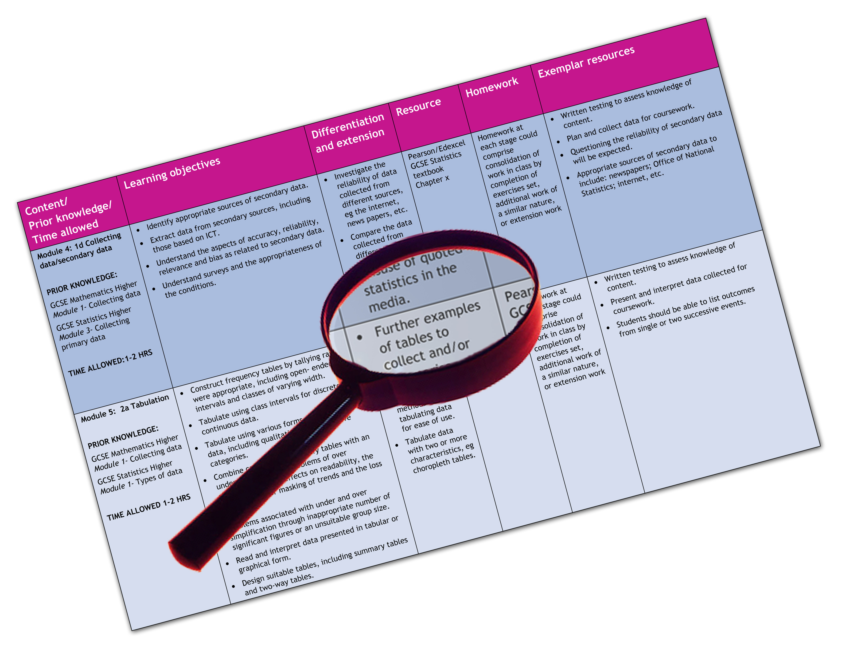


Edexcel GCE Religious Studies
We are happy to provide this scheme of work for you to amend and adapt to suit your teaching purposes.

We hope you find this useful.
Editable scheme of work

Detailed help on resources

Week by week content coverage

Exemplar activities

Learning outcome

Philosophy Foundations (AS Year 12)

Edexcel scheme of work for GCE Religious Studies 6RSO1 Foundations – Philosophy of Religion
- This scheme of work is devised on the assumption that approximately half the teaching time for Foundations is devoted to Philosophy of Religion, and half to the other chosen option for the Foundations paper. This SOW should therefore be read in conjunction with the SOW for the other Foundations option chosen – e.g. Ethics, New Testament, or one of the world religions. It is assumed therefore that teachers have two to three hours per week for the delivery of the Philosophy of Religion option.
- The SOW has also allowed for teaching of the Investigations paper, on the principle that it has been approached on an approximately 50/50 teacher input/student research basis. Because students/centres have a wide choice of investigations options available the SOW for this paper is generic only.
- In every case, the SOW can be adapted to your needs, including teaching time available. A 14 week autumn term, 12 week spring term, and up to 8 weeks teaching time in the summer term has been assumed. You can adapt the SOW to fit your school’s holiday and study leave arrangements. Two weeks for Christmas and two weeks for Easter holidays have been allowed. Half terms have not been included.
- Time is allowed for testing and consolidation of knowledge and understanding.
- Teachers may be surprised that the SOW suggests beginning teaching with miracles rather than arguments for the existence of God. This is suggested on the grounds that experience show students find this a more engaging and accessible introduction to the subject, but teachers are obviously free to change this as they wish.
- It is highly recommended that students make their own written notes, and that homework and timed essay practice form a central part of any scheme of work.
- At AS and A2 level activities must be based primarily around the central requirement of ensuring that students have a full and well founded knowledge of the topics on the specification and that they can produce appropriate essays under exam timed conditions. Teacher input in terms of subject information and guidance must take precedence over activities. When used, activities should serve only to reinforce students’ knowledge and understanding of the subject and their skills in manipulating that material to the demands of examination questions.

Week  Yr 12 | Content coverage/  key questions | Learning outcomes | Exemplar activities | Exemplar resources
1 | Introduction to the philosophy of religion: concepts, key terms, problems  Belief and Non belief in the God of Classical Theism: attributes and activities; reasons for belief and non-belief | To understand what the course will entail and to gain confidence making the move from GCSE to AS  To know and understand a range of key terms central to the subject.  To identify reasons why some people believe in God and others do not. | Mind mapping student responses to question about nature and work of God  Discussion and evaluation of reasons for belief and non belief.  Introduction by teacher to key scholarly contributions to existence of God and problems for belief in God. | A individual or department subscription to www.restuff.org may be valuable throughout the year. This ever growing bank of materials includes many resources to support teaching this unit, and which can be freely adapted to suit teachers’ needs.  Religious Studies Review, a thrice yearly magazine, published by Philip Allan Updates, provides a range of articles and examination specific advice, aimed at students. A centre subscription is recommended.  www.philipallanupdates.co.uk  Chapter 1.1 of the Edexcel AS Religious Studies student book (by Sarah K Tyler and Gordon Reid published by Pearson) covers this topic.  Topic 1B of Advanced Religious Studies (second edition) by Sarah K Tyler and Gordon Reid, published by Philip Allan Updates provides useful information.
2 | Miracles: What is a miracle? Where can we find accounts of miracles? | To know and understand a range of definitions of miracle  To identify a range of accounts of miracles and to be  able to categorise  them. | Discussion and evaluation of definitions of miracles – strong miracles, improbabilities, coincidences  Student Internet  research for modern accounts of miracles.  Teacher provides copies of biblical miracles for pairs or small groups to study and feedback to the class: type of miracle, circumstances, outcome. | Chapter 2.2 of the Edexcel AS Religious Studies student book covers this topic.  Topic 3B of Advanced Religious Studies provides useful information.
3 | Miracles: are there good reasons to believe that miracles occur? | To explain arguments in favour of the occurrence of miracles.  To understand why some people believe in the power of miracles today.  To explain why the miracles within a  religious tradition may be considered persuasive.  To assess the value of these reasons. | Discussion and evaluation of reasons for belief in miracles. Invite students to offer reasons in support of the occurrence of miracles.  In pairs, students write down what it would take to make them believe that a miracle had occurred. Feedback to class.  Teacher introduces key scholarly contributions to this debate. | Chapter 2.2 of the Edexcel AS Religious Studies student book covers this topic.  Topic 3B of Advanced Religious Studies provides useful information
4 | Miracles: reasons for scepticism | To outline and explain arguments against the occurrence of miracles  To understand why there are different views regarding the possibility of miracles. | Discussion and evaluation of reasons for skepticism regarding miracles  Viewing of Youtube clips and discussion of the issues they raise.  Students to discuss the strength of these arguments and to weigh them up against the arguments in favor of miracles. | http://www.youtube.com/watch?v=nx3urQnhpqU – example of video clip covering one of Benny Hinn’s Miracle Crusades. There are several which teachers can search to identify those most suitable for their class. They can be evaluated from a range of perspectives.  Chapter 2.2 of the Edexcel AS Religious Studies student book covers this topic.  Topic 3B of Advanced Religious Studies provides useful information
5 | Miracles: Why did David Hume reject accounts of miracles? | To know and understand the main reasons why David Hume challenged the probably of miracles occurring and the validity of testimony to miracles.  To offer critiques of Hume’s view and to understand why different positions can be taken with regard to his arguments. | Teacher led explanation of David Hume’s critique of miracles in Chapter 10 of An Enquiry Concerning Human Understanding.  Students create mind map or other diagrammatic summary of his main points.  Discussion and evaluation of Hume’s arguments. Teacher encourages students to suggest problems with his challenges. | Teachers may want to stretch more able students by giving them a copy of Hume’s article (An Enquiry Concerning Human Understanding, OUP, 2008(ed) or many other editions.  Chapter 2.2 of the Edexcel AS Religious Studies student book covers this topic.  Topic 3B of Advanced Religious Studies provides useful information
6 | Miracles: overview of the topic, revision and final conclusions | To understand the full range of material on miracles covered in the preceding five weeks.  To offer independent evaluation of the arguments raised. | Revisiting and extending investigations in to definition of miracles, reasons for belief and reasons for skepticism regarding miracles as discussion allows.  Revision test: short questions devised by teacher or by students  Practice timed essay using past paper question | Chapter 2.2 of the Edexcel AS Religious Studies student book covers this topic.  Topic 3B of Advanced Religious Studies provides useful information
7 | The problem of evil and suffering: what is evil and suffering?  Why is evil and suffering problematic for the religious believer? | To understand the concepts of evil and suffering and to be able to offer examples of different types of evil and suffering.  To explain why evil and suffering pose problems for the religious believer. | Teacher prepared PowerPoint showing examples of suffering worldwide. Ask students to explain what the suffering is which occurs, what problems it poses and how it may be explained.  Word association exercise.  Teacher led revision on attributes of God drawing students around to a consideration of why evil and suffering pose particular problems for religious belief and why they need to find a solution to that problem. | Chapter 2.1 of the Edexcel AS Religious Studies student book covers this topic.  Topic 3A of Advanced Religious Studies provides useful information  Teacher prepared PowerPoint – pictures of examples of events which cause suffering and/or which may be described as ‘evil’.  Word association exercise: teachers proposes a range of words associated with the topic – e.g. evil, pain, earthquake, murder, sin – and asks students to write a word or phrase they associated with that word. Discuss responses openly around the class.
8 | The problem of evil and suffering: solutions | To understand the particular nature of religious solutions to the problem of evil.  To explain one solution and offer a critical evaluation of it. | Teacher led revision of the nature of the problem for religious believers and why they need to find an acceptable solution.  Students invited to make suggestions as to how religious believers may solve the problem – e.g. a test of faith or endurance.  Teacher led presentation on a solution or theodicy of choice – e.g. Irenaean, Augustinian, Process, or other.  Students invited to offer evaluative responses which teacher and/or students record in note or diagrammatic form | Chapter 2.1 of the Edexcel AS Religious Studies student book covers this topic.  Topic 3A of Advanced Religious Studies provides useful information  If computer facilities are available in class, students may use Internet resources to research answers to the question ‘Why does God allow suffering?’  Biblical material may be useful – Genesis 1-3, 6-8, for example. Also examples of response of biblical characters to suffering, such as Job, Ezekiel, or Jesus. Healing miracles, for example, show that suffering is taken seriously and not denied by the biblical writers.
9 | The problem of evil and suffering: solutions | To understand the particular nature of religious solutions to the problem of evil.  To explain a further solution and offer a critical evaluation of it. | Review of solution offered and evaluated in previous lesson.  Teacher led presentation on a second solution.  Students consider the relative strengths and weaknesses of this solution compared to the first one offered. | Chapter 2.1 of the Edexcel AS Religious Studies student book covers this topic.  Topic 3A of Advanced Religious Studies provides useful information
10 | The problem of evil and suffering: solutions | To understand the particular nature of religious solutions to the problem of evil.  To understand why solutions to the problem may be inconclusive. | Review of material covered in this topic. Students may use mind mapping to summarise key areas.  Students to consider, in pairs or small groups, the successfulness of the solutions covered, and others which they may suggest or which may have been discussed.  Revision test: short questions devised by teacher or by students  Practice timed essay using past paper question | Chapter 2.1 of the Edexcel AS Religious Studies student book covers this topic.  Topic 3A of Advanced Religious Studies provides useful information.  http://www.youtube.com  Search ‘Why does God allow suffering?’ for a range of responses from different perspectives. Teacher can select a couple for discussion in class.
11 | Arguments for the existence of God: why does God’s existence need to be proved? | To understand the problems inherent in discussing the question of God’s existence or non-existence. | Some consideration of material from the first lesson – why people believe/do not believe in God – may be useful here.  Teacher led discussion of why it may be deemed necessary to prove God’s existence – e.g. lack of empirical evidence, religious ambiguity  Introduction to notions of proof and probability to enable students to address evaluative questions at this level. A PowerPoint presentation may be helpful here.  In pairs or small groups students to devise a simple proof for God’s existence. The teacher may lead with an example first. Feedback to the class. | Chapter 1.1 of the Edexcel AS Religious Studies student book covers this topic.  Topic 1C of Advanced Religious Studies provides useful information
12 | Arguments for the existence of God: the Cosmological Argument | To identify perennial questions about the origin and nature of the universe.  To describe and explain the Cosmological Argument for the existence of God. | Teacher led presentation of the Cosmological Argument. Consideration may be given of the perennial questions which underlie the argument.  Students invited to pose questions about the world which seem to justify an explanation.  Simple introduction to Aquinas and read through the first three of the Five Ways. Some careful explanation likely to be needed. | Chapter 1.3 of the Edexcel AS Religious Studies student book covers this topic.  Topic 2A of Advanced Religious Studies provides useful information  Use of primary source – Aquinas’ Five Ways – is useful here. Access it from  http://www.aquinasonline.com.
13 | Arguments for the existence of God: the Cosmological Argument | To describe and explain the Cosmological Argument for the existence of God.  To evaluate the strengths and weaknesses of the proof. | Review of argument as offered in previous lesson. A revision PowerPoint may be useful here.  Students invited to offer criticisms, both positive and negative of the proof.  Teacher led presentation of key supporters and opponents. | Chapter 1.3 of the Edexcel AS Religious Studies student book covers this topic.  Topic 2A of Advanced Religious Studies provides useful information
14 | Arguments for the existence of God: the Cosmological Argument | To assess the success of the Cosmological Argument as a proof for the existence of God and to draw conclusions as to its validity. | Students to assess whether the strengths (supporting claims) of the argument outweigh the weaknesses (opposing claims).  Revision test: short questions devised by teacher or by students  Practice timed essay using past paper question – this may be on the Cosmological Argument or one of the other topics covered this term. | Chapter 1.1 of the Edexcel AS Religious Studies student book covers this topic.  Topic 3B of Advanced Religious Studies provides useful information.  Topic 2A of Advanced Religious Studies provides useful information
15 | CHRISTMAS HOLIDAYS
16 | CHRISTMAS HOLIDAYS
17 | Arguments for the existence of God: the Design Argument | To describe and explain the Design Argument for the existence of God. | Discussion and explanation, as required, of ‘Why are we here?’ Students to particularly consider Dawkins’ claim that humans look at the world ‘through purpose coloured spectacles’ and that ‘purpose resides in us’.  Teacher led introduction to key ideas of the Design Argument in terms of the particular questions about the appearance and nature of the universe which it aims to answer.  The fifth of Aquinas’ Five Ways introduced by the teacher – explanation as necessary. Make links with the documentary. | Chapter 1.2 of the Edexcel AS Religious Studies student book covers this topic.  Topic 2B of Advanced Religious Studies provides useful information  Richard Dawkins’ Documentary ‘Why are we here?’ Available on YouTube in three instalments:  http://www.youtube.com/watch?v=gvQAlM8Mvew&feature=related  Use of primary source – Aquinas’ Five Ways – is useful here. Access it from  http://www.aquinasonline.com.
18 | Arguments for the existence of God: the Design Argument | To describe and explain the Design Argument for the existence of God.  To understand and assess strengths and weaknesses of aspects of this argument. | Review of last lesson’s work and refamiliarisation with the principles of Design.  Teacher led presentation of other forms of the argument: Paley’s analogical form, aesthetic argument  Students to consider strengths and weaknesses of the forms of the argument presented thus far. | Chapter 1.2 of the Edexcel AS Religious Studies student book covers this topic.  Topic 2B of Advanced Religious Studies provides useful information  Teacher prepared PowerPoint using visual images to illustrate order, regularity, beauty, purpose etc. Students to offer suggestions as to what element of design - if any – they may illustrate.
19 | Arguments for the existence of God: the Design Argument | To describe and explain the Design Argument for the existence of God.  To understand and assess strengths and weaknesses of aspects of this argument. | Review as necessary.  Teacher led presentation of other forms of the argument: probability; the anthropic principle; intelligent design.  Students to consider strengths and weaknesses of the forms of these forms of the argument | Chapter 1.2 of the Edexcel AS Religious Studies student book covers this topic.  Topic 2B of Advanced Religious Studies provides useful information
20 | Arguments for the existence of God: the Cosmological and Design Arguments. | To assess the overall strengths and weaknesses of the argument.  To evaluate the relative strength of both arguments, and to assess them against each other. | Review as necessary including revision of the Cosmological Argument.  Teacher guided discussion of the relative strengths and weaknesses of both theories. Students to establish which they find more persuasive.  Watch episode from Dawkins’ ‘The Genius of Charles Darwin.’ | Chapter 1.2 and 1.3 of the Edexcel AS Religious Studies student book covers this topic.  Topics 2A and 2B of Advanced Religious Studies provide useful information  http://www.amazon.co.uk/Richard-Dawkins-Collection-Charles-Enemies/dp/B0016OMFLQ/ref=sr_1_1?ie=UTF8&s=dvd&qid=1257283873&sr=1-1
21 | REVISION | To consolidate the work done on Philosophy of Religion | Revision exercises, mind maps, quizzes, practice questions, two timed essays, one on either miracles OR problem of evil, one on either Cosmological OR Design argument.
22 | INVESTIGATIONS PAPER – area of study and topic to be determined by the teacher/student. | To identifying areas of investigation and key questions raised by them.  To learn through research into topic of choice.  To describe and explain aspects of the chosen / allocated topic. | Teacher led discussion and identification of areas for investigation.  Teacher ensures that key areas are covered.  Student research on their chosen/allocated topic of investigation | Will be determined by the teacher/students’ choice of subject areas.
23 | INVESTIGATIONS PAPER – area of study and topic to be determined by the teacher/student. | To develop learning and increase knowledge base through research in to topic.  To identify target issues.  To shape a structure and direction for the material. | Teacher led discussion and assessment of the areas researched by student.  Shaping a direction for the material through clarification of common and key areas, questions posed and problems exposed. | Will be determined by the teacher/students’ choice of subject areas.
24 | INVESTIGATIONS PAPER – area of study and topic to be determined by the teacher/student. | To continue learning through research in to topic.  To focus on a narrower range of issues.  To formulate a written response based on researched and taught material. | Teacher led discussion and assessment of the areas researched by student.  Shaping a direction for the material through clarification of common and key areas, questions posed and problems exposed.  Essay plan templates introduced. | Will be determined by the teacher/students’ choice of subject areas.
25 | INVESTIGATIONS PAPER – area of study and topic to be determined by the teacher/student. | To coordinate researched material.  To recognise the scope of possible examination questions.  To plan material to meet a range of possible demands. | Teacher guidance on material to jettison and preserve.  Teacher led support in identifying common strands and recurring themes which may offer scope for a range of stimulus questions. | Will be determined by the teacher/students’ choice of subject areas.
26 | INVESTIGATIONS PAPER – area of study and topic to be determined by the teacher/student. | To organise material to accommodate a range of possible essay plans.  To understand how to apply researched and teacher guided material into an essay response. | Completion of a range of essay plan templates which enable students to target their material to specific questions.  Further research if necessary.  Further teacher input on common areas as necessary. | Will be determined by the teacher/students’ choice of subject areas.
27 | INVESTIGATIONS PAPER – area of study and topic to be determined by the teacher/student. | To understand how to identify the demands made by an essay question.  To write a full length essay based on one or more templates. | Each student, or pairs of students, to produce a full essay based on one or more templates. This may be written to exam conditions or as a more extended activity which may carry over into homework. | Will be determined by the teacher/students’ choice of subject areas.
28 | REVISION | To review and consolidate material as per student needs. | Revision exercises, mind maps, quizzes, practice questions, timed pieces as fits student needs.
29 | EASTER HOLIDAYS
30 | EASTER HOLIDAYS
31 | MOCK EXAM | Full practice in timed conditions of Foundations paper to establish students’ increasing confidence at writing to the task in timed conditions. | Use of lesson time, or other time provided by the centre to complete a full Foundations mock paper. | Edexcel website past paper resources, Sample Assessment Materials available in hard copy or on line.  Levels of assessment, mark schemes
32 | MOCK EXAM | Full practice in timed conditions of Investigations paper to establish students’ increasing confidence at writing to the task in timed conditions. | Use of lesson time, or other time provided by the centre to complete a full Investigations mock paper. | Edexcel website past paper resources, Sample Assessment Materials available in hard copy or on line.  Levels of assessment, mark schemes
33 | REVISION | To review and consolidate Foundations and Investigations material and to ensure that students can meet the demands of the examination format and timing. | Review of mock exam performance.  Teacher led guidance on how to improve responses and overall performance.
34 | REVISION | To review and consolidate Foundations and Investigations material and to ensure that students can meet the demands of the examination format and timing. | Revision exercises, mind maps, quizzes, practice questions, timed pieces as fits student/class needs. Another full mock paper may be set at any time.
35 | REVISION | To review and consolidate Foundations and Investigations material and to ensure that students can meet the demands of the examination format and timing. | Revision exercises, mind maps, quizzes, practice questions, timed pieces as fits student/class needs. Another full mock paper may be set at any time.
36 | REVISION | To review and consolidate Foundations and Investigations material and to ensure that students can meet the demands of the examination format and timing. | Revision exercises, mind maps, quizzes, practice questions, timed pieces as fits student/class needs. Another full mock paper may be set at any time.
37 | REVISION | To review and consolidate Foundations and Investigations material and to ensure that students can meet the demands of the examination format and timing. | Revision exercises, mind maps, quizzes, practice questions, timed pieces as fits student/class needs. Another full mock paper may be set at any time.
38 | REVISION | To review and consolidate Foundations and Investigations material and to ensure that students can meet the demands of the examination format and timing. | Revision exercises, mind maps, quizzes, practice questions, timed pieces as fits student/class needs. Another full mock paper may be set at any time.

