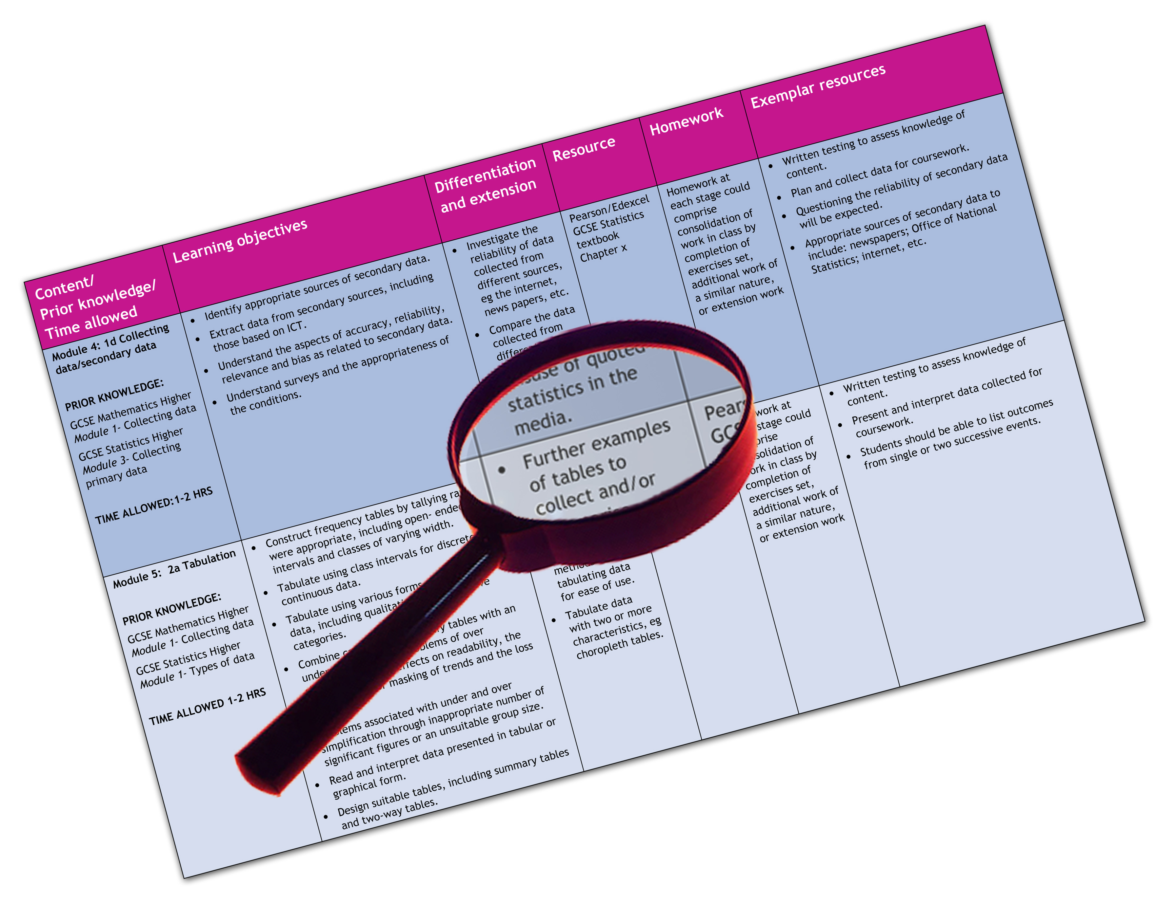


Edexcel GCE Religious Studies
We are happy to provide this scheme of work for you to amend and adapt to suit your teaching purposes.

We hope you find this useful.
Editable scheme of work

Detailed help on resources

Week by week content coverage

Exemplar activities

Learning outcome

Ethics Foundations (AS Year 12)

Edexcel scheme of work for GCE Religious Studies 6RSO1 Foundations – Ethics
- This scheme of work is devised on the assumption that approximately half the teaching time for Foundations is devoted to Ethics, and half to the other chosen option for the Foundations paper. This SOW should therefore be read in conjunction with the SOW for the other Foundations option chosen – e.g. Philosophy of Religion, New Testament, or one of the world religions. It is assumed therefore that teachers have two to three hours per week for the delivery of the Ethics option.
- The SOW has also allowed for teaching of the Investigations paper, on the principle that it has been approached on an approximately 50/50 teacher input/student research basis. Because students/centres have a wide choice of investigations options available the SOW for this paper is generic only.
- In every case, the SOW can be adapted to your needs, including teaching time available. A 14 week autumn term, 12 week spring term, and up to 8 weeks teaching time in the summer term has been assumed. You can adapt the SOW to fit your school’s holiday and study leave arrangements. Two weeks for Christmas and two weeks for Easter holidays have been allowed. Half terms have not been included.
- Time is allowed for testing and consolidation of knowledge and understanding.
- It is highly recommended that students make their own written notes, and that homework and timed essay practice form a central part of any scheme of work.
- At AS and A2 level activities must be based primarily around the central requirement of ensuring that students have a full and well founded knowledge of the topics on the specification and that they can produce appropriate essays under exam timed conditions. Teacher input in terms of subject information and guidance must take precedence over activities. When used, activities should serve only to reinforce students’ knowledge and understanding of the subject and their skills in manipulating that material to the demands of examination questions.

Week | Content coverage/  key questions | Learning outcomes | Exemplar activities | Exemplar resources
1 | Introduction to ethics: key concepts, ideas and problems. | To understand the focus of studies in ethics and the issues which will arise during the course.  To understand how and people use different approaches in ethical decision making. | Mind map brainstorming exercise on the meaning of terms ‘ethics’ and ‘morality’, ‘good’.  In pairs, small groups or as a class, students identify areas which have an interest for ethicists and suggest reasons why they are ‘moral issues.’  Teacher provides sheet of ethical dilemmas and in pairs students discuss possible resolutions and feedback to the class | A individual or department subscription to www.restuff.org may be valuable throughout the year. This ever growing bank of materials includes many resources to support teaching this unit, and which can be freely adapted to suit teachers’ needs.  Religious Studies Review, a thrice yearly magazine, published by Philip Allan Updates, provides a range of articles and examination specific advice, aimed at students. A centre subscription is recommended. www.philipallanupdates.co.uk.  An internet search for ‘ethical dilemmas’ will reveal several websites which offer a range of scenarios which students can consider.  Chapter 3.1 of the Edexcel AS Religious Studies student book (by Sarah K Tyler and Gordon Reid published by Pearsons) covers this topic.  Topic 1B of Advanced Religious Studies (second edition) by Sarah K Tyler and Gordon Reid, published by Philip Allan Updates provides useful information.
2 | The relationship between religion and morality | To understand the range of possible relationships between religion and morality.  To explain the reasons why morality may be dependent upon religion. | In pairs or small groups, students identify ways in which morality may derive from religion. The teacher may offer a starting point, such as the Ten Commandments.  Students feedback to the whole class who discuss the suggestions.  Teacher provides linking material to enable students to make a record of ways in which morality may be considered dependent on religion.  Students encouraged to begin to assess the implications of these connections. | Chapter 3.2 of the Edexcel AS Religious Studies student covers this topic.  Teacher prepared PowerPoint could be used to offer illustrations of religious morality  Topic 2 of Advanced Religious Studies provides useful information.
3 | The relationship between religion and morality | To understand the contributions of philosophers and scholars to the debate about the relationship between religion and morality.  To assess the strengths and weaknesses of these contributions. | Review of material covered in the last lesson.  Teacher led presentation of key scholars and issues in the debate – e.g. Divine Command Ethics, Aquinas, Kant.  Each of these positions divided amongst the students who in pairs or small groups produce a mind map or other diagrammatic summary of strengths and weaknesses.  Students feedback to the group and a shared record is produced.  Students watch selected clips from ‘The Most Hated Family in America’ and discuss the implications this has for the relationship between religion and morality. | Chapter 3.2 of the Edexcel AS Religious Studies student covers this topic.  Topic 2 of Advanced Religious Studies (second edition) by Sarah K Tyler and Gordon Reid, published by Philip Allan Updates provides useful information.  http://www.amazon.co.uk/Louis-Theroux-Strange-Dangerous-DVD/dp/B001ARYYQ8/ref=sr_1_2?ie=UTF8&s=dvd&qid=1257931226&sr=1-2  The episode ‘The most hated family in America’ offers a good foundation for critiquing the link between religion and morality.
4 | The relationship between religion and morality | To understand the view that morality is independent of religion.  To assess the strengths and weaknesses of this view. | Review of previous lesson’s work.  Teacher led presentation of the key ideas in the argument that morality is independent of religion.  Students given extracts from biblical narratives to assess – e.g. Genesis 22, Job 1, Judges 11, Luke 10. Feedback and discussion. | Chapter 3.2 of the Edexcel AS Religious Studies student covers this topic.  Topic 2 of Advanced Religious Studies (second edition) by Sarah K Tyler and Gordon Reid, published by Philip Allan Updates provides useful information.  Biblical extracts
5 | The relationship between religion and morality. | To explain and assess arguments for and against the dependence/independence of morality on religion.  To reach evaluative conclusions as to which position may be considered the stronger. | Review of previous work.  Students watch clips from ‘The Root of all Evil?’ and assess the argument offered by Dawkins.  In pairs students plan essay on topic and feedback to the class.  Short revision questions and/or write up essay to time. | Chapter 3.2 of the Edexcel AS Religious Studies student covers this topic.  Topic 2 of Advanced Religious Studies (second edition) by Sarah K Tyler and Gordon Reid, published by Philip Allan Updates provides useful information.  http://www.amazon.co.uk/Richard-Dawkins-Collection-Charles-Enemies/dp/B0016OMFLQ/ref=sr_1_1?ie=UTF8&s=dvd&qid=1257932814&sr=1-  Clips from ‘The Root of all Evil?’ can be used to illustrate Dawkins’ argument of the independence of morality from religion.
6 | Ethical theories: Utilitarianism | To understand the role of ethical theories in moral decision making.  To explain and understand the key ideas of Utilitarianism. | Teacher led explanation of the role of ethical theories. Students encouraged to think about how theories may help or hinder moral decision making.  Students recall key ideas of a religious based ethic from the previous topic.  Teacher explains the background to the emergence of Utilitarianism. Links made to other subjects and topics to help students to understand the issues.  Plenary to allow students to clarify and consolidate these new ideas. | Chapter 3.3 of the Edexcel AS Religious Studies student covers this topic.  Topic 1C of Advanced Religious Studies (second edition) by Sarah K Tyler and Gordon Reid, published by Philip Allan Updates provides useful information.  Teacher prepared PowerPoint illustrating the conditions of the historical era before and during the inception of Utilitarianism.
7 | Ethical theories: Utilitarianism | To explain and understand the key ideas of Utilitarianism.  To assess the effectiveness of Utilitarianism as a method of moral decision making. | Review and consolidation.  Teacher led presentation of Bentham’s Utilitarianism.  Students assess the theory, considering how it may be practically applied and problems which may arise from it.  Students study worksheet or other presentation of J S Mill’s adaptations of Utilitarianism and discuss how it may improve (or not) on Bentham’s approach. | Chapter 3.3 of the Edexcel AS Religious Studies student covers this topic.  Topic 1C of Advanced Religious Studies (second edition) by Sarah K Tyler and Gordon Reid, published by Philip Allan Updates provides useful information.  Teacher may give students sample moral dilemmas and invite them to assess how effectively Utilitarianism may address the issues posed by them.
8 | Ethical theories : Utilitarianism | To explain and understand the key ideas of Utilitarianism.  To assess the effectiveness of Utilitarianism as a method of moral decision making. | Review of previous material.  Teacher offers presentation on further approaches to Utilitarianism.  Students invited to make evaluative comparisons between versions of the theory.  In pairs, students plan an essay on this topic and feedback to the class. | Chapter 3.3 of the Edexcel AS Religious Studies student covers this topic.  Topic 1C of Advanced Religious Studies (second edition) by Sarah K Tyler and Gordon Reid, published by Philip Allan Updates provides useful information.
9 | Ethical theories: Utilitarianism/Situation Ethics | To assess the effectiveness of Utilitarianism as a method of moral decision making.  To understand the background to the emergence of Situation Ethics. | Revision timed essay – students may choose between the relationship between religion and morality or Utilitarianism.  In pairs, students research the background to Situation Ethics – moral, social, cultural changes in the mid- to late mid-twentieth century and feedback to the class.  Teacher facilitates discussion as to why the Church needed to address the demands of morality in the light of these changes. | Chapter 3.3 of the Edexcel AS Religious Studies student covers this topic.  Topic 1C of Advanced Religious Studies (second edition) by Sarah K Tyler and Gordon Reid, published by Philip Allan Updates provides useful information.
10 | Ethical theories: Situation Ethics | To examine and understand the key ideas of Situation Ethics.  To assess the usefulness of the theory as a method of moral decision making. | Teacher led presentation of the key ideas of Situation Ethics.  In pairs, students study episodes from Jesus’ ministry as examples of the theory in action. Feedback to the class.  Students study two or three of Fletcher’s real life examples and discuss them as a class.  Class assessment of the effectiveness of the theory so far | Chapter 3.4 of the Edexcel AS Religious Studies student covers this topic.  Topic 1C of Advanced Religious Studies (second edition) by Sarah K Tyler and Gordon Reid, published by Philip Allan Updates provides useful information.  Biblical extracts  http://socyberty.com/sociology/a-moral-dilemma-mrs-bergmeier/  An interesting site inviting feedback on the dilemma faced by Mrs Bergmeier.
11 | Ethical theories: Situation Ethics | To examine and understand the key ideas of Situation Ethics.  To assess the usefulness of the theory as a method of moral decision making. | Teacher presents further key ideas of Situation Ethics – e.g. J A T Robinson’s contribution in ‘Honest to God’.  Students complete a mind map or other diagrammatic summary of all key ideas, leaving room for evaluative comments to be added.  Teacher led presentation of key thinkers opposed to Situation Ethics – e.g. William Barclay, response from the Church at the time.  Students add evaluative comments to mind map or other diagram. | Chapter 3.4 of the Edexcel AS Religious Studies student covers this topic.  Topic 1C of Advanced Religious Studies (second edition) by Sarah K Tyler and Gordon Reid, published by Philip Allan Updates provides useful information.
12 | Ethical theories: Situation Ethics/Utilitarianism/Relationship between religion and morality. | To assess the usefulness of Situation Ethics as a method of moral decision making.  To compare Situation Ethics with Utilitarianism and make a parallel evaluation.  To assess how far Situation Ethics helps or hinders an understanding of the relationship between religion and morality. | Review of mind map.  In pairs or small groups, the teacher divides three tasks between students: (i) to compare and contrast Utilitarianism and Situation Ethics; (ii) To assess which theory offers a better method of moral decision making; (iii) to assess how far Situation Ethics helps an understanding of the relationship between religion and morality.  NB: These are not suggested as an indication of forthcoming examination questions but as critically evaluative exercises.  Feedback from each pair/ group. Teacher ensures all the class have access to all the material after the class.  Revision test questions or written timed essay. | Chapter 3.4 of the Edexcel AS Religious Studies student covers this topic.  Topic s 1C, 2, 3A, of Advanced Religious Studies (second edition) by Sarah K Tyler and Gordon Reid, published by Philip Allan Updates provide useful information.
13 | Selected problems in ethics: War and Peace | To understand the key ideas associated with war and pacifism. | Teacher presents PowerPoint and invites student feedback on what moral issues it raises about war.  Students offer a range of reasons why war needs to be justified – e.g., suffering inflicted, humanitarian and environmental issues.  Teacher led presentation on the principles of the Just War Theory. | Chapter 4.2 of the Edexcel AS Religious Studies student covers this topic.  Topic 4A of Advanced Religious Studies (second edition) by Sarah K Tyler and Gordon Reid, published by Philip Allan Updates provides useful information.  Teacher prepared PowerPoint depicting a range of issues associated with war
14 | Selected problems in ethics: War and Peace | To understand the key ideas associated with war and pacifism.  To assess the strengths and weaknesses of the Just War Theory | Review of principle of JWT and continuation of teaching as necessary.  In pairs or small groups, students invited to consider the principles and to assess their advantages and disadvantages.  Feedback to the class. Teacher ensures that all students have a written record of the discussion.  Teacher led presentation of key ideas associated with pacifism. Students research on history of pacifism and attitudes to it. | Chapter 4.2 of the Edexcel AS Religious Studies student covers this topic.  Topic 4A of Advanced Religious Studies (second edition) by Sarah K Tyler and Gordon Reid, published by Philip Allan Updates provides useful information.
15 | CHRISTMAS HOLIDAYS
16 | CHRISTMAS HOLIDAYS
17 | Selected problems in ethics: War and Peace | To understand the key ideas associated with war and pacifism.  To assess the strengths and weaknesses of a pacifist position and its relationship to ideas of Just War.  To assess how far ideas of just war and pacifism are associated with religious beliefs. | Review of work on this topic so far.  In pairs or small groups, students consider the strengths and weaknesses of a pacifist position. Feedback to whole class.  Teacher led presentation of religious ideas and implications of pacifism.  As a class or in pairs/small groups students consider (i) how far Just War and pacifism are compatible; (ii) how far both ideas are influenced by religious beliefs.  NB: These are not suggested as an indication of forthcoming examination questions but as critically evaluative exercises.  Feedback to whole class/revision timed essay. | Chapter 4.2 of the Edexcel AS Religious Studies student covers this topic.  Topic 4A of Advanced Religious Studies (second edition) by Sarah K Tyler and Gordon Reid, published by Philip Allan Updates provides useful information.
18 | Selected problems in ethics: Sexual ethics | To understand a range of appropriate issues in sexual ethics.  To understand the moral and religious questions raised by these issues. | Teacher led presentation on the nature of sexual ethics and particular concerns associated with it. Students encouraged to offer feedback and discussion.  Students research a key area in sexual ethics – e.g. homosexuality, pre- or extra-marital sexual relationships, pornography or contraception.  Feedback to the class.  Teacher identifies key issues for religion deriving from these areas. | Chapter 4.12 of the Edexcel AS Religious Studies student covers this topic.  Topics 3C and D of Advanced Religious Studies (second edition) by Sarah K Tyler and Gordon Reid, published by Philip Allan Updates provide useful information.
19 | Selected problems in ethics: Sexual ethics | To understand a range of appropriate issues in sexual ethics.  To understand the moral and religious questions raised by these issues. | In pairs or small groups students produce clear summaries of at least one dilemma in sexual ethics. (Avoid overly specific case studies)  Teacher leads students in applying religious principles to these dilemmas.  Students discuss non-religious issues arising from them and secular ways of resolving these dilemmas, if they still exist in a non-religious context. | Chapter 4.1 of the Edexcel AS Religious Studies student covers this topic.  Topics 3C and D of Advanced Religious Studies (second edition) by Sarah K Tyler and Gordon Reid, published by Philip Allan Updates provide useful information.
20 | Selected problems in ethics: Sexual ethics | To understand a range of appropriate issues in sexual ethics.  To understand the moral and religious questions raised by these issues.  To evaluate how effectively these dilemmas are resolved using a range of approaches. | In pairs or small groups, students are given a range of evaluation questions to consider, e.g: (i) to what extent are religious approaches to sexual ethics outdated? (ii) How far should matters of sexual ethics be left to personal choice? (iii) Why do matters of sexual ethics raise questions about freedom?  NB: These are not suggested as an indication of forthcoming examination questions but as critically evaluative exercises.  Students consider how far ethical theories may help resolve these problems.  Revision test/essay. | Chapter 4.1 of the Edexcel AS Religious Studies student covers this topic.  Topics 3C and D of Advanced Religious Studies (second edition) by Sarah K Tyler and Gordon Reid, published by Philip Allan Updates provide useful information.
21 | REVISION
22 | INVESTIGATIONS PAPER – area of study and topic to be determined by the teacher/student. | To identifying areas of investigation and key questions raised by them.  To learn through research into topic of choice.  To describe and explain aspects of the chosen/allocated topic. | Teacher led discussion and identification of areas for investigation. Teacher ensures that key areas are covered.  Student research on their chosen/allocated topic of investigation | Will be determined by the teacher/students’ choice of subject areas.
23 | INVESTIGATIONS PAPER – area of study and topic to be determined by the teacher/student. | To develop learning and increase knowledge base through research in to topic.  To identify target issues.  To shape a structure and direction for the material. | Teacher led discussion and assessment of the areas researched by student.  Shaping a direction for the material through clarification of common and key areas, questions posed and problems exposed. | Will be determined by the teacher/students’ choice of subject areas.
24 | INVESTIGATIONS PAPER – area of study and topic to be determined by the teacher/student. | To continue learning through research in to topic.  To focus on a narrower range of issues.  To formulate a written response based on researched and taught material. | Teacher led discussion and assessment of the areas researched by student.  Shaping a direction for the material through clarification of common and key areas, questions posed and problems exposed.  Essay plan templates introduced. | Will be determined by the teacher/students’ choice of subject areas.
25 | INVESTIGATIONS PAPER – area of study and topic to be determined by the teacher/student. | To coordinate researched material.  To recognise the scope of possible examination questions.  To plan material to meet a range of possible demands. | Teacher guidance on material to jettison and preserve.  Teacher led support in identifying common strands and recurring themes which may offer scope for a range of stimulus questions. | Will be determined by the teacher/students’ choice of subject areas.
26 | INVESTIGATIONS PAPER – area of study and topic to be determined by the teacher/student. | To organise material to accommodate a range of possible essay plans.  To understand how to apply researched and teacher guided material into an essay response. | Completion of a range of essay plan templates which enable students to target their material to specific questions.  Further research if necessary.  Further teacher input on common areas as necessary. | Will be determined by the teacher/students’ choice of subject areas.
27 | INVESTIGATIONS PAPER – area of study and topic to be determined by the teacher/student. | To understand how to identify the demands made by an essay question.  To write a full length essay based on one or more templates. | Each student, or pairs of students, to produce a full essay based on one or more templates. This may be written to exam conditions or as a more extended activity which may carry over into homework. | Will be determined by the teacher/students’ choice of subject areas.
28 | REVISION | To review and consolidate Foundations material | Revision exercises, mind maps, quizzes, practice questions, timed pieces as fits student needs.
29 | EASTER HOLIDAYS
30 | EASTER HOLIDAYS
31 | MOCK EXAM | Full practice in timed conditions of Foundations paper to establish students’ increasing confidence at writing to the task in timed conditions. | Use of lesson time, or other time provided by the centre to complete a full Foundations mock paper. | Edexcel website past paper resources, Sample Assessment Materials available in hard copy or on line.  Levels of assessment, mark schemes
32 | MOCK EXAM | Full practice in timed conditions of Investigations paper to establish students’ increasing confidence at writing to the task in timed conditions. | Use of lesson time, or other time provided by the centre to complete a full Investigations mock paper. | Edexcel website past paper resources, Sample Assessment Materials available in hard copy or on line.  Levels of assessment, mark schemes
33 | REVISION | To review and consolidate Foundations and Investigations material and to ensure that students can meet the demands of the examination format and timing. | Review of mock exam performance.  Teacher led guidance on how to improve responses and overall performance.
34 | REVISION | To review and consolidate Foundations and Investigations material and to ensure that students can meet the demands of the examination format and timing. | Revision exercises, mind maps, quizzes, practice questions, timed pieces as fits student/class needs. Another full mock paper may be set at any time.
35 | REVISION | To review and consolidate Foundations and Investigations material and to ensure that students can meet the demands of the examination format and timing. | Revision exercises, mind maps, quizzes, practice questions, timed pieces as fits student/class needs. Another full mock paper may be set at any time.
36 | REVISION | To review and consolidate Foundations and Investigations material and to ensure that students can meet the demands of the examination format and timing. | Revision exercises, mind maps, quizzes, practice questions, timed pieces as fits student/class needs. Another full mock paper may be set at any time.
37 | REVISION | To review and consolidate Foundations and Investigations material and to ensure that students can meet the demands of the examination format and timing. | Revision exercises, mind maps, quizzes, practice questions, timed pieces as fits student/class needs. Another full mock paper may be set at any time.
38 | REVISION | To review and consolidate Foundations and Investigations material and to ensure that students can meet the demands of the examination format and timing. | Revision exercises, mind maps, quizzes, practice questions, timed pieces as fits student/class needs. Another full mock paper may be set at any time.

