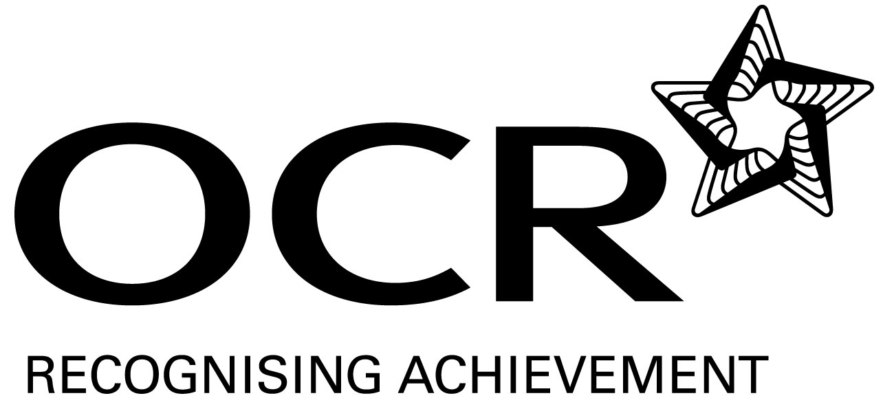
Support Material
GCE Modern Foreign Languages
OCR Advanced GCE in Portuguese: H596
Unit: F888

This Support Material booklet is designed to accompany the OCR Advanced GCE specification in Portuguese for teaching from September 2008.

Contents
Contents 2
Introduction 3
Portuguese H596: Listening, Reading and Writing 2: F888 5
Sample Lesson Plan: Portuguese H596 Listening, Reading and Writing 2: F888 10
Other forms of Support 12

Introduction

Background
A new structure of assessment for A Level has been introduced, for first teaching from September 2008. Some of the changes include:
- The introduction of stretch and challenge (including the new A* grade at A2) – to ensure that every young person has the opportunity to reach their full potential
- The reduction or removal of coursework components for many qualifications – to lessen the volume of marking for teachers
- A reduction in the number of units for many qualifications – to lessen the amount of assessment for learners
- Amendments to the content of specifications – to ensure that content is up-to-date and relevant.
OCR has produced an overview document, which summarises the changes to Portuguese. This can be found at www.ocr.org.uk, along with the new specification.
In order to help you plan effectively for the implementation of the new specification we have produced this Scheme of Work and Sample Lesson Plans for Portuguese. These Support Materials are designed for guidance only and play a secondary role to the Specification.

Our Ethos
All our Support Materials were produced ‘by teachers for teachers’ in order to capture real life current teaching practices and they are based around OCR’s revised specifications. The aim is for the support materials to inspire teachers and facilitate different ideas and teaching practices.

Each Scheme of Work and set of sample Lesson Plans is provided in:

- PDF format – for immediate use

- Word format – so that you can use it as a foundation to build upon and amend the content to suit your teaching style and students’ needs.

The Scheme of Work and sample Lesson plans provide examples of how to teach this unit and the teaching hours are suggestions only. Some or all of it may be applicable to your teaching.

The Specification is the document on which assessment is based and specifies what content and skills need to be covered in delivering the course. At all times, therefore, this Support Material booklet should be read in conjunction with the Specification. If clarification on a particular point is sought then that clarification should be found in the Specification itself.

A Guided Tour through the Scheme of Work


= Innovative Teaching Idea
All the teaching ideas contained in the SOW are innovative, but the icon is used to
Highlight exceptionally innovative ideas.

= Stretch & Challenge Activity
This icon is added at the end of text when there is an explicit opportunity to offer
Stretch and Challenge.

= ICT Opportunity
This icon is used to illustrate when an activity could be taught using ICT facilities.

Portuguese H596: Listening, Reading and Writing 2: F888
Suggested teaching time | 8 hours | Topic | The Environment: the individual and the environment
Skills | Suggested teaching and homework activities | Suggested resources | Points to note
Listening  = Innovative teaching idea  = Stretch and challenge opportunity idea  = ICT opportunity | - Extract 1 on eg the recycling of school textbooks in Portugal: students listen for gist comprehension.  - Extract 2 on eg the expansion of public transport in Macau: students answer questions on text in English and gap-fill a written version of the text.  - Extract 3 on eg raising public awareness of river pollution in São Paulo, Brazil: students answer questions on text in Portuguese. | - At the time of writing the suggested extracts could all be found on the internet as audio files with accompanying video footage (which could be used at the teacher’s discretion to aid comprehension and add variety): the first from the RTP website, the second from Radio Macau and the third from BBC Brasil.  - There is a wealth of such material to be found on the internet and on radio and television. Alternatively, printed texts could be adapted and recorded by the teacher.  - A growing range of textbooks include texts and recorded extracts on this topic: suitable material may be found in Português sem fronteiras 2 and Português ao vivo 2, for example.  - Past exam papers may also provide suitable materials. | - These listening activities would be spread across the eight hours, and would serve as springboards for other activities, eg the recycling text leads naturally on to a class discussion on students’ own efforts to recycle and reduce waste.  - Students could use the public transport extract to prepare and record their own radio/TV report on public transport initiatives in their local area.  - More able students could be encouraged to find other short clips and reports from a list of suitable websites provided by the teacher. Summarising in written English or spoken Portuguese.
Speaking  = Innovative teaching idea  = Stretch and challenge opportunity idea  = ICT opportunity | - A range of short texts on the individual’s relationship with the environment (eg on littering, excessive or conspicuous consumption in the West, recycling initiatives), in both Portuguese and English, to serve as the basis for oral comprehension and discussion.  - The ‘Fortunately/Unfortunately’ game to get class thinking and speaking about the pros and cons associated with the topic (eg student1: ‘Felizmente há muitas latas de lixo neste colégio.’ student 2: ‘Infelizmente ninguém as usa.’…and so on.  - ‘Just a minute’ game where each student talks for a minute on an aspect of the topic.  - Class debate on public versus private transport. | - As with the listening section above, the internet is a rich source of texts and statistics; newspapers and magazines in both Portuguese and English routinely carry items of various lengths on this topic. | - The ‘Just a minute’ session could be used first as preparation homework, and then done spontaneously later in the topic as students gain confidence.
Reading  = Innovative teaching idea  = Stretch and challenge opportunity idea  = ICT opportunity | - Text 1 on eg the impact of environmental change on communities across Europe (flooding in England, forest fires in Portugal and the Balkans…): students answer true/false and English-language questions.  - Text 2 on eg environmental issues in Angola (favelas, mining, oil) and their impact on communities: students answer questions in Portuguese.  - Text 3 on eg illegal logging in Brazil and its consequences for indigenous peoples: students complete a gap-fill exercise and answer questions in Portuguese.  - Text 4: an extract (or range of extracts) from an appropriate work of literature (eg Ramos,Vidas Secas or Amado, Capitães da Areia) exploring the ways in which the environment affects individuals and communities in different areas of Brazil: independent or class reading. | - For texts 1-3, appropriate materials can be found in textbooks, newspapers and magazines, as well as websites such as visão.pt, vejaonline, globo.com, nova escola online – o site para quem educa and bbcbrasil.com and bbcparaafrica.com.  - The choice of literary texts is vast and at the teacher’s discretion. | - All four reading texts could be used as a basis for written homeworks.  - This activity allows the teacher to incorporate literature into the new specification. More able students could read one whole novel or a wider range of extended extracts.
Writing  = Innovative teaching idea  = Stretch and challenge opportunity idea  = ICT opportunity | - Students read a range of texts similar to those suggested above for Listening, Speaking and Reading, and answer comprehension questions in Portuguese.  - Students write a range of short essay responses (150-200 words) on issues arising from the texts studied (eg environmental concerns in the home, community recycling, noise pollution).  - Students translate appropriate texts from Portuguese to English and from English to Portuguese.  - Exam essay preparation: students write a 250-400 word essay on one or more of the issues covered in this topic.  - More able students write a critical analysis of the themes and ideas found in the novel or literary texts studied for this topic. | - As before, texts may be found in past papers, in textbooks, newspapers and magazines and online.  - These mini-essays should start first with students’ own interests and experiences (‘the individual and the environment’) before branching out into the wider issues of the topic.  - Some websites carry both Portuguese and English versions of news items and texts, which may help the teacher in selecting material for translation work. | - Essay and translation work could usefully be preceded by some grammar work on conditional sentences and uses of the subjunctive (in sentences such as If we recycled our household waste the environment would benefit…/ Unless we cut down on carbon emissions the planet will continue to suffer…).
Consolidation | - This topic is rich in important vocabulary, idioms and expressions: students should be tested regularly on these.  - Students should be encouraged to listen and read independently, especially as this is a ‘live’ topic and is constantly in the news. They could then from time to time report back to the rest of the class on what they have recently heard or read.  - Students should compile their own vocabulary and expressions lists to supplement those provided by the teacher or compiled in class.  - Appropriate sections of past papers should be attempted at the end of the topic and again in the run-up to the exam. | - The teacher should encourage students to make careful vocabulary notes in class. Ideally, a crib sheet of vocabulary and expressions should accompany each test studied. | - A quick vocabulary test can serve as a useful starter exercise.  - The teacher could assign a different website to each student to research periodically.
= Innovative teaching idea
= Stretch and challenge opportunity idea
= ICT opportunity
= Innovative teaching idea
= Stretch and challenge opportunity idea
= ICT opportunity

Sample Lesson Plan: Portuguese H596 Listening, Reading and Writing 2: F888

Listening for gist; discussing recycling and other contributions the individual can make to improve the environment
OCR recognises that the teaching of this qualification will vary greatly from school to school and from teacher to teacher. With that in mind, this lesson plan is offered as a possible approach but will be subject to modifications by the individual teacher.
Lesson length is assumed to be one hour.

Learning objectives for the lesson
Objective 1 | Students should learn, recognise and begin to use vocabulary and expressions related to the topic ‘The individual and the environment’.
Objective 2 | Students should be able to express opinions and debate/discuss some environmental issues.
Objective 3 | Students should be able to listen to a text for gist comprehension.
Objective 4 | Students should be able to complete a gap-filling exercise using topic-related vocabulary.
Objective 5 | Students should be able to write a short essay recounting their own experiences of recycling and/or other contributions they make to environmental improvement.

Recap of previous experience and prior knowledge
- This lesson plan is intended to serve as an introduction to the topic; it is assumed students will already be able to express opinions in Portuguese.

Content
Time | Content
5 minutes | Starter/warm-up exercise: students take turns to express an opinion on any subject of their choice, each student having to use a different opinion expression (eg Acho que…/Segundo meu irmão…/É óbvio que…).
5 minutes | Students are asked to call out any ‘environment’ words they already know in Portuguese (eg the obvious meio ambiente, reciclagem, lixo, poluição…); these should be noted and supplemented by a list prepared by the teacher to accompany the listening text.
10 minutes | Students listen to/watch two or three times the extract on schoolbook recycling in Portugal (from the Minuto verde TV slot on RTP, originally broadcast on the internet, 03/08/07) and make notes to give a gist summary of the text. (Differentiation note: less able students may prefer to do this in English).
5 minutes | Students discuss their answers and one of them writes a class résumé on the board.
5 minutes | Students listen to the text a final time and complete a gap-fill transcript or similar text.
10-15 minutes | Students express in Portuguese their opinions on the subject-matter of the listening text and are then encouraged to open out the discussion to include their own efforts and experiences in recycling and related matters. (Differentiation note: the teacher may want to prompt the discussion with a crib-sheet of appropriate vocabulary).

Consolidation
Time | Content
10 minutes | Teacher-led review of list of prepared sentences relating to the topic and designed to stretch students grammatically (eg the future subjunctive may be introduced/consolidated in sentences such as Se reciclarmos mais, não esbanjaremos tantos recursos naturais…).
5 minutes | Homework task; students to use today’s notes and vocabulary to write a 100-word mini-essay on their approach to recycling at home and in school.

Other forms of Support
In order to help you implement these new specification effectively, OCR offers a comprehensive package of support. This includes:

OCR Training

Get Ready…introducing the new specifications
A series of FREE half-day training events are being run during Autumn 2007, to give you an overview of the new specifications.

Get Started…towards successful delivery of the new specifications
These full-day events will run from Spring 2008 and will look at the new specifications in more depth, with emphasis on first delivery.
Visit www.ocr.org.uk for more details.

Mill Wharf Training
Additional events are also available through our partner, Mill Wharf Training. It offers a range of courses on innovative teaching practice and whole-school issues - www.mill-wharf-training.co.uk.

e-Communities
Over 70 e-Communities offer you a fast, dynamic communication channel to make contact with other subject specialists. Our online mailing list covers a wide range of subjects and enables you to share knowledge and views via email.
Visit https://community.ocr.org.uk, choose your community and join the discussion!

Interchange
OCR Interchange has been developed to help you to carry out day to day administration functions online, quickly and easily. The site allows you to register and enter candidates online. In addition, you can gain immediate a free access to candidate information at you convenience. Sign up at https://interchange.ocr.org.uk

Published Resources
Published Resources
OCR offers centres a wealth of quality published support with a fantastic choice of ‘Official Publisher Partner’ and ‘Approved Publication’ resources, all endorsed by OCR for use with OCR specifications.

Publisher partners
OCR works in close collaboration with three Publisher Partners; Hodder, Heinemann and Oxford University Press (OUP) to ensure centres have access to:

- Better published support, available when you need it, tailored to OCR specifications
- Quality resources produced in consultation with OCR subject teams, which are linked to OCR’s teacher support materials
- More resources for specifications with lower candidate entries
- Materials that are subject to a thorough quality assurance process to achieve endorsement

Oxford University Press (OUP) is the publisher partner for OCR GCE Modern Foreign Languages

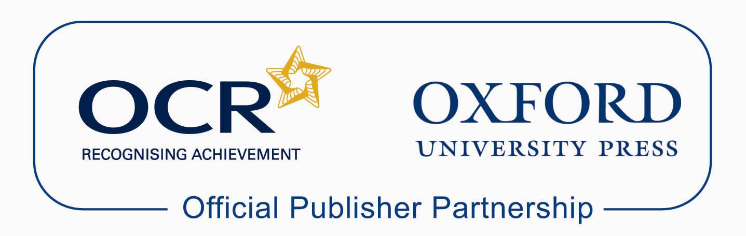

Approved publications
OCR still endorses other publisher materials, which undergo a thorough quality assurance process to achieve endorsement. By offering a choice of endorsed materials, centres can be assured of quality support for all OCR qualifications.

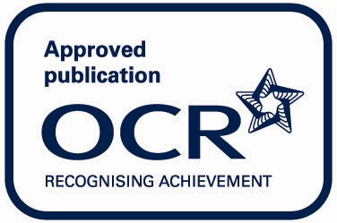

Endorsement
OCR endorses a range of publisher materials to provide quality support for centres delivering its qualifications. You can be confident that materials branded with OCR’s “Official Publishing Partner” or “Approved publication” logos have undergone a thorough quality assurance process to achieve endorsement. All responsibility for the content of the publisher’s materials rests with the publisher.

These endorsements do not mean that the materials are the only suitable resources available or necessary to achieve an OCR qualification. Any resource lists which are produced by OCR shall include a range of appropriate texts.

