

Dulwich College
Physics Department

Guide
to
“AS” Level Physics
Practical Examinations

(For OCR Physics “A” syllabus)

This guide is for AS practical examination skills.

Measurement and observation.

The number of observations to be made (usually six) is almost always indicated on the question paper. Six readings are required for a linear trend and nine (or more) for a curved trend. All reading made must be plotted on the subsequent graph.

The range over which the readings are to be taken is almost always specified in the question paper. It is expected that you will use sensible intervals between each reading in this range. The range is usually given in such a way so that you should not find it difficult to decide what values to choose. For example, if a quantity d was to be measured, the question may instruct you in the following way '... for values of d in the range 15 cm < d < 75 cm measure the time for ... until you have six sets of readings for d and t ...', in which case a sensible interval would be 10 cm.

d/cm | t/s
20.0
30.0
40.0
50.0
60.0
70.0
Acceptable (intervals are fine)

d/cm | t/s
20.0
22.0
26.0
44.0
68.0
70.0

Not acceptable (first three readings and last two readings are too close together)

Repeated Readings.

It is expected that you will repeat readings and calculate an average. All raw readings should be recorded but it is only necessary to repeat readings so that two sets of values are obtained. Make sure that you do the experiment carefully.

Significant figures.

You will often be asked to explain why you have given a calculated quantity to a specific number of significant figures. In your explanation it is expected that the number of significant figures in the final calculated quantity will be related to the number of significant figures in the raw data which has been used in the calculation. As a rule of thumb, use the same number of significant figures as in your data, or fewer.

Common errors include:

(a) Vague statements such as 'it increases the accuracy of the experiment'.

(b) 'I am going to plot a graph, so I will give my answers to 2 sig. figs.'

(c) Confusion between significant figures and decimal places (e.g. 'I have given x to two decimal places so x3 should be given to two decimal places').

Consider pairs of values such as those shown in the table below;

x | x3
6.52 | 277.17
6.53 | 278.45
6.54 | 279.73

Too many sf in the values of x3 (5 sf values from 3 sf data)

Clearly both sets of values for x and x3 are given to two decimal places. However, values of x3 are given to five significant figures, which is not justified from the accuracy of the values of x. Changing the third significant figure in the value for x (2, 3 or 4) changes the third significant figure in the value of x3 (7, 8 and 9). Hence the values for x3 should only be quoted to three significant figures (to be consistent with the values of x from which they were derived).

x | x3
6.52 | 277
6.53 | 278
6.54 | 280

sf in values of x3 are correct (3 sf values from 3 sf data)

Similar difficulties apply when large numbers are involved. Consider the case of a voltmeter having a resistance of 50 000 Ω. It is unclear as to whether this value is correct to one, two, three, four or five significant figures. In this case you should use scientific notation or multiplying prefixes to indicate how many significant figures are intended to be shown.

i.e. R = 50 000 Ω (could be 1, 2, 3, 4 or 5 sf)
R = 5 x 104 Ω (1 sf)
R = 5.0 x 104 Ω (2 sf, 1 dp)
R = 5.00 x 104 Ω (3 sf, 2 dp)
R = 50 kΩ (2 sf)
R = 50.0 kΩ (3 sf, 1 dp)

Estimation of uncertainty and percentage uncertainty.

In some papers you will be asked to calculate a simple percentage uncertainty or state the uncertainty in a measurement. When repeated readings have been done then it is expected that the uncertainty will be half the range. Use the expression:

Percentage uncertainty = uncertainty/average value x 100

If single readings have been taken then the uncertainty should be half of the smallest interval on the measuring instrument (assuming no zero error).

This table suggests the accuracy of some typical laboratory instruments.

Instrument | Typical Uncertainty | Typical quoted value
Metre Rule | ± 1mm | 27.4 ± 0.1cm
Vernier Calipers | ± 0.1mm | 57.1 ± 0.1mm
Micrometer screw gauge | ± 0.01mm | 0.27 ± 0.01mm
Wall clock | ± 1 second | 43 ± 1s
Stop clock* | ± 0.1s (but can be up to 0.4s) | 30.4 ± 0.1 s
Electric balance (2 d.p.) | ± 0.01g | 126.67 ± 0.01 g
Lab thermometer | ± 1ºC | 42.5 ± 0.05 ºC

*Note that for the stop clock, the uncertainty (0.1s) is much greater than the apparent precision (0.01s) of the instrument might imply. This is because the reaction time of the person using the stop clock becomes significant in this case, so a time will be recorded to the nearest 0.1s only.

Combining Errors

Most physical quantities that you need to derive in the practical examination will be either products or quotients, e.g $v=fλ$ or $R=\frac{V}{I}$. In both these cases to calculate the percentage error in the derived quantity, you should add the percentage error in the measured quantities.

For example: -
% error in v = % error in f + % error in λ
and
% error in R = % error in V + % error in I

In the unlikely event that the calculated quantity is either a sum or difference, you should add the absolute errors in the measured quantity to find the absolute error in the derived quantity

If f = a + b then the absolute error in f (represented by Δf) is calculated as $Δf=Δa+Δb$.

If g = c – d then the absolute error in g (represented by Δg) is calculated as $Δg=Δc+Δd$.
Presentation of results.

Presentation of results is dealt with in three main areas; column headings, consistency of raw readings and significant figures in calculated quantities. Procedures for dealing with these are as follows:

1. Column headings.

It is expected that all column headings will consist of a quantity and a unit.

The quantity may be represented by a symbol or written in words. There must be some kind of distinguishing notation between the quantity and the unit.

For example, a length l measured in centimetres may be represented as follows:

l/cm (this is the best way to do it!), l (cm), l in cm, and are all acceptable as column headings.

If the distinguishing notation between a quantity and its unit are not clear then credit will not be given. Examples of this are show below:

l cm, lcm, or just 'cm' are not acceptable.

2. Consistency of presentation of raw data.

All the raw readings of a particular quantity should be recorded to the same number of decimal places. These should be consistent with the apparatus used to make the measurement. In the example shown below a rule with a millimetre scale has been used to make a measurement of length. We may expect all the readings of length therefore to be given to the nearest millimetre, even if a value is a whole number of centimetres.

l/cm | t/s
2
3.7
4.9
5.9
6.3

Not acceptable, since the first reading is to the nearest cm and all the others are to the nearest mm.

l/cm | t/s
2.0
3.7
4.9
5.9
6.3

Acceptable, since all the raw readings have been given to the same degree of precision.

NEVER add extra zeros to the readings. This makes the readings inconsistent with the apparatus used in measuring that particular quantity. In the case of a thermometer which can measure to a precision of about half a degree it is unreasonable to give temperatures which indicate that a precision of one hundredth of a degree have been achieved.
θ/OC | t/s
22.00
35.50
47.00
58.50
77.00
89.50

Not acceptable - too many dp in the values of θ - not achievable with a mercury-in-glass thermometer.

However, you must record all readings to the maximum accuracy of the measuring instrument.

3. Significant figures in calculated quantities.

Calculated quantities should be given to the same number of significant figures as the measured quantity of least accuracy. Consider the table of readings below:

V/V | I/A | R/Ω
3.0 | 1.43 | 2.1
4.0 | 1.57 | 2.5
5.0 | 1.99 | 2.5
6.0 | 2.45 | 2.4
7.0 | 3.02 | 2.3

If values of V and I are measured to two and three significant figures respectively, we would expect R to be given to two significant figures. This is because a value of
V = 3.1 V in the first row of figures would give R = 2.2 Ω (i.e. changing the second significant figure in the value of V will change the second significant figure in the value of R).

Three significant figures would be acceptable for R, but not one (2 Ω) or four
(2.098 Ω).

The exception to this rule is when you use stopwatches reading to 0.01 s. You cannot measure to this accuracy. Therefore it would be acceptable for you to round down to the nearest tenth of a second and give values of a calculated quantity (e.g. period) to three significant figures.

20T/s | T/s
10.49 | 0.525
14.31 | 0.716
17.69 | 0.885
24.88 | 1.24
29.61 | 1.48
33.02 | 1.65

Acceptable. Note that some values of T are to three dp and others are to two dp, but all the values of T are to 3 sf.

Graphical work.

Credit for graphical work usually falls into five categories:

• Choice of scale

• Plotting of points

• Line of best fit

• Calculation of gradient

• Determination of the y-intercept

1. Choice of scales.

a. Scales should be chosen so that the plotted points occupy at least half the graph grid in both the x and y directions.

Not acceptable (scale in the y-direction is compressed)

Acceptable (points fill more than half the graph grid in both the x and y directions).

b. It is expected that each axis will be labelled with the quantity, which is being plotted.

c. The scale direction must be conventional (i.e. increasing from left to right).

Not acceptable (unconventional scale direction).

Acceptable (conventional scale direction)

This problem often occurs when scales are used with negative numbers.

d. Choose scales that are easy to work with to make everyone’s life easy.

Acceptable scale divisions.

Not acceptable. Awkward scale on the x-axis.
Other examples are 6:10, 7:10 and 8.319:10 !!)

e. Scales should be labelled reasonably frequently (i.e. there should not be more than three large squares between each scale label on either axis).

Not acceptable (too many large squares with no label)

Acceptable (scales have regular labels)

f. There should be no 'holes' in the scale.

Acceptable. Scale labelling is regular

Not acceptable (non-linear scale on the x-axis).

2. Plotting of points.

a. Plots in the margin area are not allowed under any circumstances.

Not acceptable (last point has been plotted in the margin area).

Acceptable (all plotted points are on the graph grid)

b. It is expected that all observations will be plotted (e.g. if ten observations have been made then it is expected that there will be ten plots).

c. Plotted points must be accurate to half a small square.

d. Plots must be clear (and not obscured by the line of best fit or other working).

e. Thick plots are not acceptable. If it cannot be judged whether a plot is accurate to half a small square (because the plot is too thick) then the plotting mark will not be awarded.

Thick plots not acceptable

3. Line (or curve) of best fit.

a. There must be at least five plots on the graph grid for a 'best fit' mark to be awarded. Four plots on the grid (or fewer) cannot score this mark.

b. There must be a reasonable balance of points about the line. Use a clear plastic rule.

Not acceptable (too many points above the line)

Acceptable balance of points about the line.

Not acceptable (forced line through the origin)

c. The line must be thin and clear. Thick/hairy/point-to-point/kinked lines are not credited.

Not acceptable (thick line)

Not acceptable (hairy).

Not acceptable (point-to-point)

4. Measurement of Gradient.

a. All the working must be shown. A 'bald' value for the gradient will not be credited. Draw the triangle on the graph grid and label the co-ordinates of the vertices.

b. The length of the hypotenuse of the triangle should be greater than half the length of the drawn best fit line.

Not acceptable (triangle used is too small).

Acceptable (large triangle used)

c. The value of Δx and Δy must be given to an accuracy of at least one small square (i.e. the 'read-off' values must be accurate to half a small square).

d. If plots are used which have been taken from the table of results then they must lie on the line of best fit (to within half a small square).

Acceptable (plots fit line)

Not acceptable (data points used which do not lie on the line of best fit)

e. A gradient value has no unit since it is a ratio of two numbers from the graph.

5. Intercept.

a. The y-intercept must be read from an axis where x = 0.

Acceptable (value taken from the line x = 0)

Not acceptable (y-intercept found from the line x = 5)

6. Calculations from straight line graphs
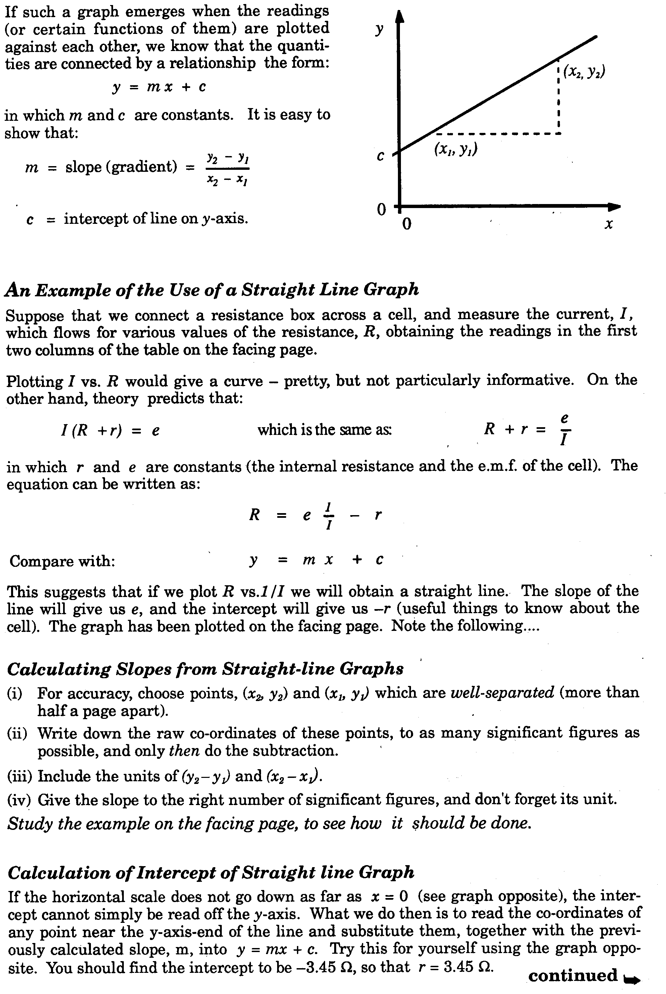
7. Straight Line Graph (An example).
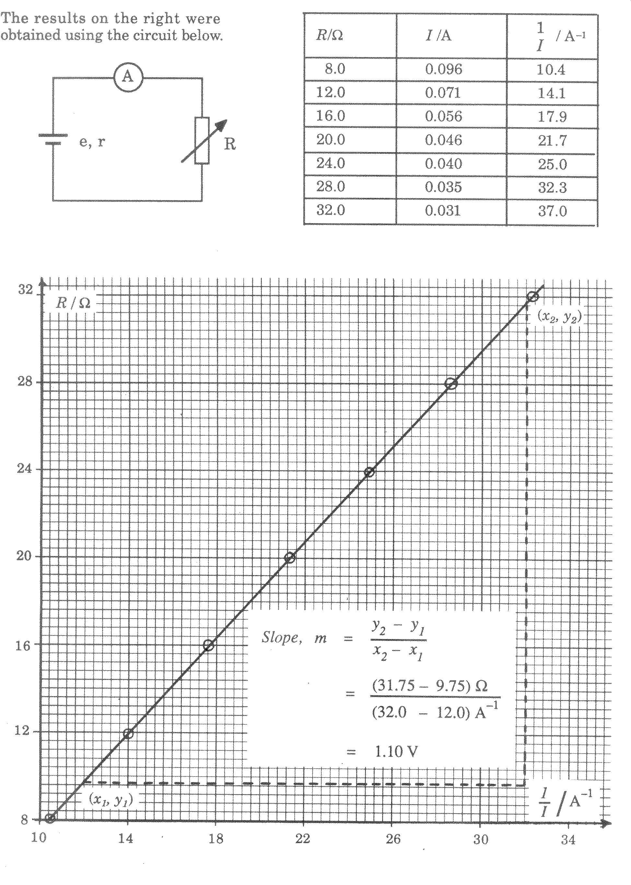

Describing your results

If asked if results are reliable, comment on the quality of the repeats – are they similar to each other.
If asked how confident you can be in your conclusion, comment on how close your points are to the line of best fit on the graph.
If asked how to make results more precise, suggest an instrument with a smaller scale division.
If asked to suggest how the experiment could be improved, identify the main sources of error in the experiment and make specific and realistic suggestions on how this can be addressed.

Other tips

In short questions always try to take a repeat of every reading and note down all the readings you take so it is clear you have done it!
Be careful you leave enough time to answer all the questions
If asked to describe the method you are going to use, ensure you are specific, mentioning actual measuring instruments you are going to use, the range of values etc. Avoid vagueness – show all working methodically and make sure it is very clear what you are doing at all stages.

