Working of DC and AC Electric Motors
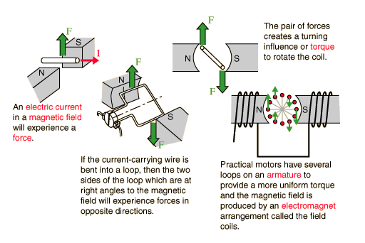
a. DC Motor Operation

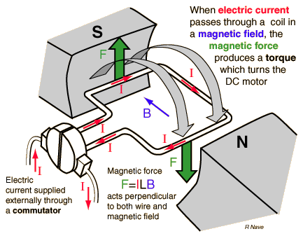

Magnetic Interactions with Moving Charge

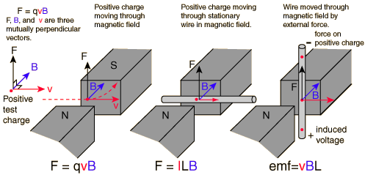

1. Magnetic Force on Moving Charge

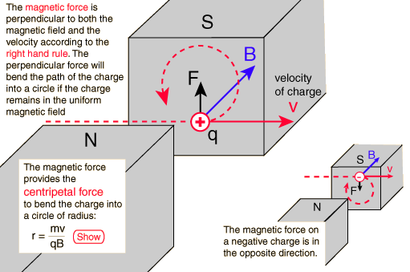
The magnetic force on a free moving charge is perpendicular to both the velocity of the charge and the magnetic field with direction given by the right hand rule. The force is given by the charge times the vector product of velocity and magnetic field.

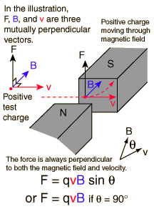

2. Magnetic Force on a Current

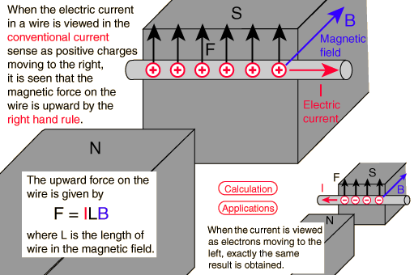
The magnetic force on a current-carrying wire is perpendicular to both the wire and the magnetic field with direction given by the right hand rule.

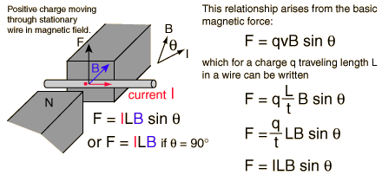

3. Voltage Generated in a Moving Wire

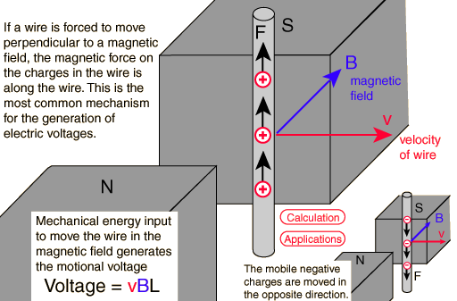

When a conductor moves through a magnetic field, there will be a generated motional emf. This is one example of Faraday's Law and it arises from the magnetic force. The voltage generated in a length of wire, presuming that the entire length moves through a uniform field.

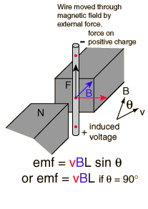

Current in DC Motor

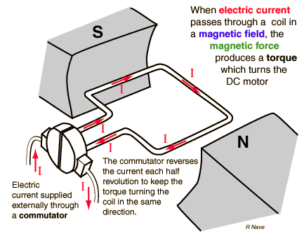

Magnetic Field in DC Motor

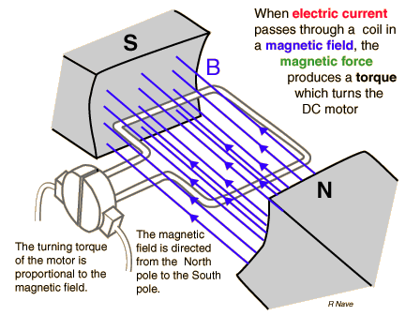

Force in DC Motor

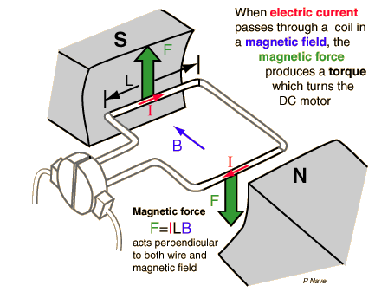

Torque in DC Motor

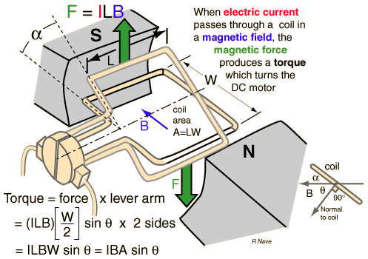

Torque on a Current Loop
The torque on a current-carrying coil, as in a DC motor, can be related to the characteristics of the coil by the "magnetic moment" or "magnetic dipole moment". The torque exerted by the magnetic force (including both sides of the coil) is given by
The coil characteristics can be grouped as
called the magnetic moment of the loop, and the torque written as
The direction of the magnetic moment is perpendicular to the current loop in the right-hand-rule direction, the direction of the normal to the loop in the illustration. Considering torque as a vector quantity, this can be written as the vector product
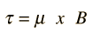
Since this torque acts perpendicular to the magnetic moment, then it can cause the magnetic moment to precess around the magnetic field at a characteristic frequency called the Larmor frequency.
If you exerted the necessary torque to overcome the magnetic torque and rotate the loop from angle zero to 180 degrees, you would do an amount of rotational work given by the integral
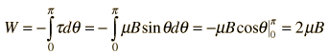

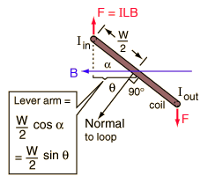
The position where the magnetic moment is opposite to the magnetic field is said to have a higher magnetic potential energy.
Torque Variation in DC Motor
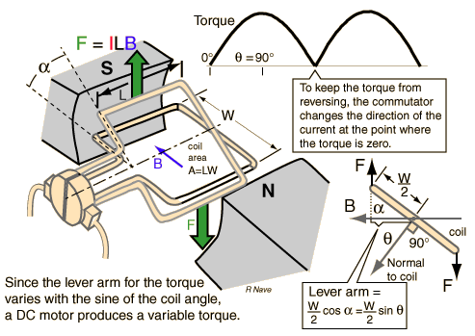

Commutator and Brushes on DC Motor
To keep the torque on a DC motor from reversing every time the coil moves through the plane perpendicular to the magnetic field, a split-ring device called a commutator is used to reverse the current at that point. The electrical contacts to the rotating ring are called "brushes" since copper brush contacts were used in early motors. Modern motors normally use spring-loaded carbon contacts, but the historical name for the contacts has persisted.
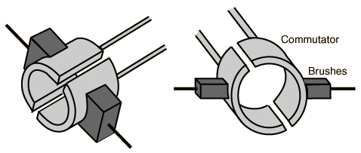
b. AC Motor

As in the DC motor case, a current is passed through the coil, generating a torque on the coil. Since the current is alternating, the motor will run smoothly only at the frequency of the sine wave. It is called a synchronous motor. More common is the induction motor, where electric current is induced in the rotating coils rather than supplied to them directly.
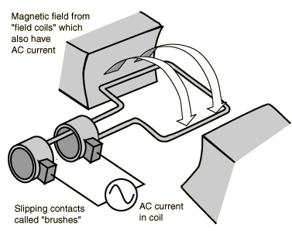
One of the drawbacks of this kind of AC motor is the high current which must flow through the rotating contacts. Sparking and heating at those contacts can waste energy and shorten the lifetime of the motor. In common AC motors the magnetic field is produced by an electromagnet powered by the same AC voltage as the motor coil. The coils which produce the magnetic field are sometimes referred to as the "stator", while the coils and the solid core which rotates is called the "armature". In an AC motor the magnetic field is sinusoidally varying, just as the current in the coil varies.

AC Generator
The turning of a coil in a magnetic field produces motional emfs in both sides of the coil which add. Since the component of the velocity perpendicular to the magnetic field changes sinusoidally with the rotation, the generated voltage is sinusoidal or AC. This process can be described in terms of Faraday's law when you see that the rotation of the coil continually changes the magnetic flux through the coil and therefore generates a voltage.
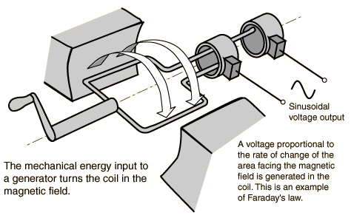
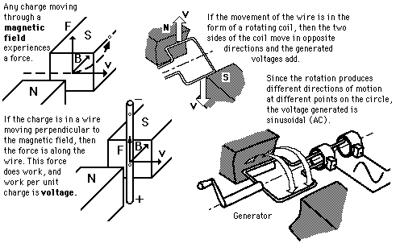

Generator and Motor
A hand-cranked generator can be used to generate voltage to turn a motor. This is an example of energy conversion from mechanical to electrical energy and then back to mechanical energy
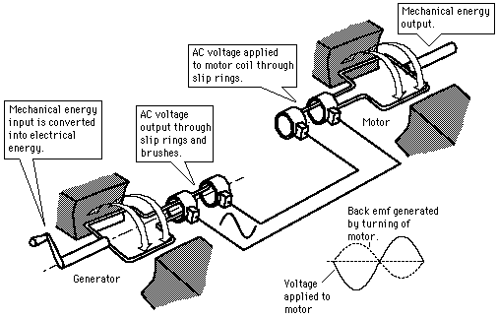

Induction Motor Action
Induction motors use shorted wire loops on a rotating armature and obtain their torque from currents induced in these loops by the changing magnetic field produced in the stator (stationary) coils.
At the moment illustrated, the current in the stator coil is in the direction shown and increasing. The induced voltage in the coil shown drives current and results in a clockwise torque.
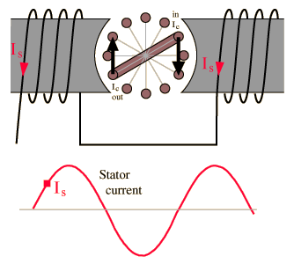
Note that this simplified motor will turn once it is started in motion, but has no starting torque. Various techniques are used to produce some asymmetry in the fields to give the motor a starting torque.
Induction in Armature Coils
Induction motor action involves induced currents in coils on the rotating armature.
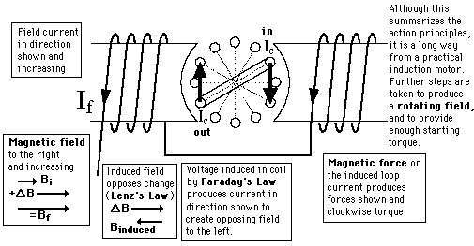

Simple AC Induction Motor

A large percentage of small AC motors are classed as induction motors. This implies that there is no current supplied to the rotating coils. These coils are closed loops which have large currents induced in them because of their low resistance.

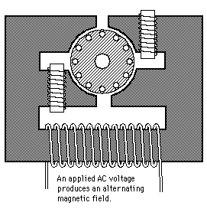
An induction motor must achieve a rotating magnetic field to continue to exert a torque on the armature coils. In this example, the rotating field is achieved by the extra coils on the pole pieces.
Simple AC Induction Motor
