Section I
1. Read the passage and then answer the questions at the end.

What is lightning?
Lightning has been a source of wonder to all generations. Its origins, in the processes of the electrification of thunderstorms, are being studied by means of laboratory experiments, together with observational and theoretical studies.
Summer airmass storms and winter-time cold frontal storms can become electrified and produce
lightning and thunder. The high currents in the lightning strokes (typically 20 000 A) heat the air sufficiently to cause rapid expansion; the resulting shock wave is heard as thunder. Travelling at the speed of sound, 340 m s⁻¹, the noise arrives after the flash is seen and so the distance to the storm may be estimated. The flash is seen as a result of the effect of the electrical discharge on the gases through which the discharge travels. The lightning may occur completely within the cloud as a cloud stroke, often called sheet lightning, or it may reach the Earth as a ground stroke.
In the production of a ground stroke, the lightning channel first makes its way towards the ground as a weakly luminous negative leader which attracts positive charge from sharp objects on the ground. This leader is a column of negatively charged ions which flow from the charged lower regions of the cloud in a stepwise fashion to form a conducting channel between the cloud and the ground. When a conducting channel is completed the negative charge flows to the
ground. The brightest part of the channel appears to move upwards at about 30% of the speed of light. Often there is sufficient charge available to allow several strokes to occur along the same lightning channel within a very short time. The resulting flickering can be observed by the eye and the whole series of strokes is called a flash. The peak electrical power is typically 1 x 10⁸ W per metre of channel, most of which is dissipated in heating the channel to around
30 000 ºC.
In London the average number of days per year on which thunder is heard is 17, the peak thunderstorm activity being in the late afternoon and evening during summer. When a person is struck by lightning, heart action and breathing stop immediately. Heart action usually starts again spontaneously but breathing may not and, on average, four people are killed by lightning each year in Britain.

(a) (i) Explain how the distance from an observer to a lightning flash may be estimated.
Illustrate this for the case where the distance is 1.5 km.
(ii) Explain the meaning of the phrase sheet lightning (paragraph 2). (5 marks)
(b) The diagram represents a storm cloud over a building with
a high clock tower. Copy the diagram. Explain, with the aid
of additions to your diagram, what is meant by a
negative leader (paragraph 3). (5 marks)

(c) Suppose lightning strikes from a cloud to the Earth along a
channel 400 m long. Calculate (i) a typical potential difference
between cloud and Earth, (ii) the average electric field strength
along such a lightning channel.
(5 marks)

(d) (i) Use the passage to explain how thunder is produced.
(ii) Estimate the pressure of the air within a lightning channel
immediately after a lightning flash. Take the atmospheric
pressure to be 100 kPa. State any assumptions you make. (7 marks)

(e) Suggest why those who are killed each year by lightning are usually alone. (2 marks)

(f) The flash is seen as a result of the electrical discharge on the gases through which the discharge travels
(paragraph 2).
Rewrite this sentence using the phrases “ionises or excites” and “visible photons”. You may be awarded a mark for the clarity of your answer. (4 marks)

(g) Describe how you would attempt to demonstrate in the laboratory that the electric field strength needed to produce a spark in air is about 3000 V mm⁻¹ (3 x 10⁶ V m⁻¹).
Suggest why this value differs from that which you calculated in (c)(ii). (4 marks)
(Total 32 marks)

[The passage is taken from “Scientific Statement on Lightning”. Dr C P R Saunders, Weather, Vol 49 No 1, the Royal Meteorological Society. Reproduced by permission.]
Section II (Answer ALL questions)

2. The diagram shows a water skier being pulled at a steady speed in a straight line. Her mass plus the mass of the ski is 65 kg. The pull of the tow-rope on her is 520 N.

(a) (i) What are the horizontal and vertical components X
and Y of the push of the water on the ski? (Ignore air
resistance.) (ii) Her weight and the 520 N towing force
exert moments around the point on the ski through which
the resultant of X and Y act. Explain how she can remain
in equilibrium as she is towed along if the size of the
towing force varies. (4 marks)

(b) Later, while still being towed, she moves in a curved path from behind the boat to approach a ramp from which she makes a jump, remaining in the air for over two seconds. Describe the force which enables her to accelerate centripetally as she moves in a curved path. Why does she feel “weightless” while in the air during her jump? (3 marks)

(c) After her jump she again moves with her original velocity, experiencing a towing force of 520 N. Suddenly, she lets go of the tow-rope. Calculate her initial deceleration. Why does her deceleration reduce as she slows down? (3 marks)

(d) An observer notices that the waves she produces approaching the shore diffract as they pass through a gap leading to a boatyard. The diffraction of electro-magnetic waves is involved when we collect information about stars and galaxies.
Explain how light diffracted through gratings can yield information about distant stars and galaxies. You may be awarded a mark for the clarity of your answer. (5 marks)
(Total 15 marks)

3. Apparatus to demonstrate electromagnetic levitation
is shown in the diagram.
When there is an alternating current in the 400-turn
coil, the aluminium ring rises to a few centimetres
above the coil. Changes in the size of the alternating
current make the ring rise to different heights.

(a) (i) Explain why, when there is a varying current in
the coil, there is an induced current in the aluminium
ring. Suggest why the ring then experiences an
upward force. You may be awarded a mark for the
clarity of your answer. (6 marks)

(ii) In one experiment the power transfer to the
aluminium ring is 1.6 W. The induced current is then 140 A. Calculate the resistance of the aluminium ring. The dimensions of the aluminium ring are given on the diagram below. Use your value for this resistance to find a value for the resistivity of aluminium. (5 marks)
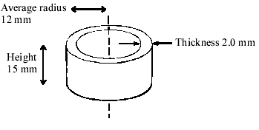
(b) The aluminium ring becomes hot if the alternating current is left on for a few minutes. In order to try to measure its temperature it is removed from the steel rod and then dropped into a small plastic cup containing cold water.
(i) State what measurements you would take and what physical properties of water and aluminium you would need to look up in order to calculate the initial temperature of the hot aluminium ring. (3 marks)
(ii) Explain whether experimental errors would make your value for the initial temperature of the aluminium ring too big or too small. (2 marks)
(Total 16 marks)

4. (a) (i) Particle accelerators are used to increase the energy of charged particles. Circular accelerators can accelerate charged particles to higher energies than can be achieved in linear accelerators. Discuss the principles of physics used in a circular accelerator. You should refer to principles from more than one unit. You may be awarded a mark for the clarity of your answer. (6 marks)

(ii) Show that, if the speed of a charged particle in a circular accelerator is increased, the radius of the circular path increases. (3 marks)

(b) (i) A bubble chamber contains liquid hydrogen at high pressure. When the high pressure is suddenly released, visible tracks of particles moving through the chamber are produced.
Describe the processes which lead to these tracks being made visible. (3 marks)

(ii) The photograph shows tracks in a hydrogen bubble chamber. The tracks associated with one particular interaction are reproduced as a diagram alongside. There is a magnetic field into the page.
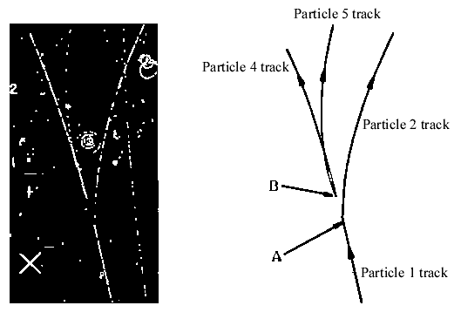
The tracks in the diagram show particle 1 decaying at A into two particles 2 and 3, with particle 3 leaving no track. What can you deduce about particle 2?
Suggest why particle 3 leaves no track. (3 marks)

(iii) Particle 3 subsequently decays at B into another pair of particles, 4 and 5.
The sum of the masses of particles 4 and 5 is less than the mass of particle 3.
Explain how this can be the case. (2 marks)
(Total 17 marks)

