Topic C - Nuclear and Particle Physics

3. (a) The strong force is one of the fundamental interactions. What exchange particle is associated with this force?
List the other fundamental interactions. Circle the one for which the photon is the exchange particle. (5 marks)

(b) Complete the table below which compares alpha particle scattering with deep inelastic scattering.
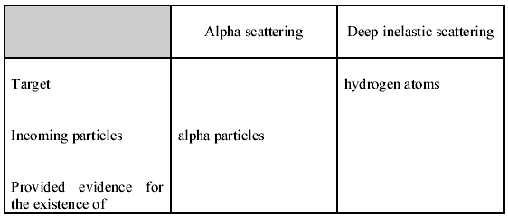
(4 marks)

(c) The Ω⁻ (omega minus), a particle with strangeness -3 was identified in 1964 in an experiment involving an
interaction between a K⁻ meson of strangeness -1 and a proton.
Is the Ω⁻ a baryon or a meson? Give two reasons for your answer. (2 marks)
Using the information in the table, deduce the quark composition of all particles in the equation.
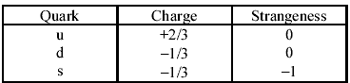
(4 marks)

(d) Complete the following nuclear equation showing the beta-minus decay of an isotope of oxygen.
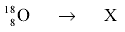 (2 marks)
Sketch a graph showing the energy spectrum for a typical beta-minus decay. (2 marks)
Explain why the shape of this graph is consistent with the decay process involving a further particle, an antineutrino. You may be awarded a mark for the clarity of your answer. (4 marks)

(e) The theory of relativity established that all forms of energy possess mass and, conversely, that material particles are a form of energy. If enough energy is concentrated, new particles of matter will appear. Thus, the violent collision of two protons, for example, can produce more protons. Whenever matter is created this way in the laboratory it is always accompanied by an equivalent quantity of antimatter. Each lepton and quark possesses an antiparticle in which all the physical properties except mass are reversed. If an antiparticle encounters its mirror particle they annihilate each other, usually in the form of gamma radiation.
[Adapted from Paul Davies: The particles and forces of nature, in Revised NAS Physics, Longman 1986.]

(i) The collision between two protons is described as being a violent collision. Explain why the collision must be a violent one in order to produce more protons. (2 marks)
(ii) Whenever matter is created “it is always accompanied by an equivalent quantity of antimatter”.
What conservation laws does this statement imply? (3 marks)
(iii) An electron encounters a positron. The rest mass of an electron and that of a positron is 0.000 55u.
Describe the outcome of the encounter.
Support your description with relevant calculations. (4 marks)
(Total 32 marks)

