Topic D - Medical Physics

4. (a) Give two physiological effects of radiation on cells. (2)

(b) Iodine ¹³¹₅₃I is a radioisotope that is sometimes used in nuclear medicine. It decays with the emission of both a β⁻ particle and a γ-ray to form xenon Xe. Write a balanced nuclear equation to represent this decay process, showing nucleon and proton numbers for all symbols. (3)

(c) Technetium ^{99m}₄₃Tc is the radioisotope most widely used in diagnostic studies. Explain the meaning of the symbol 'm' and what this implies about this radioisotope. (2)
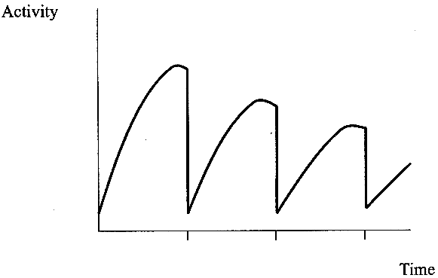
^{99m}₄₃Tc is produced in hospitals from
molybdenum in an elution cell.
The graph shows the activity of the elution
cell against time during several elutions.
Add a suitable time scale to a copy of the graph. (1)
Explain clearly the shape of the graph.
You may be awarded a mark for the clarity
of your answer. (4)

(d) What is meant by the term ultrasound? (2)
The acronym 'sonar' stands for 'sound navigation
and ranging' and is a principle used for ultrasonic diagnosis.
Outline the sonar principle and state what sort of information it provides. (3)
Show that the speed of ultrasound in soft tissue is approximately 1500 m/s using the data given below.
Ultrasound frequency = 1.50 MHz
Ultrasound wavelength == 1.03 mm (2)

Calculate the specific acoustic impedance of soft tissue which has a density of 1060 kg m⁻³. (2)
An ultrasonic pulse travelling through soft tissue is incident on a bone within the human body which has a specific acoustic impedance of 6.5 x 10⁶ kgm⁻²s⁻¹. Calculate the percentage of the incident intensity of the ultrasound that is transmitted into the bone. (4)
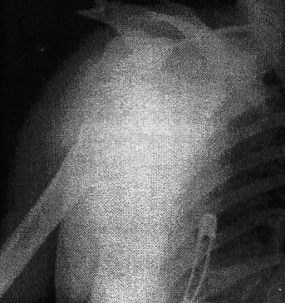
(e) X-rays can be used for diagnosis or for therapy.
With reference to energies, distinguish between the
X-rays used in diagnosis and those used in therapy. (3)
The X-ray image below shows a dislocated shoulder.
Explain why some areas of the image are white, whilst
others are grey.
Use the information given to quantify your explanation.
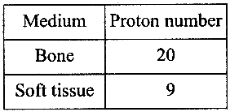 (4)

(Total 32 marks)

