SECTION I
1. Read the passage and then answer the questions at the end.

The betatron

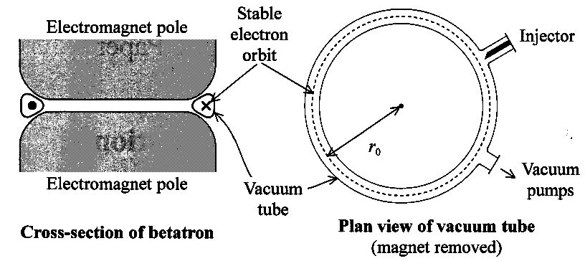
Van de Graaff generators and linear accelerators (linacs) can accelerate electrons in straight lines to very high energies. A quite different type of machine, known as a betatron, was developed in 1940 by D W Kerst. In a betatron, which is a ring accelerator, electrons are given energy while moving in a circular orbit of constant radius. The electrons are given energy by a tangential force that acts on them all the way round the circumference of a ring-shaped vacuum tube. This tube is mounted between the specially shaped poles of an electromagnet, which are shaped so that the average field between them, B_{av}, is twice the field in which the electrons are moving. B₀
The current in the electromagnet is
gradually increased over a period of a few
milliseconds. As the magnetic field increases,
an e.m.f. is induced in the circuit formed by
the orbiting electrons. It is rather as if the
beam of free electrons formed a single turn
secondary coil in a transformer. To maintain
acceleration in an orbit of constant radius r_{o},
the changing magnetic field must provide both
the tangential accelerating force produced
by the transformer effect, and the appropriate
centripetal force.
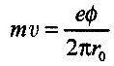
Consider an electron of charge e and mass m moving in a circular orbit of radius r_{o} at the instant when its tangential velocity is v. If the magnetic flux density of the magnetic field in which it is moving has at this instant risen to B₀, the momentum of the electron is given by mv = e B₀ r_{o}. At this moment, the secondary e.m.f. round the orbit is given by the rate of change of f, the magnetic flux linking the orbit, and it is this e.m.f. that gives energy to the electrons. When the magnetic flux has increased from zero to Φ, it can be deduced that

In a betatron, a hot filament in the injector provides the electrons. These electrons can reach energies of 20MeV, and consequently their masses become many times greater than their rest mass. To remove these electrons from the betatron, the magnetic field is disturbed slightly and the electrons can then be made to strike a target where they can, for example, produce electromagnetic waves with the wavelength of γ-rays.
(Source: adapted from Modern Physics, 3rd edition, by Caro, McDonell & Spicer, Edward Arnold 1978.)

1. (a) (i) In what basic way does a betatron differ from a Van de Graaff generator?
(ii) List three ways in which a betatron differs from a cyclotron. (4)
(b) (i) What produced the 'appropriate centripetal force' for the orbiting electrons in a betatron?
(ii) Prove that, as in the cyclotron, an electron moving in a circle at a speed v perpendicular to a uniform magnetic field of magnetic flux density B has a path of radius r = mv/Be.
Hence explain how r can be kept constant when the momentum of the electron is increased. (4)
(c) (i) Define magnetic flux and write down the magnetic flux Φ linking a circuit of radius r_{o} through which there is a
magnetic field of flux density B_{av}.
(ii) Use the two equations given in the passage for the momentum of the electrons to deduce a relationship between Φ, the magnetic flux linking the circuit, and B₀, the magnetic flux density at the orbit. Hence show that in a betatron the magnetic field within the orbit must have an average value of magnetic flux density B_{av} equal to 2B₀. (5)
(d) Use the equation mv = eΦ / 2π r_{o} to find the unit for magnetic flux in terms of base units.
Show that your unit is consistent with the magnetic flux density B being measured in NA ⁻¹m ⁻¹. (4)
(e) In the cross-section diagram in the insert, the X shows the electrons orbiting into the paper and the • shows them
orbiting out of the paper.
(i) Is the polarity of the electromagnet's poles required to make electrons orbit as shown N above and S below OR S above and N below? Explain how you made your decision.
(ii) The orbiting electrons themselves produce a magnetic field.
Explain the effect this field has on the resultant field between the poles of the electromagnet. (5)
(f) (i) An electron in a certain betatron gains 180eV while travelling in one orbit of radius 0.85m.
How far does it travel in reaching 20MeV? (2)
(ii) When an electron is accelerated from rest to 20MeV, its kinetic energy is increased to 3.2 x 10 ⁻¹² J. What increase in mass does this represent? Hence show that the masses of 20 MeV electrons become 'many times greater than their rest mass'. (5)
(g) Draw the circuit symbol for a transformer and label your diagram to describe what forms the primary and secondary
in a betatron 'transformer'. (3)

TOTAL FOR SECTION I: 32 MARKS
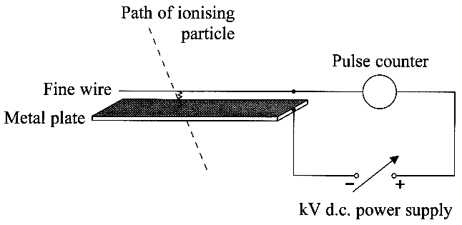
SECTION II
(Answer ALL questions)

2. (a) The diagram shows the principle of a
simple spark detector or counter. The fine
wire is supported 1.0 mm above the metal
plate by insulating material, not shown.
The power supply is adjusted until, at 3.2 kV,
sparking across the air gap occurs only when an
ionising particle passes between the wire and the plate.
(i) The diagram opposite shows a cross-section of the wire and plate.
Add to a copy of this diagram the shape of the electric field
between the wire and the plate. (2)
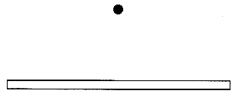
(ii) Explain why the electric field close to the wire
is more than 3.2 x 10 ⁶ Vm ⁻¹. (2)
(iii) Describe what happens to produce a spark
across the air gap when an a-particle passes along
the dashed path shown. (3)

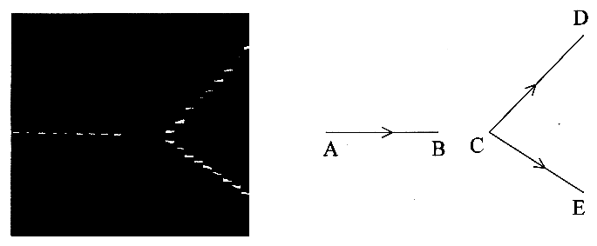
(b) The photograph shows the
appearance of particle tracks
in an early spark chamber.
The short sparks occur between
thin sheets of metal foil placed
about 3 mm apart.
The diagram on the right labels
the tracks: A→B and C→D are
those of negatively charged
particles; C→E is that of a
positively charged particle.
(i) Sketch the shape these tracks would have if there were a strong magnetic field acting down perpendicular to the plane of the photograph. What is the purpose of using such magnetic fields when photographing particle tracks in spark chambers? (4)
(ii) Suggest what might have travelled from B→C. Explain your answer. (2)

(c) Modem drift chambers contain many hundreds of wires and the time of arrival of released electrons at any wire enables the track of a charged particle to be deduced.
What advantages do modem spark or drift chambers have over cloud or bubble chambers for tracking charged particles? (2)

3. (a) (i) Outline how the kinetic theory of gases describes an ideal gas.
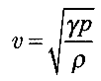
List two assumptions on which the kinetic model of a gas, leading to the
relation p = ⅓ ρ < c² >, is founded. (4)
(ii) The kinetic theory can be used to predict that the speed of sound v in a gas is given by
where p is the pressure and ρ is the density of the gas. For air, γ is a numerical constant
equal to 1.4.Using this relation and the relation given in (i), show that the speed of
sound v in air is about 70% of the root mean square speed √(< c² >), for air. Comment on this result. (4)

(b) (i) The kinetic theory of gases also predicts that the average kinetic energy of a gas particle (molecule or atom) is ³/₂ kT, where k is a constant equal to 1.4 x 10 ⁻²³ J K ⁻¹ and T is the kelvin temperature.
Compare quantitatively the energy of (1) an ideal gas particle at room temperature and (2) the energy of a photon of visible light. (4)
Q3 is continued on the next page.
Q3 (b)(ii) To ionise an air particle requires an energy of the order of 10eV. Very few air particles in a room are ionised. Discuss why this is so, and suggest under what circumstances many more ions might be produced.
You may be awarded a mark for the clarity of your answer. (4)

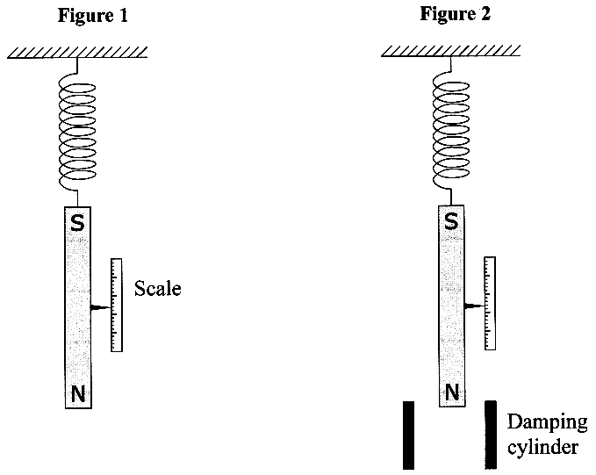
4. The diagrams opposite show a
long bar magnet suspended by a
coiled spring from a rigid support.
The amplitude of vertical oscillations
of the magnet can be measured by
observing the motion of a pointer
(a) The mass of the suspended magnet
is 0.40 kg and the spring extends 25 cm
when the magnet is first hung from it.
(i) Use the relation F = kx to determine
the spring constant k of the spring. (2)
(ii) Calculate the period T of the
vertical oscillations. (1)
(iii) The period T is independent of
the amplitude of the oscillations.
Explain in general terms why large
oscillations have the same period
as small oscillations. (3)

(b) The lower end of the magnet is now surrounded
by a cylinder of aluminium - figure 2.
This produces damping of the vertical oscillations. The net energy transfer is from mechanical energy in the oscillating system to internal energy in the damping cylinder (ignoring air resistance).
(i) Explain how the energy transfer takes place as the N-pole of the magnet moves into and out of the aluminium damping cylinder. (3)
(ii) Sketch a displacement-time graph for these damped oscillations.
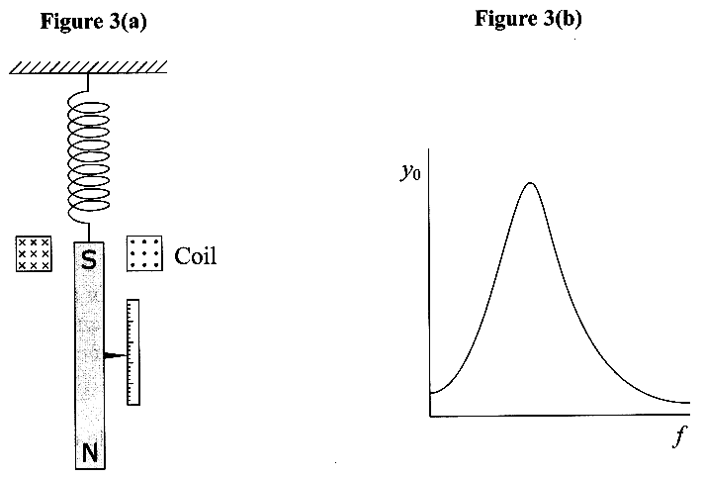
Show at least three complete oscillations. (6)

(c) In figure 3(a) a flat horizontal
coil has been placed around the
S-pole of the long magnet and the
damping cylinder removed.
When there is an alternating
current in the coil, the magnet is
forced to oscillate vertically.
The graph, figure 3(b), shows
how the amplitude of the
oscillations y_{o} varies with f, the
frequency of the alternating current.
(i) Explain the shape of the graph
and suggest a value for f when y_{o} has
a maximum value. (3)
(ii) Add a second graph line
labelled D, to copy of figure 3(b),
to show how y_{o} varies with f when
the damping cylinder is replaced in its original position. (2)

TOTAL FOR SECTION II: 48 MARKS
TOTAL FOR PAPER: 80 MARKS

