Topic D – Medical Physics

4. (a) (i) The equation I = P / 4nr² can be used to determine the intensity of X-rays from a source. Use this equation to show that the base units of intensity are kg s⁻³. (3)

(ii) An X-ray beam has an intensity of 5.7 W mm ⁻ ² at a distance of 0.4 m from an X-ray tube.
How far from the X-ray tube should a radiographer stand in order to reduce the
intensity to 0.80 W mm ^{– 2} ? (3)

(b) An X-ray tube works by accelerating electrons through a potential of 65 kV towards a target.
(i) Show that the energy of an electron arriving at the target is approximately 1 x 10 ⁻ ¹⁴ J. (2)
(ii) Assuming that the usual kinetic energy formula is valid, calculate the theoretical speed reached by an electron. (3)
(iii) What happens to the energy of the electrons when they strike the X-ray tube target? (2)
(iv) A typical X-ray tube has an efficiency of less than 1.
List two features of an X-ray tube target that enable it to cope with this low efficiency. (2)
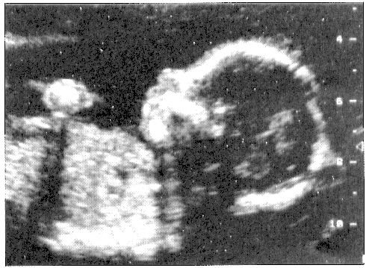
(c) An ultrasound image of a 19-week-old unborn baby
is shown opposite.
(i) Is this an A-scan or a B-scan? (1)
(ii) Outline the principles for producing such a scan,
with reference to the above image.
You may be awarded a mark for the clarity of
your answer. (5)

(d) (i) Define each of the following in terms of a
radioactive tracer which may be given to a patient.
Radioactive half-life;
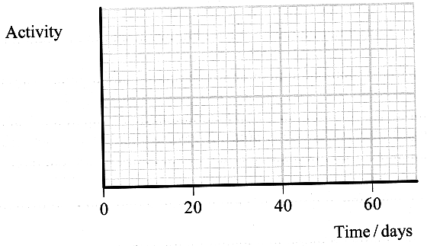
Biological half-life;
Effective half-life (3)

(ii) An isotope of iodine ¹²⁵I has an
effective half-life of 16 days when it
is used to label the human serum albumin.
If it has a radioactive half-life of 60 days
calculate its biological half-life. (3)

(iii) On a copy of the axes opposite sketch
two curves, one showing the activity of
the ¹²⁵I within a patient and the other
showing the activity of an identical sample
that was kept in a laboratory.
Label your curves P (patient) and E (laboratory). (3)

(iv) What type of radiation should ¹²⁵I emit in order to be used as a tracer?
Justify your answer. (2)

Total 32 marks

