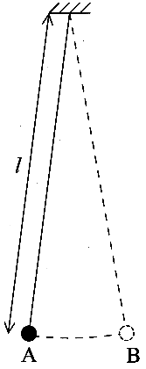
1. A body performs simple harmonic motion when its acceleration is proportional to its displacement
from a fixed point and is directed towards that point.
What additional condition must be satisfied for the oscillations of a pendulum to be
simple harmonic? [1]
The diagram opposite shows a long pendulum which is oscillating between points A and B.
The pendulum takes 5.72 s to swing from A to B. Calculate its period T.
The acceleration due to gravity is 9.81 m s ⁻². Calculate the length l of the pendulum. [3]

2. To make an object of mass m move at speed v around a circular path of radius r, a resultant
force must act on it. The magnitude of the resultant force is given by mv²/r.
Explain why a resultant force is required, and state its direction. [3]
When vehicles corner on a level road, the resultant force is provided by friction.
For a given vehicle and road surface, the friction cannot exceed a certain maximum value.
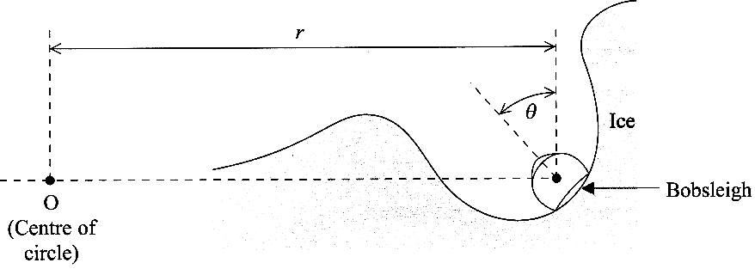
Use these facts, together with the expression for the resultant force, to explain why roads designed for high-speed travel have no sharp bends. [2]
On a bobsleigh run, the bobsleigh travels along an ice
channel with little friction. When cornering, it slides
up the side of the channel until the required resultant
force is provided. The diagram shows a head-on view
of a bobsleigh travelling at speed v round a bend which
is part of a horizontal circle centred at the point 0.
The bobsleigh is tilted through an angle θ.

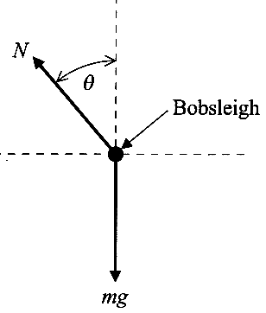
Below the first diagram is a free-body force diagram
for the bobsleigh. Friction is assumed to be negligible.
The normal contact force exerted by the ice on the bobsleigh is N, and its weight is mg.
Write down an equation expressing the condition for no vertical acceleration.
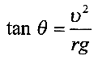
Write down an equation applying Newton's second law horizontally.
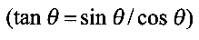
Hence show that

[4]
Calculate the value of angle θ for a bobsleigh travelling at 30.0 m s ⁻¹
around a bend of radius 20.0 m. [1]

3. You are provided with a double slit whose slit separation is known to be 0.20 mm.
Describe how you would use it to measure the wavelength of the light from a
monochromatic source. Mention any step you would take to make the measurement as accurate as possible.
You should include a diagram of the experimental arrangement, and state a suitable value for any other important dimension. [7]
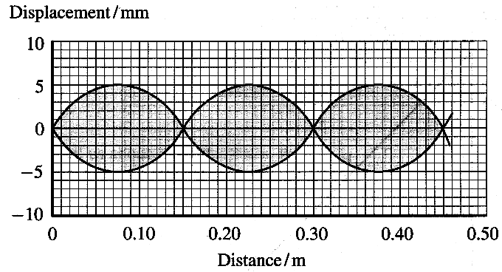
4. A stationary wave is produced on a stretched string by
a vibration generator attached to one end. The graph
shows part of the wave. The two full lines represent
the extreme positions of the string.
State the wavelength of this wave. [1]
Mark a letter A on a copy of the graph to label
an antinode. [1]
The stationary wave is formed by the superposition
of two waves travelling along the string in opposite
directions. The frequency of the vibrator is 36.0 Hz.
Calculate the speed of the travelling waves. [2]
State the phase relationship between the two travelling waves at an antinode. [1]
Determine the amplitude of each of the travelling waves. [1]
5. The graph shows how frequency varies with wavelength
for electromagnetic waves in a vacuum. Note that the scales
are logarithmic.
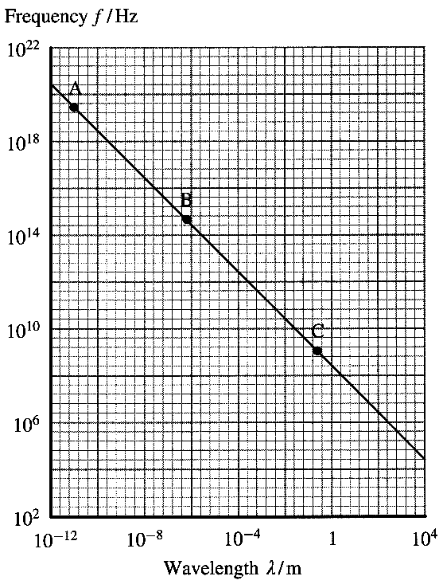
Three different waves are labelled by the letters A, B and C
on the graph. In a copy of the table below, write the appropriate
letter to identify each of the waves described. [2]
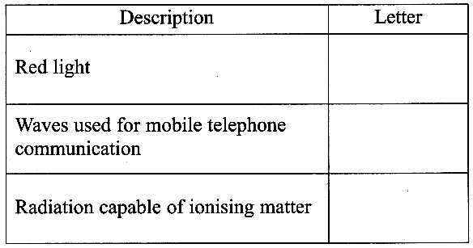

How does the graph confirm that frequency is inversely
proportional to wavelength? [1]
What does this tell us about electromagnetic waves? [1]

6. Define the intensity of an electromagnetic wave. [1]
Two beams of monochromatic electromagnetic radiation,
A and B, have equal intensities.
Their wavelengths are:
Beam A 300 nm
Beam B 450 nm

In the table below, E denotes the energy of a photon and N denotes the number of photons passing per second through
unit area normal to the beam. The subscripts A and B refer to the two beams.
Copy this table and in the second column of the table, state the value of each ratio, and in the third column explain your answer. [4]
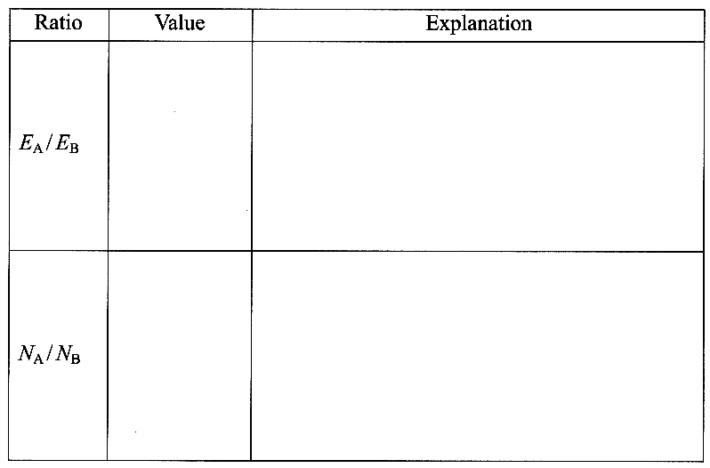

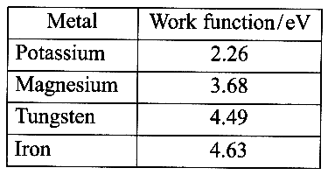

The table above right gives the work functions of four metals.
Define the term work function. [1]
A metal plate made from one of these metals is exposed to beams A and B in turn. Beam A causes electrons to be emitted from the plate, but beam B does not.
Calculate the photon energies in each beam and hence deduce from which metal the plate is made. [4]

7. Four of the energy levels of a lithium atom are shown opposite.
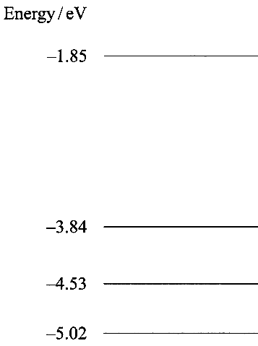
Draw on a copy of the diagram all the possible transitions which the
atom could make when going from the -3.84 eV level to
the -5.02 eV level. [2]
Photons of energy 3.17 eV are shone onto atoms in lithium vapour.
Mark on your diagram, and label with a T, the transition which
could occur. [1]

One way to study the energy levels of an atom is to scatter electrons
from it and measure their kinetic energies before and after the collision.
If an electron of kinetic energy 0.92eV is scattered from a lithium atom
which is initially in the -5.02eV level, the scattered electron can have
only two possible kinetic energies.
State these two kinetic energy values, and explain what has happened to
the lithium atom in each case. (You should assume that the lithium atom
was at rest both before and after the collision.) [4]

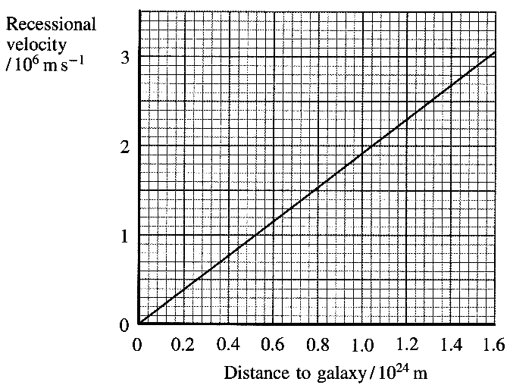
8. (a) The graph shows the best-fit line obtained when recessional velocity
is plotted against distance from Earth for a large number of galaxies.

Use this graph to calculate a value for
the Hubble constant. [2]

A spectral line measured using a
laboratory source has a wavelength
of 372.7 nm. The same line, measured
in light from a distant galaxy, has an apparent
wavelength of 410.0 nm. Estimate the distance
of this galaxy from Earth. [4]

(b) The diagram below shows a deflated balloon.
It has three dots on its surface, labelled P, Q and R.
Copy this diagram and in a space next to your diagram,
draw the balloon as it would appear when fully inflated.
Mark the new positions of the three dots. [2]
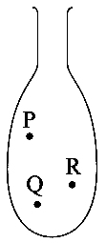

Explain how the inflation of the balloon can be used to model the expansion of the Universe.
You may be awarded a mark for the clarity of your answer. [4]

TOTAL FOR PAPER: 60 MARKS

