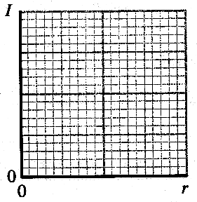
Topic D - Medical Physics

4. (a) On a copy of the axes opposite sketch a graph showing how
the intensity I of an X-ray beam varies with distance r from a
point X-ray source in air. (2)
If the X-ray intensity is 7.0 MW m⁻² at a distance of 0.20 m from
the source, calculate the intensity at a distance of 2.0 m
from the source. (3)

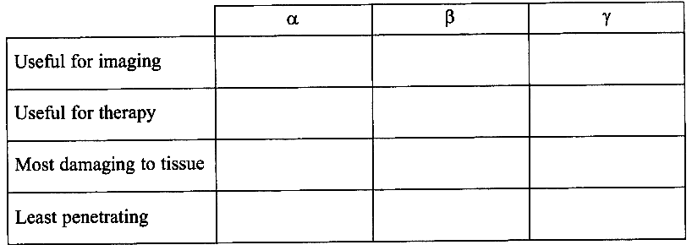
(b) Complete a copy of
the table opposite to
compare α, β and γ
radiation by ticking in
the appropriate boxes. (4)

Beta radiation can be
either positive or negative.
Phosphorus, ³²₁₅P,
decays to sulphur, S, by
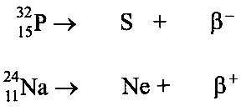
β ⁻ emission. Sodium, ²⁴₁₁Na,
decays to neon, Ne, by β ⁺ emission.
The equations opposite show these two decays.
Complete a copy of these equations by adding the missing
nucleon and proton numbers. (3)

(c) A known quantity of a radionuclide which can label red blood cells is injected into a patient.
Describe what further steps are needed to estimate the patient's blood volume.
You may be awarded a mark for the clarity of your answer. (5)

(d) Calculate the wavelength in soft tissue of an ultrasound pulse of frequency 6.0 MHz (speed of sound in soft tissue = 1540 m s⁻¹). (3)
Would ultrasound of this frequency be suitable for eye investigations? Explain your answer. (1)
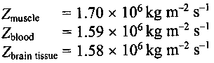
Show that the reflection coefficient for ultrasound at a boundary between muscle and blood is approximately 1 x 10⁻³.
Data: Specific acoustic impedances:

The reflection coefficient at a boundary between brain tissue and blood is approximately 1 x 10⁻⁵. Use this value to explain why ultrasound can be used to investigate blood flow in muscle but not in the brain. (2)

(e) Each accelerated electron in an X-ray tube has an energy of 120 keV.
State the value of the operating voltage of this X-ray tube. (1)
Explain what happens to most of the energy of these electrons. (1)
State two features of the target anode in an X-ray tube. (2)
This tube produces X-rays with energies of the order of tens of keV.
Would these X-rays be more suitable for diagnostic or therapeutic use? Explain your answer. (2)

(Total 32 marks)

