Topic C - Nuclear and Particle Physics
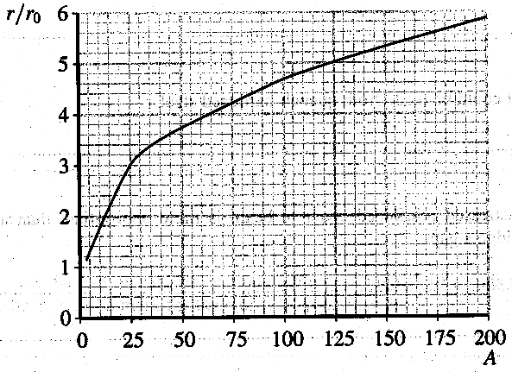
3. (a) The graph shows how measured
ratios r/r₀, where r is the radius of the
nucleus, vary with nucleon number A

Show that this graph is consistent with
the relationship r = r₀A^{1/3} for two
values of A ≥ 50. (3)

(b) The radius of a nucleus of tin, ¹¹⁹₅₀Sn,
is 6.0 x 10 ⁻¹⁵ m. Calculate the density of
this nucleus of tin. (4)

(c) Explain what is meant by the term
binding energy.
Iron has the highest binding energy per nucleon of any nucleus.
What does this tell you about an iron nucleus? (3)

(d) Carbon-14, ¹⁴₆C, is unstable and decays by β ⁻ emission to nitrogen, N.
Write a full nuclear equation for this decay. (3)
Carbon-14 has a half-life of 5730 years. Living organisms contain approximately 100 atoms of ¹⁴₆C for every 1020 atoms of stable carbon-12, ¹²₆C. Estimate the age of a fossil which is found to contain approximately 12 atoms of ¹⁴₆C for every 1020 atoms of ¹²₆C. (2)
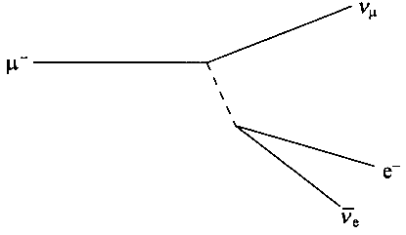
(e) The Feynman diagram represents the
decay of a muon.
By what type of interaction does this
decay take place? Justify your answer. (2)
Label the exchange particle on the diagram
with its name. (1)

(f) The following strong interaction has been observed.
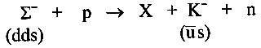

Is particle X positive, negative or neutral? (1)
Is particle X a baryon, a meson or a lepton? (1)
State the quark composition of the proton and the neutron. (1)
Explain why particle X cannot contain a strange quark, and deduce the identity of particle X.
You may be awarded a mark for the clarity of your answer. (4)

(g) High energy collisions occur in machines that either collide hadrons such as protons and antiprotons or leptons such as electrons and positrons.
Name one other hadron and one other lepton. (2)
Are hadrons fundamental particles? Explain your answer. (2)
An electron and a positron each of energy E collide head on and annihilate.
Calculate the minimum value of E in MeV needed to produce a Z° particle of mass 98 u. (3)

(Total 32 marks)

