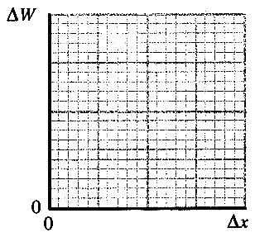
Topic B - Solid Materials

2. (a) Show that the energy stored in a stretched wire below the
limit of proportionality can be written ΔW = ½ k(Δx)² where k
is the Hooke's law constant. (2)

On a copy of the axes opposite sketch a graph showing how
energy stored ΔW varies with extension Δx of a wire below
its elastic limit. (2)

(b) The graph below shows the stress-strain relationship for copper.
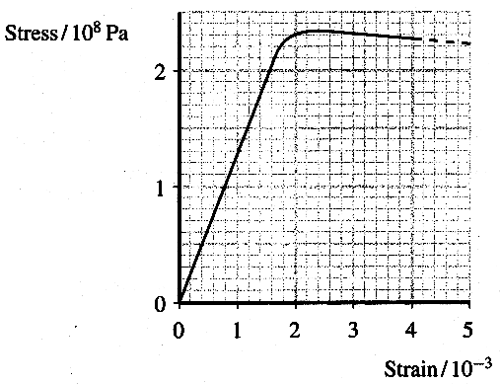

Use the graph to determine the Young modulus of copper. (4)
A student is measuring the extension of a copper wire for a number of forces.
Why should a long wire be used in this experiment? (1)

The wire has a radius of 7.1 x l0 ⁻⁴ m.
Calculate the stress produced when the wire is stretched by a force of 280 N. (3)
Mark this point on a copy of the stress-strain graph. Label it P. (1)

Is the behaviour of the wire at this stress likely to be elastic or plastic? Justify your answer. (1)

(c) Explain with the aid of a single diagram what is meant by an edge dislocation. (2)
Describe how the presence of dislocations can reduce the risk of metals failing by cracking.
You may be awarded a mark for the clarity of your answer. (4)

(d) Describe how high density polythene (HDPE), Melamine and Perspex behave on heating. (3)
Suggest a typical use for each polymer. (3)

(e) Describe the difference between the processes of annealing and quench-hardening. (2)
Suggest an item that could be made from quench-hardened steel. (1)

(f) Explain why a pre-stressed reinforced concrete beam is more appropriate than a simple concrete beam to bridge a gap. (3)

(Total 32 marks)

