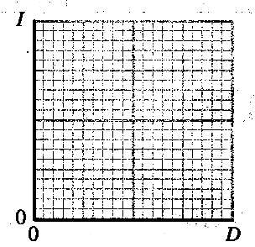
Topic A - Astrophysics

1. (a) On a copy of the axes opposite sketch a graph showing how
the intensity I of a star varies with distance D from the star. (2)
Give two reasons why measurements of a star's intensity are often
made from above the Earth's atmosphere. (2)

(b) The graph below shows the energy distribution in the spectra
of two stars β_{Car} and β_{And}.
What can be deduced about the colours of the two stars from the graph? (1)
Estimate the surface temperature of β_{And}. (3)
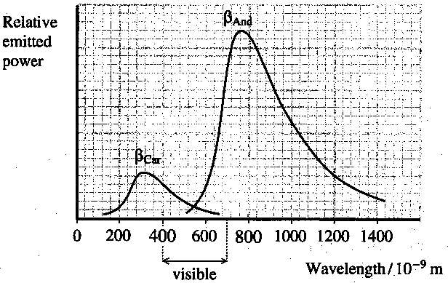
The luminosity of β_{Car}
is 2.0 x l0²⁸ W and it has a
surface temperature of 9300 K.
Calculate the surface area of β_{Car}. (3)
By comparing the areas under the two
graphs, estimate the luminosity of β_{And}. (2)

(c) Explain what is meant by a main
sequence star. (1)
Outline the life story of a white dwarf star
starting from when it was a main sequence
star.You may be awarded a mark for the
clarity of your answer. (4)
What determines whether or not a main sequence star
eventually becomes a white dwarf? Quantify your answer. (2)

(d) Sirius A has a luminosity of 9.96 x l0²⁷ W.
Calculate the rate at which mass is being converted to energy in Sirius A. (4)
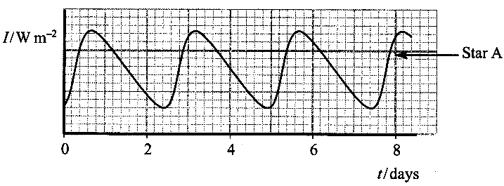
(e) Cepheid variables are giant
stars that have entered an unstable
stage of their evolution.
More luminous Cepheid variables
pulsate at a slower rate than less
luminous ones.
The graph, called a light curve, shows
how the intensity of a Cepheid variable
(star A) varies with time.

Determine the period of pulsation of star A. Show how you arrived at your answer. (2)
Add to a copy of this graph another light curve showing how the intensity of a more luminous Cepheid variable (star B) might vary with time. Assume that star B has approximately the same average intensity as star A. (3)
Describe how the pulsations of a Cepheid variable can be used to estimate the distance to the galaxy in which it is found. (3)

(Total 32 marks)

