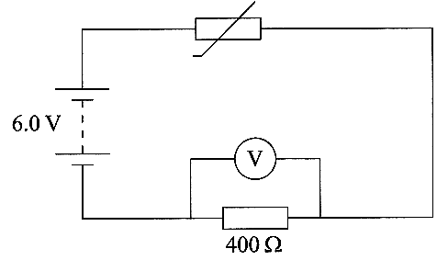
1. A student connects the circuit as shown in
the diagram.
The reading on the voltmeter is 1.8 V.
Calculate the current in the resistor. [1]
Calculate the resistance of the thermistor. [2]

The graph shows how the resistance of the thermistor
depends on its temperature
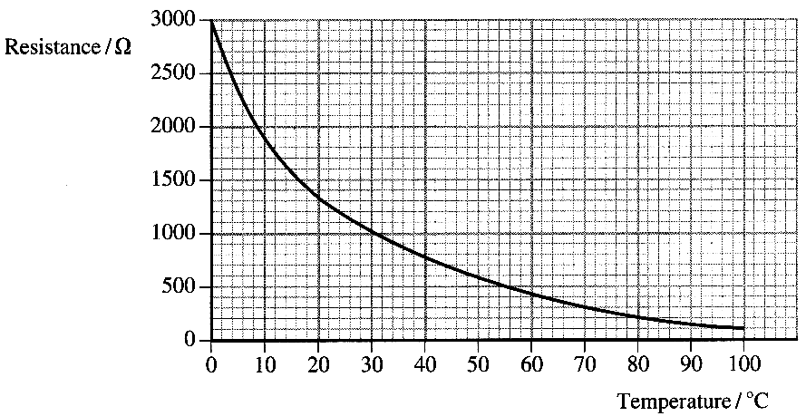
Determine the
temperature of the
thermistor. [1]
If the e.m.f. of the supply were
doubled, would the reading on
the voltmeter double?
Explain your answer. [3]

2. Define the term
specific latent heat of fusion. [3]

A cooling curve for an organic substance,
which is initially a liquid, is shown opposite
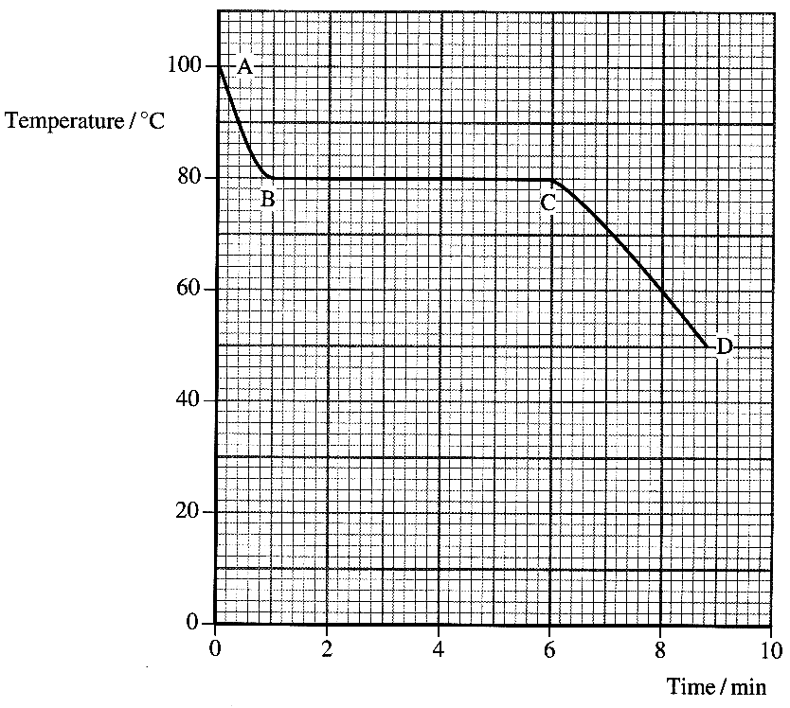
State what is happening during each section
of the graph. [4]
The specific heat capacity
of the substance in
its liquid state is
2100 J kg ⁻¹ K ⁻¹.
Calculate the energy given out by
0.500kg of the substance when the
temperature falls by 20 °C. [2]

The total energy given out by this mass
between points A and C on the graph
is 106 000 J.
Calculate the specific latent heat of fusion
of this substance. [3]

3. A student is asked to carry out an
experiment to find the resistivity of
the material of a length of resistance wire.
Draw an appropriate circuit diagram. [2]
List all the measurements the student should
take to find the resistivity. [3]
How should these measurements be used to find the resistivity? [3]
Suggest two precautions the student should take to ensure an accurate result. [2]

4. All hydraulic systems use the same physical principles.
Explain how large forces can be produced from relatively small forces in such systems.
You may be awarded a mark for the clarity of your answer. [4]
5. Modem electric showers need to be very powerful because they are required to heat the water flowing through them very quickly.
(a) A typical flow rate of water through a shower is 75 g s ⁻¹ when the water is being heated through a temperature rise of 30 °C. The specific heat capacity of water is 4200 J kg ⁻¹ K ⁻¹.
Show that the shower provides thermal energy at a rate of approximately 9 kW. [3]
The shower operates at a voltage of 230 V.
Calculate the current necessary to provide a power of 9 kW. [2]
(b) The shower is connected to the electrical supply by a copper cable 15 m long. A conductor inside the cable has a cross-sectional area of 6.0 x 10 ⁻⁶ m².
The resistivity of copper is 1.7 x 10 ⁻⁸ Ω m. Find the resistance of the conductor. [3]
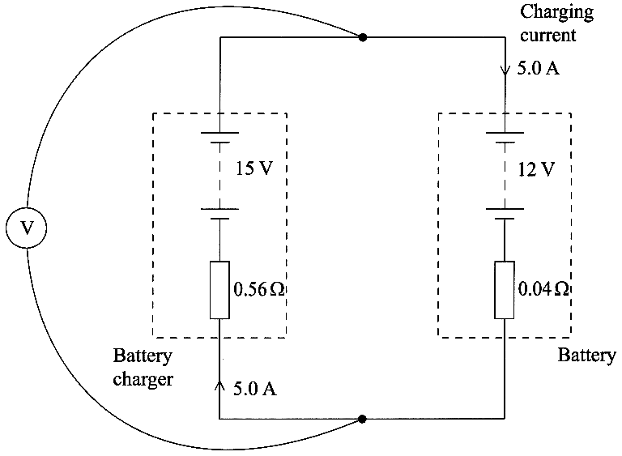
The conductors used for most electrical circuits in homes are copper but they have a smaller cross-sectional area. Suggest why the manufacturer of the shower recommends that the thicker wire is used in the shower cable. [2]

6. A 12 V car battery is recharged
by passing a current of 5.0 A
through it in the reverse
direction using a 15 V
battery charger.
The internal resistance of
the charger and the battery
are 0.56 Ω and 0.04 Ω
respectively.
The circuit used is
shown opposite.

The terminal p.d. across the
battery charger is found by
solving the following equation:
Terminal p.d. - 15 V - (5.0 A x 0.56 Ω)
Determine the reading on the voltmeter. [1]
Write an equivalent equation for the terminal p.d. across the battery. [3]
Calculate the rate at which energy is being wasted during the recharging process. [2]
Hence determine the efficiency of the recharging process. [2]
The internal resistance of this car battery is 0.04 Ω.
Explain why a car battery is designed to have a very low internal resistance. [2]

7. The kinetic model gives the following formula for the pressure exerted by a gas.
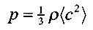
where the symbols have their usual meanings.
[3]
Write an expression for the density of a gas in terms of the number of molecules N, the mass of each molecule m and the volume of the gas V. [1]
For ideal gases: pV = nRT.
Show that for a given mass of an ideal gas the mean kinetic energy of a molecule is proportional to the kelvin temperature of the gas. [3]

TOTAL FOR PAPER: 60 MARKS

