1. Listed below are six physical quantities:
energy force moment momentum power velocity

Select from this list the quantity or quantities fitting each description below.
You may use each quantity once, more than once or not at all.
(a) A quantity which can be measured in newton second (N s).
(b) A quantity which equals the rate of change of another quantity in the list.
(c) A quantity which equals the product of two other quantities in the list.
(d) A quantity with base units kg m² s ⁻³.
(e) Two quantities which have the same base units. [5]

2. A neutron of mass 1.7 x l0 ⁻²⁷ kg travelling at 2.96 x 10⁷ m s⁻¹ collides with a stationary nucleus of nitrogen of mass 23.3 x 10 ⁻²⁷ kg.
Calculate the magnitude of the momentum of the neutron before it collides with the nucleus of nitrogen. [2]
Given that the neutron 'sticks' to the original nucleus after the collision, calculate the speed of the new heavier nucleus of nitrogen. [3]
An elastic collision is one where kinetic energy is conserved.
Make suitable calculations to determine whether this collision is elastic. [3]
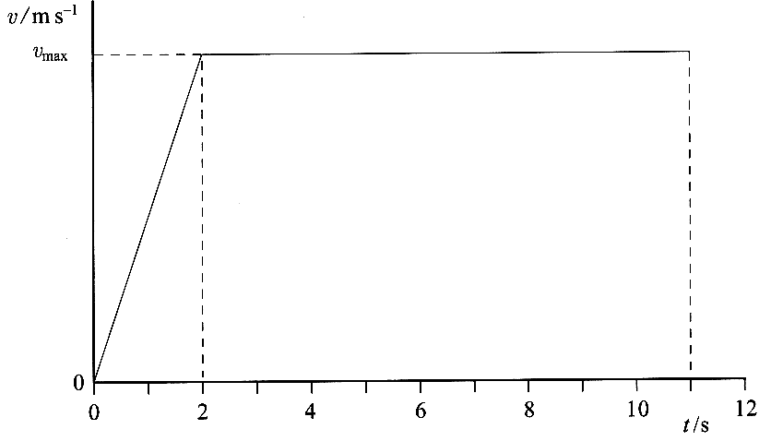
3. An athlete runs a 100m race.
The idealised graph opposite shows how the
athlete's velocity v changes with time t for a
100 m sprint.

By considering the area under the graph, calculate
the maximum velocity v_{max} of the athlete. [3]

Using a copy of the axes below the first graph,
sketch a graph showing how the acceleration of
this athlete changes with time during this race.
Mark any significant values on the axes. [4]
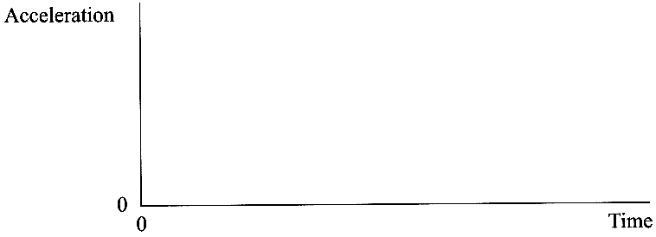
4. The nucleus of a radioisotope of carbon (C)
contains 6 protons and 8 neutrons.
Write down a nuclear equation for the decay
of this isotope by beta minus emission to
nitrogen (N). [3]
The diameter of a carbon nucleus is
approximately 10 ^{n} m.
Suggest a value for n. [1]
The mass of the carbon nucleus is 2 x 10 ⁻²⁶ kg.
Estimate its density. [3]
Comment on your value, relating it to the density of an everyday material. [2]

5. A smoke detector contains a small radioactive source
A typical source contains 1.2 x 10 ⁻⁸g of americium-241, which has a half-life of 432 years.
Show that the decay constant of americium-241 is approximately 5 x 10 ⁻¹¹ s⁻¹. [2]

Calculate the number of nuclei in 1.2 x 10 ⁻⁸g of americium-241, given that 241 g
contains 6.0 x 10 ²³ nuclei. [1]
Hence calculate the activity of 1.2 x 10 ⁻⁸g of americium-241. [2]
The diagram opposite shows the principle of
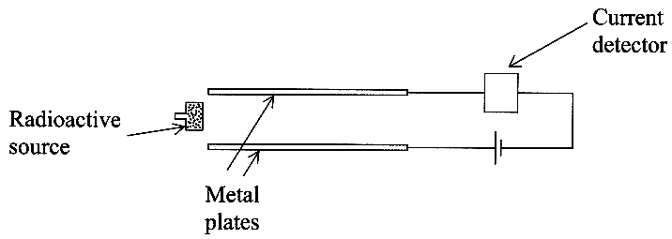
the smoke detector.

Radiation from the source ionises the air
between the plates, and a small current is
detected. If smoke enters the detector, the ions 'stick' to
the smoke particles, reducing the current and
triggering an alarm. Americium-241 is an alpha emitter.
Explain why an alpha emitter is a suitable source
for this apparatus. [2]
Discuss other features of this americium sample which make it a suitable source for the smoke detector. [3]

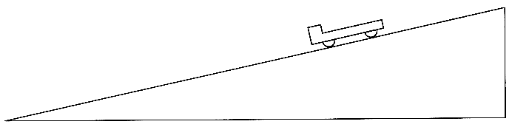
6. A trolley is released from rest at the top of an inclined plane.

A student claims that the acceleration of the trolley
should be uniform.
Describe how you could test this claim experimentally.
Your answer should include:
(i) any additional apparatus required (add this to a copy of the diagram above),
(ii) how the apparatus is used,
(iii) how the results are analysed. [6]

With reference to the forces involved, explain why the student expected the acceleration to be constant. [2]
Explain whether you would expect the acceleration to remain constant if the slope were much longer so that the trolley reached a high speed. [1]
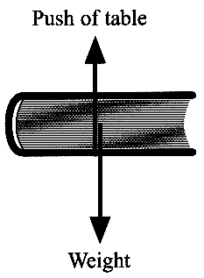
7. A book is resting on a table. A student draws a correct free-body force diagram
for the book as shown opposite.

The student makes the incorrect statement that "The forces labelled above
make a Newton third law pair; therefore the book is in equilibrium".
Criticise this statement. [3]
Each of the forces shown in the diagram has a 'pair' force related to it by Newton's third law.
Complete a copy of the table below. [4]
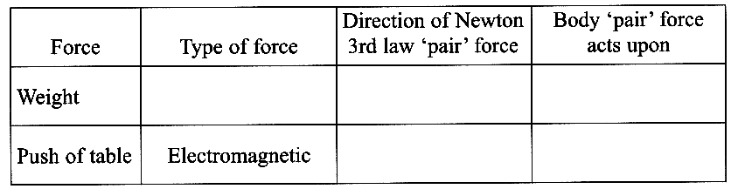

8. A car is travelling along a horizontal road. The driver applies the brakes and the car comes to rest. Describe the principal energy transformation which occurs as the car comes to rest. [1]

On another occasion, the same car is travelling with the same speed, but down a hill. The driver applies the brakes, which produce the same average braking force as before. With reference to the energy transformations which occur, explain why the braking distance will be greater on the hill than on the horizontal road. You may be awarded a mark for the clarity of your answer. [4]

TOTAL FOR PAPER: 60 MARKS

