SECTION I
1. Read the passage and then answer the questions at the end.
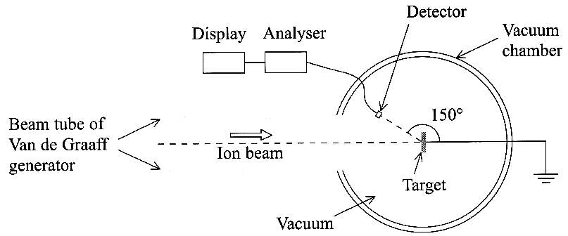
Rutherford backscattering
The elastic scattering of energetic ions of elements of low nucleon number
from surfaces was first reported by Rutherford and his co-workers.
This phenomenon, now known as Rutherford backscattering or RBS,
was used during early unmanned lunar exploration
to obtain the first factual information on the elemental
composition of the Moon's surface. More recently the
RBS technique has been used to determine
quantitatively the number and nature of trace atoms
located in the first few thousand atomic layers of any surface.

The RBS technique is illustrated above. Samples are mounted in a vacuum chamber which is connected to the beam tube of a Van de Graaff generator. This provides a mono-energetic beam of ions which strike the target sample. The particles backscattered through any particular angle, e.g. the 150° shown above, are detected and their energy is analysed. A typical incoming beam energy for helium ions is 2 MeV.

When a flux of high energy ions strikes a material, a very few of the incident particles undergo 'snooker ball' type collisions with the target nuclei. These collisions only occur to those ions which pass close enough to a target nucleus (within about 10 ⁻⁵ nm) for wide-angle elastic scattering due to coulombic repulsion to take place. In this type of scattering both energy and momentum are conserved: the ion rebounds with an energy characteristic of the mass of the target nucleus, and the target nucleus recoils.

The kinetic energy T of the scattered ion is always less than its original incoming kinetic energy T_{o} and is given by T = kT_{o}, where k depends on the masses m_{i} and m_{t} of the ion and the target nucleus and on the angle of scatter. For the extreme case of the ion being scattered through 180°, it can be shown that Measuring k thus enables RBS to distinguish between the different elements in the surface of the target, though it is more difficult to discriminate between heavy elements in the target material than between light ones.
[Adapted from Rutherford Backscattering by I. V. Mitchell in loP Physics Bulletin.]

(a) Explain the meaning of the following phrases used in the passage: (i) nucleon number (paragraph 1),
(ii) elemental composition (paragraph 1), (iii) a mono-energetic beam (paragraph 2), (iv) coulombic repulsion (paragraph 3). [4]

(b) (i) Describe the make-up of a doubly ionised helium-4 ion.
(ii) Show that the speed of such an ion that has an energy of 2MeV is about 10⁷ ms⁻¹. (Unified atomic mass unit u= 1.66 x 10⁻²⁷ kg)
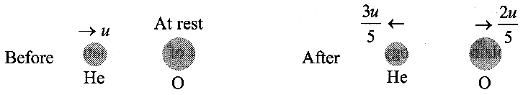
(iii) Suggest how a beam of such ions from a Van de Graaff generator might differ from a beam of 2 MeV α-particles from a radioactive source. [5]

(c) The diagram shows the result of a helium ion of
mass 4m being scattered through 180° after colliding
with a stationary oxygen nucleus of mass 16m,
where m is the mass of a proton or a neutron. Velocities are shown above the particles.

(i) Show that momentum is conserved in this collision.
(ii) Use the relationships given in paragraph 4 to calculate k for this collision in two different ways. [5]

(d) A beam of high energy helium ions, each of mass 4m, is scattered through 180° from target nuclei of carbon, magnesium, titanium and tin of masses 12m, 24m, 48m and 120m respectively.
(i) Tabulate values for m_{t} and k for these targets and sketch a graph in your answer book showing how k varies with m_{t}.
(ii) Use your graph to explain why, when using RBS, it is more difficult to discriminate between trace amounts of heavy elements in the target material than light ones. [6]

(e) Explain carefully the difference between the elastic scattering that occurs in RBS, and the inelastic scattering that occurs in experiments to probe the structure of protons and neutrons. You may be awarded a mark for the clarity of your answer. [5]

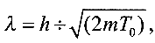
(f) In a beam of helium ions, each helium ion has a de Broglie wavelength λ associated with it.
(i) Prove that where m is the mass of a helium ion and T_{o} its kinetic energy.

(ii) For 2 MeV helium ions λ = 1.0 x 10 ⁻¹⁴ m. When shorter wavelengths are required it is necessary to use higher energy ion beams. Explain the principle of a linear accelerator (a linac) which can produce higher energy particles. Your answer should include a diagram. [6]
TOTAL FOR SECTION I: 31 MARKS
SECTION II
(Answer ALL questions)

2. (a) (i) In the study of the decay of a radioactive source the activity A appears as the subject of the equation A = λN.
Explain in words what is meant by activity and state its unit. [3]
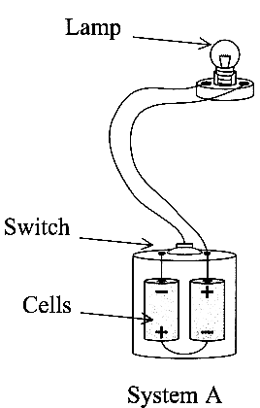
(ii) The discharge of a capacitor through a resistor is analogous to radioactive decay.
Write down the equation for capacitor discharge which is analogous to A = λN.
Explain the analogy between A and the subject of your equation. [4]
(iii) Outline another analogy in physics and state the similar mathematical relationships
which describe the two different phenomena. [3]

(b) An isolated weather station is fitted with a power source driven by the decay of an
isotope of curium, ²⁴⁴₉₆Cm.
(i) Use the following data to show that about 2 x 10²² atoms of curium-244 are needed to
produce an initial power of 20 W.
Half-life of curium-244 = 18 year, Energy per decay of curium-244 = 9.3 x 10 ⁻¹³ J [4]

(ii) After how long will the power of a 20 W source driven by curium-244 fall to 15 W? [3]

3. The front lamp of a bicycle can be powered by a battery or by a dynamo (a small electrical generator).
The battery, in System A, consists of two cells plus a sliding switch. The dynamo, in System B,
consists of a permanent magnet that is made to rotate close to a fixed coil of wire.
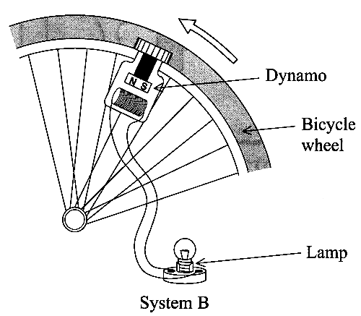
The two systems are represented opposite.

(a) State the energy changes occurring (i) in System A when the lamp is lit,
and (ii) in System B when the lamp is lit. [3]
(b) Discuss the difference in performance of the two lighting systems
(i) during a dark hilly journey of one hour, (ii) over two years of irregular night use. [4]
(c) (i) Draw a circuit diagram for the battery system.
(ii) The cells are each of constant e.m.f. 1.2V and each has a capacity of 0.80 Ah,
i.e. each can deliver 800 mA for 1 hour or 80 mA for 10 hours, etc.
Calculate the total energy that the battery can supply. [5]
(d) (i) Explain how the dynamo generates electricity.
(ii) Sketch a graph of current against time for the lamp when the dynamo is operating
on a bicycle moving at a constant speed. [5]

4. A TV set is connected to its aerial by a long cable. A signal entering the TV set can be
reflected back up to the aerial and then reflected again down to the TV set. This can
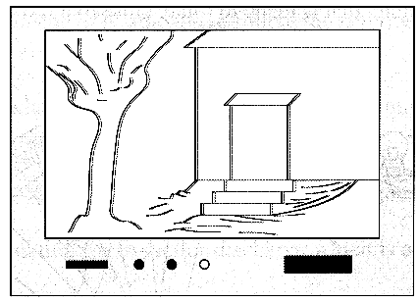
sometimes produce a faint 'shadow' picture to the right of the original picture as shown.
(a) (i) Calculate the delay time between the arrival of the main signal and the reflected
signal when the connecting cable is 7.5 m long. Take the speed of transmission of the
signals along the cable to be 1.9 x 10 ⁸ ms ⁻¹.
(ii) The time-base setting in the TV set is 2.0 μ cm ⁻¹. Make appropriate calculations to
decide whether the 'shadow' picture will be noticeably displaced from the original picture.
(iii) Suggest why any faint shadow appears to the right of the original picture. [7]

(b) The cable is made up of a central copper wire, and an outer copper sheath wrapped
around an insulating material, as shown below. It is called a coaxial cable.
The wire and the sheath become oppositely charged when they carry a signal
(i) Sketch a cross-section of the coaxial cable and draw the electric field produced by
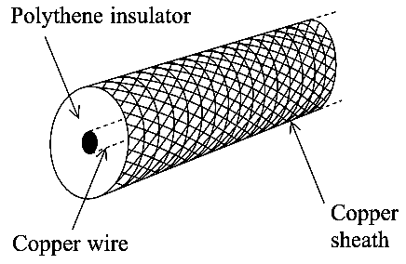
the wire and the sheath when they carry a signal.
(ii) Describe the magnetic field both inside and outside the coaxial cable when charges
flow in opposite directions along the wire and sheath. [4]
(c) The inner and outer conductors of a coaxial cable form a capacitor with a
capacitance per unit length of 120 pF m ⁻¹.
(i) What is the capacitance C of the 7.5 m cable used to connect the TV set to its aerial?
(ii) The property of the cable that is useful in reducing the reflections referred to above
is called its impedance Z. For a signal of frequency f,
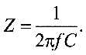
the impedance Z is given by

Show that the unit of Z is the ohm. [4]

TOTAL FOR SECTION II: 49 MARKS TOTAL FOR PAPER: 80 MARKS

