1. An acetate rod is rubbed with a duster. The rod becomes positively charged.
Describe what happens during this process. [2]

The rod is then lowered at a constant speed, towards another positively charged rod that rests on an electronic balance.
.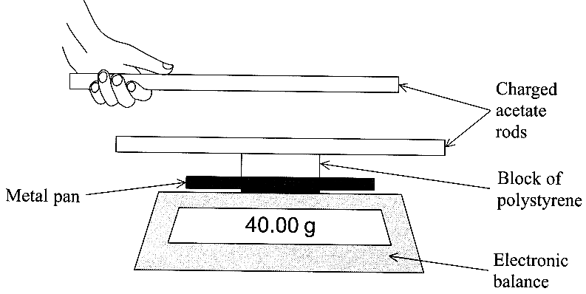

Explain why it is necessary to have the block of polystyrene beneath the bottom rod. [2]

Describe and explain what would happen to the reading on the balance as the top rod slowly approaches, and comes very close to, the bottom rod.
You may be awarded a mark for the clarity of your answer. [4]

2. The diagram shows the top view of a square of wire of side 1.5 cm.
It is in a uniform magnetic field of flux density 8.0 mT formed between magnetic north and south poles.
The current in the wire is 2.0 A.
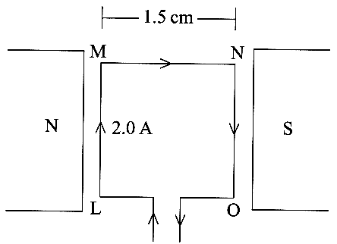

What is the meaning of uniform in the phrase uniform magnetic field? [1]

Determine the sizes and directions of the electromagnetic forces that act on the sides LM and NO
of the square of wire. [3]
Why do no electromagnetic forces act on the sides MN and OL of the square? [1]
What effect will the forces acting on LM and NO have on the square of wire? [1]

The magnetic poles are now moved further apart. Describe and explain what effect, if any, this will have on the magnitudes of the forces produced on LM and NO assuming the current \of 2.0 A is unchanged. [2]

3. The potential difference between the plates of a 220 µF capacitor is 5.0 V.
Calculate the charge stored on the capacitor. [2]
Calculate the energy stored by the capacitor. [2]

Describe how you would show experimentally that the charge stored on a 220 aF capacitor is proportional to the potential difference across the capacitor for a range of potential differences between 0 and 15 V.
Your answer should include a circuit diagram. [5]

4. State Lenz's law of electromagnetic induction. [2]
A bar magnet is dropped from rest through the centre of a coil of wire which is connected to a resistor and datalogger.

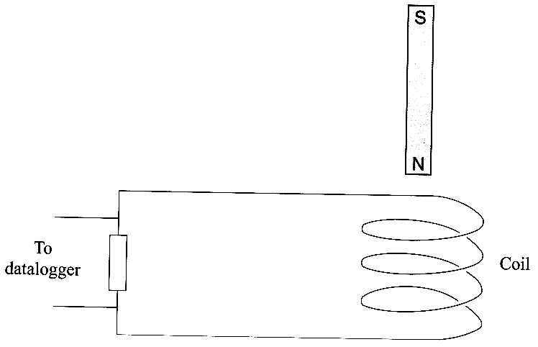

State the induced magnetic polarity on the top-side of the coil as the magnet falls towards it.

On a copy of this diagram, add an arrow to the wire to show the direction of the induced current as the magnet falls towards the coil. [2]

The graph shows the variation of induced current in the resistor with time as the magnet falls.

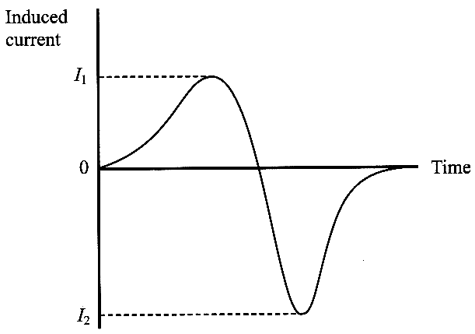

Explain why the magnitude of I₂ is greater than I₁. [2]

5. The orbit of the Moon, which has a mass m, is a circle of approximate radius 60R, where R |is the radius of the Earth. Show that the gravitational attraction between the Earth, mass M, and the Moon is given by

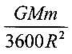 [1]

The mass of the Earth is 6.0 x 10²⁴ kg and its radius is 6.4 x 10⁶ m.
Show that the orbital speed of the Moon around the Earth is approximately 1 km s⁻¹. [4]

Hence confirm that it takes the Moon about 30 days to orbit the Earth. [4]

TOTAL FOR PAPER: 40 MARKS

